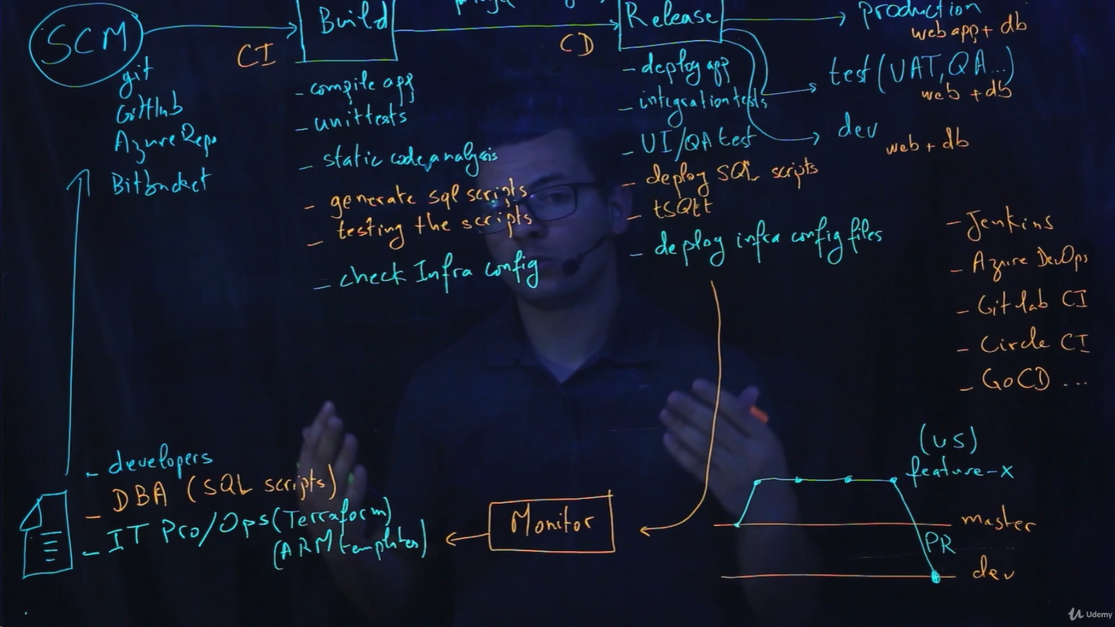

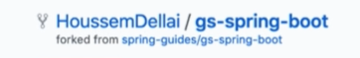

Fork/push the code into GitHub and create the new project in the Azure DevOps.

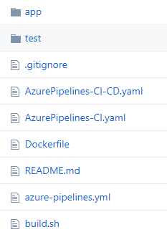

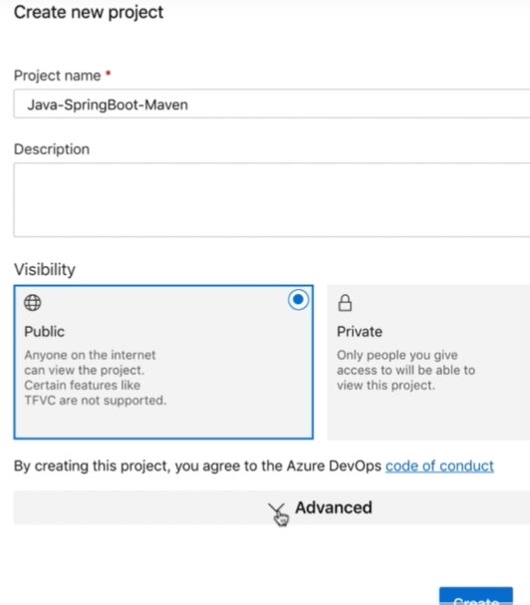

Go to the pipelines and created new build and select GitHub code

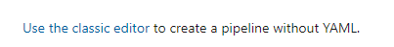

Select use classis editor and connect to the GitHub then select GitHub repository.

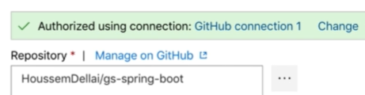

Select which templet your going to user for building and testing using maven and finally generating the output.

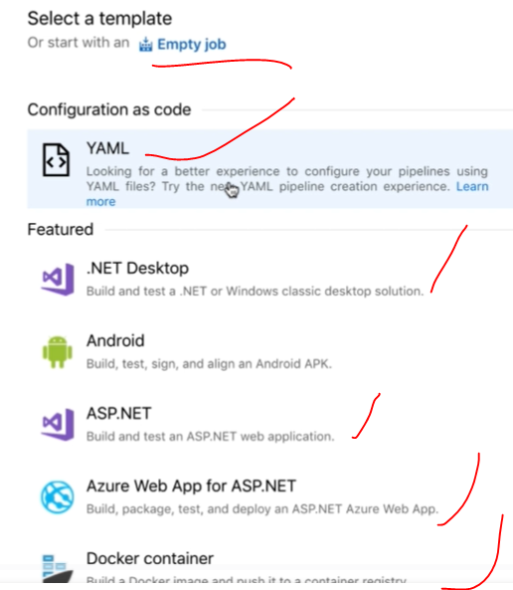

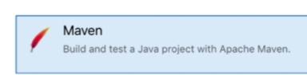

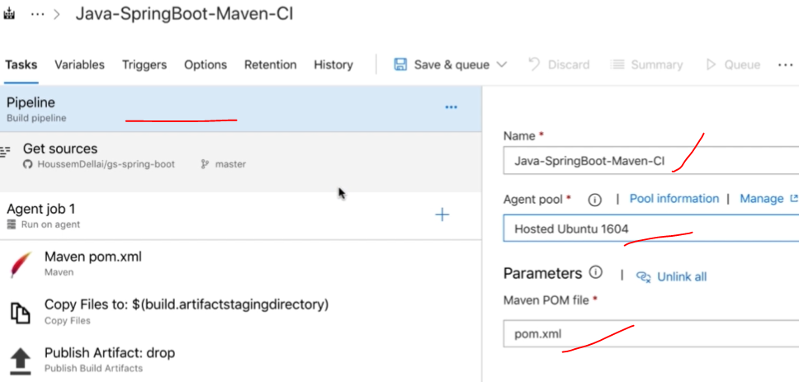

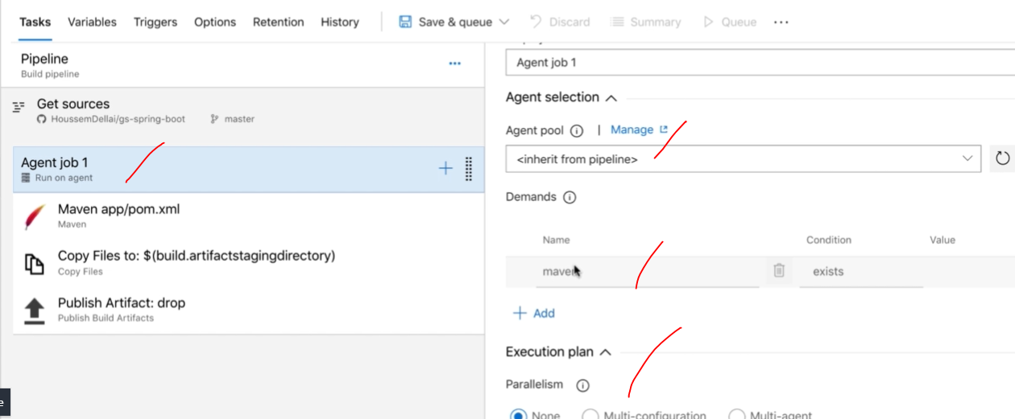

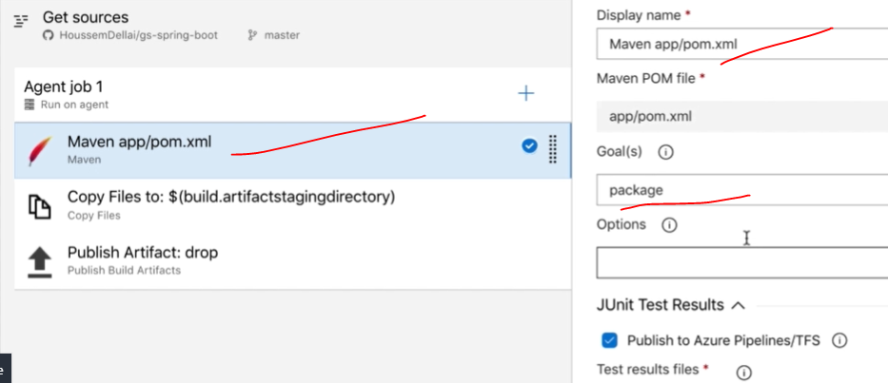

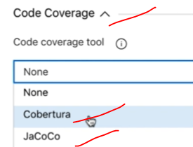

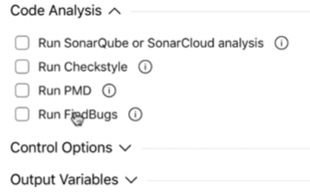

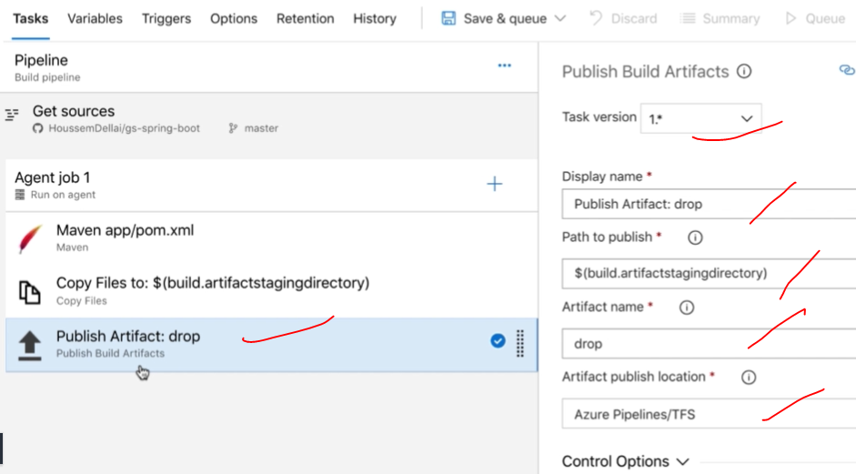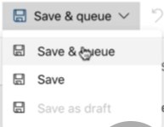

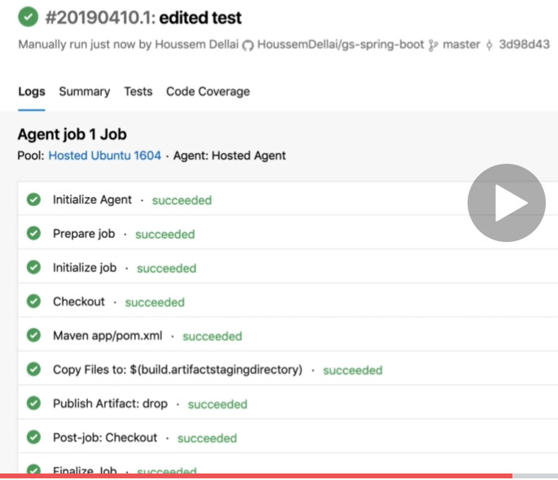

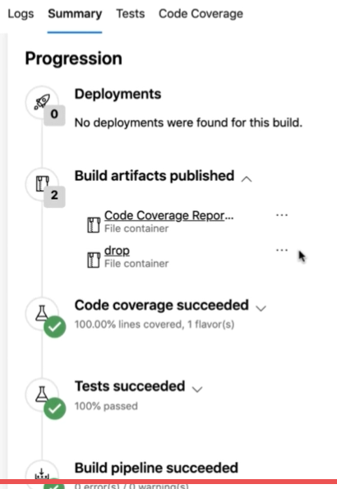

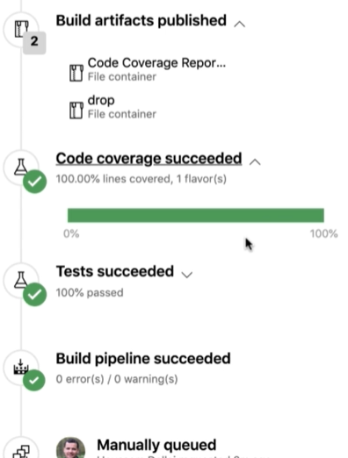

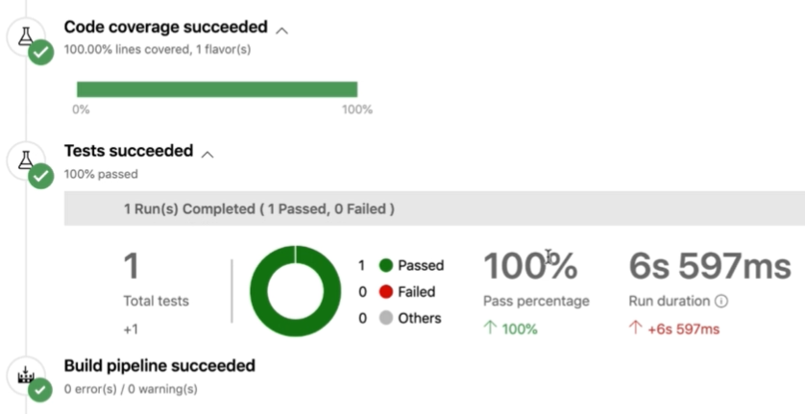

Creating new webapp for the deployment purposes.

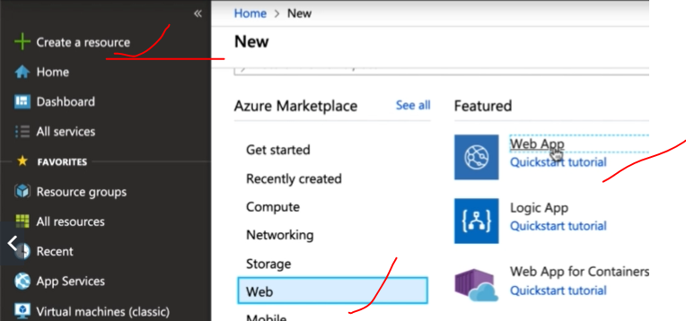

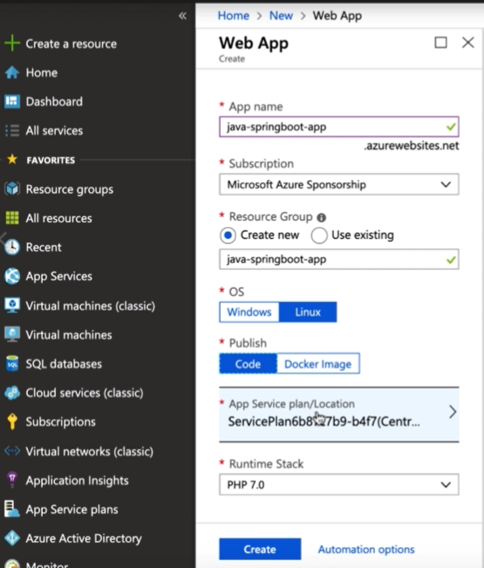

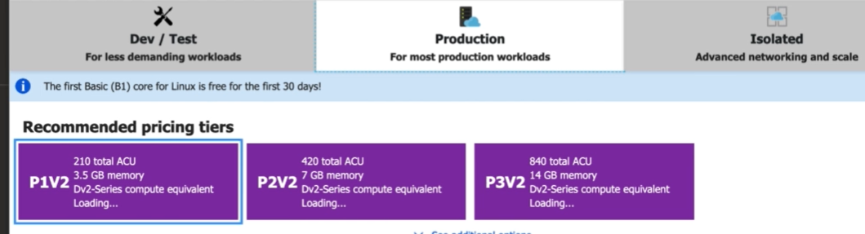

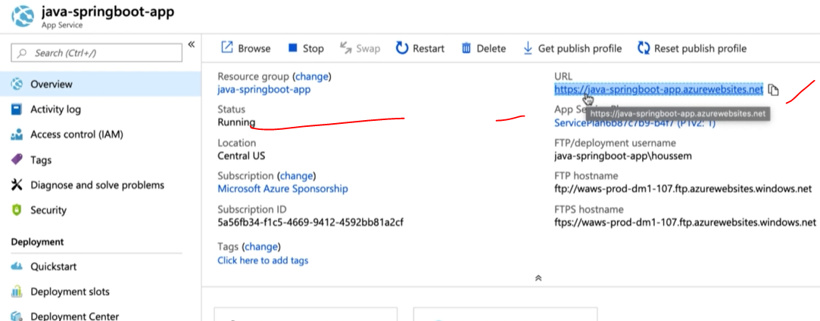

Now out web app is ready to deploy and now in the pipeline we can select **Release** option to deploy the code into out webapp. Then select where you’re going to deploy your code.

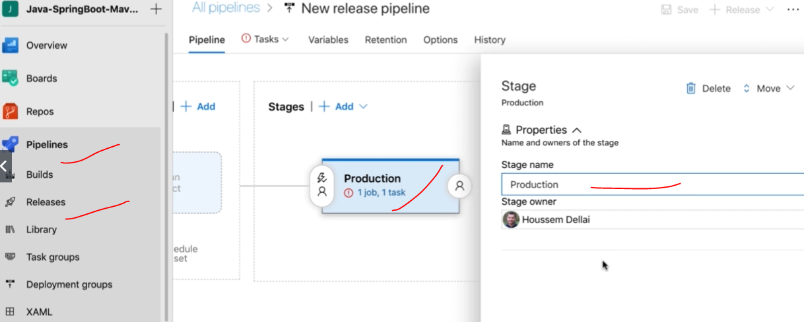

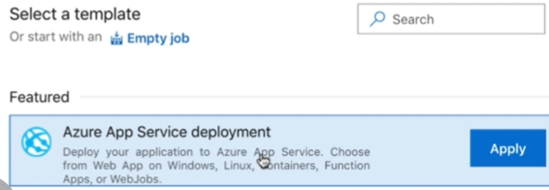

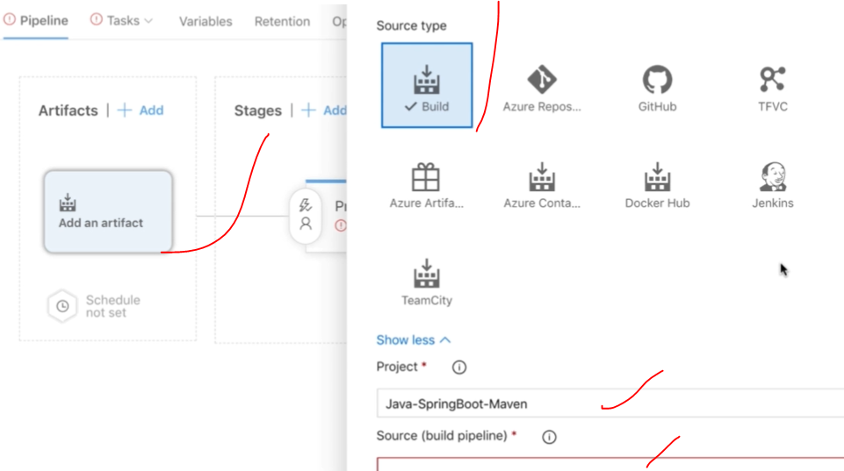

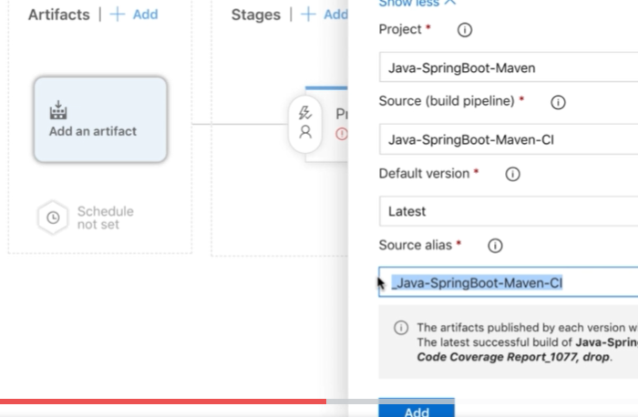

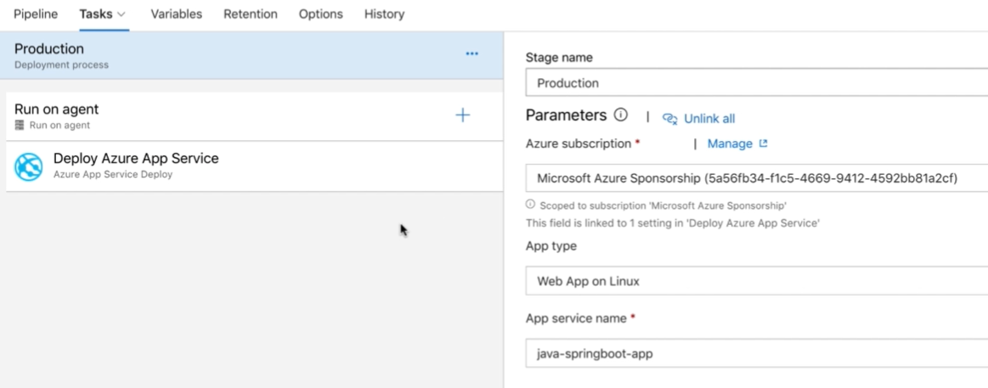

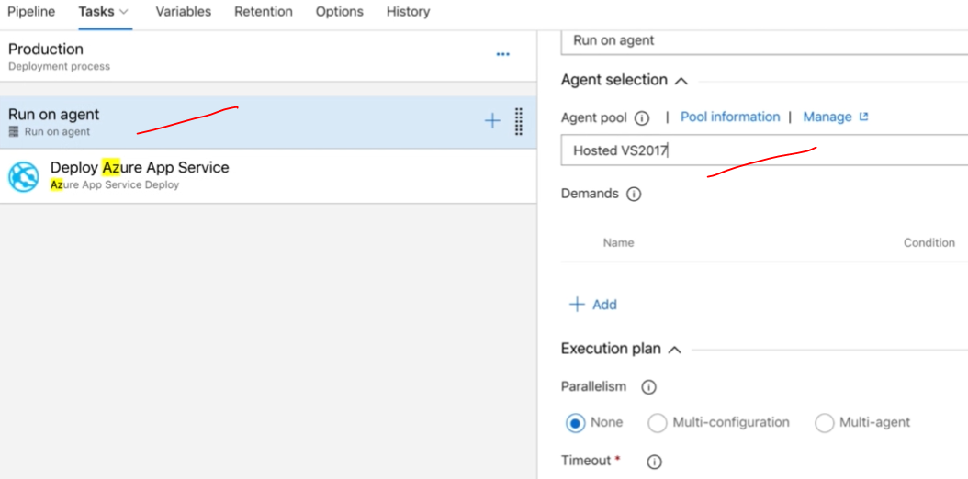

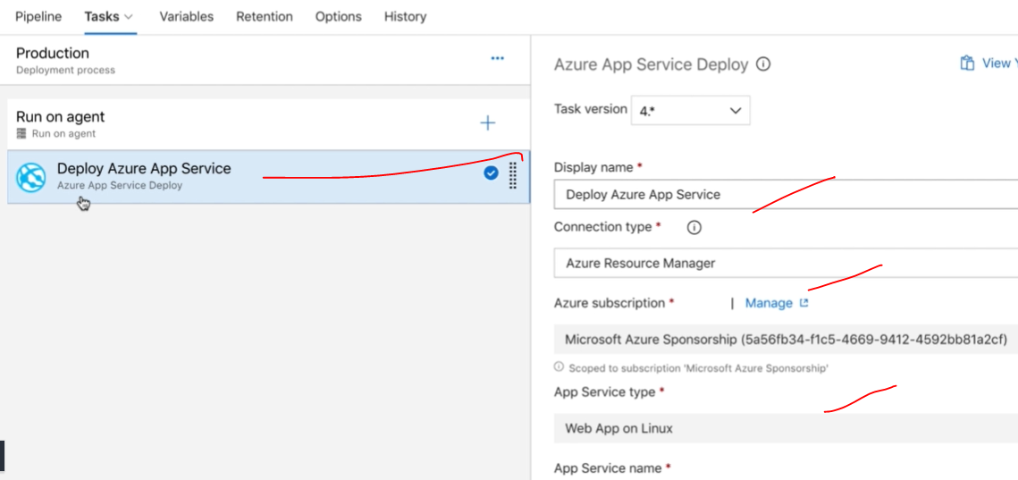

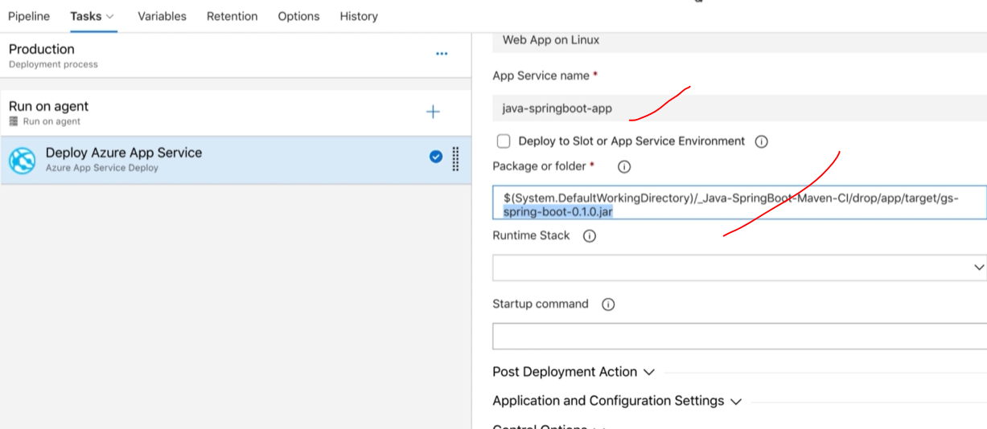

Then save it and release the build.

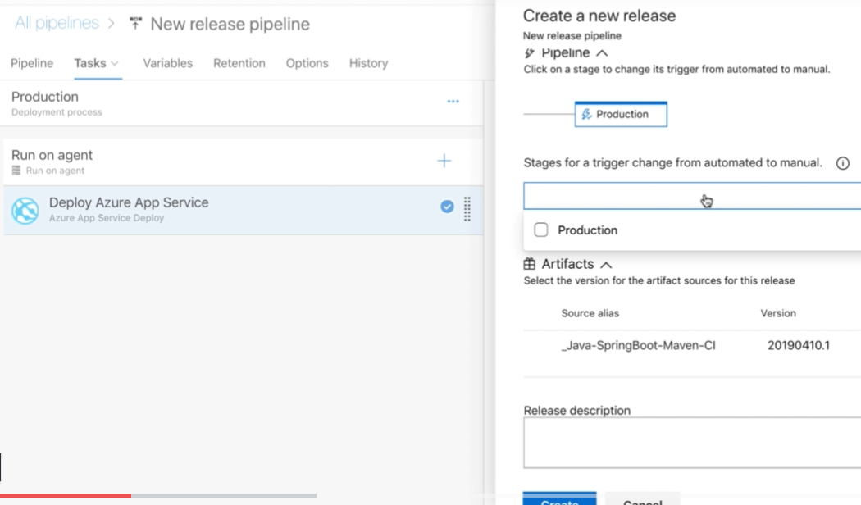

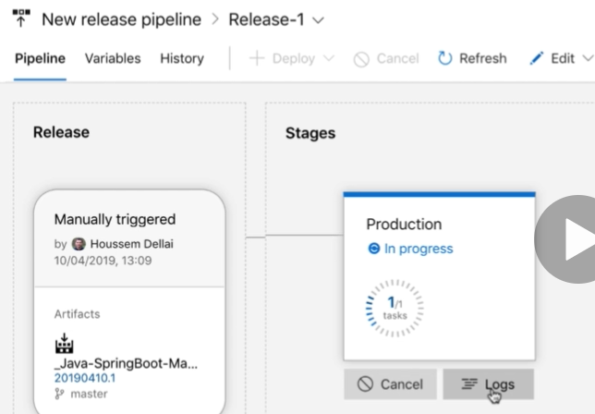

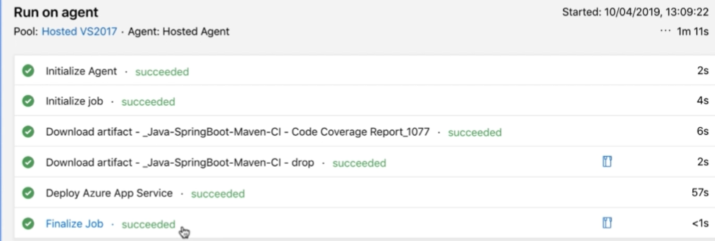

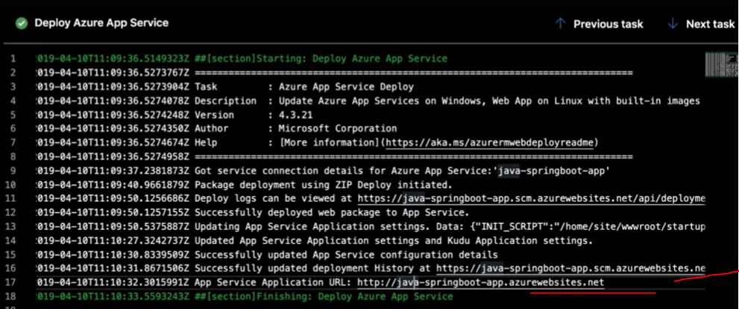

Open the above URL and check the code has deployed successfully or not

CI pipeline with YAML:

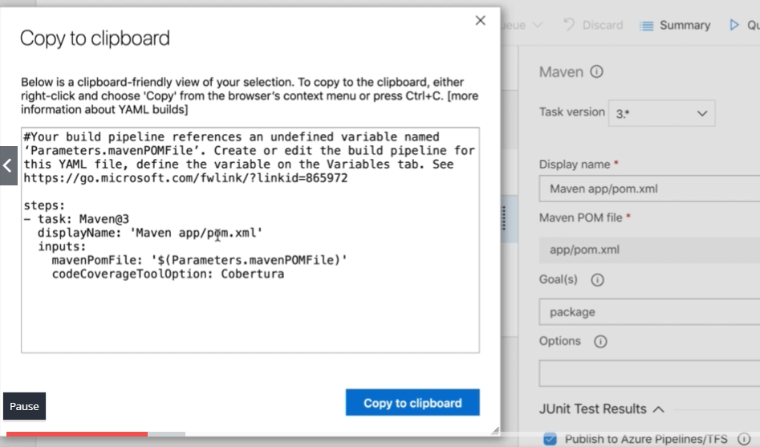

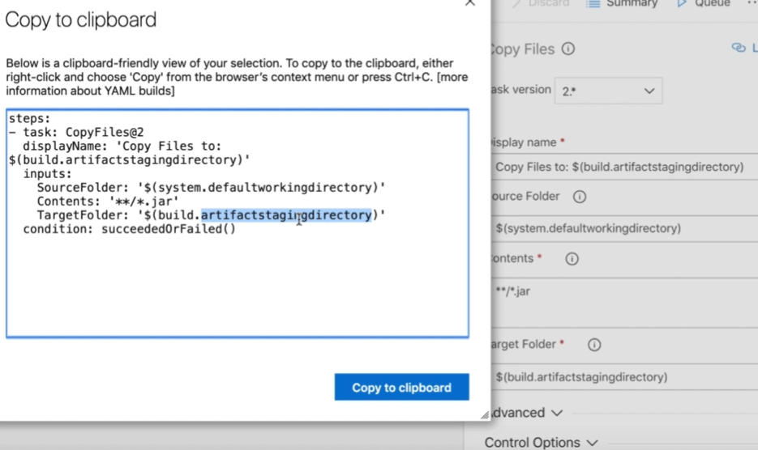

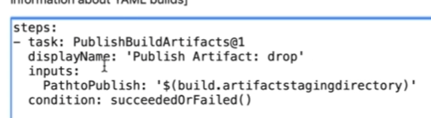

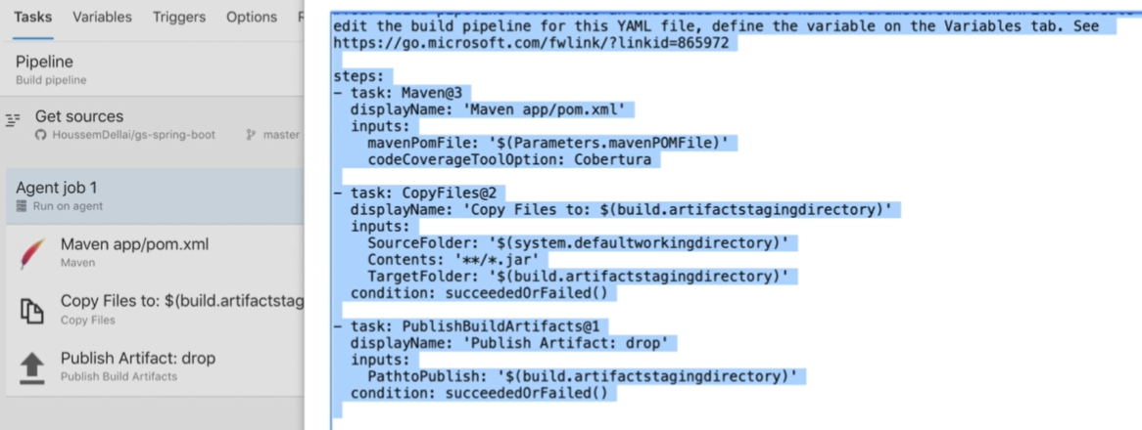

Here is the full code: above instead of bit bit code:

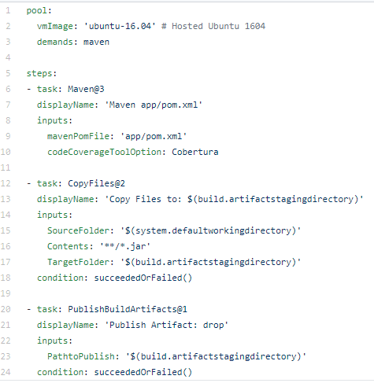

If we need to run with azurepipeline.yml file need to select with below configuration as a code template after GitHub section. Click

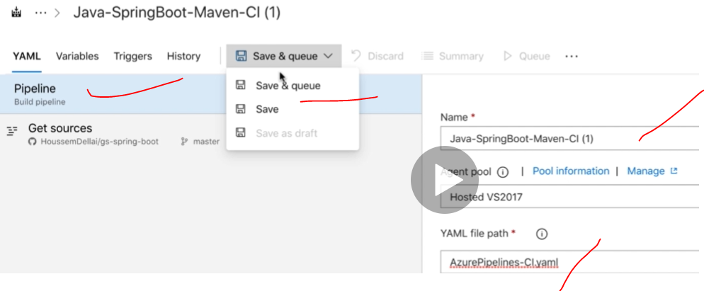 apply

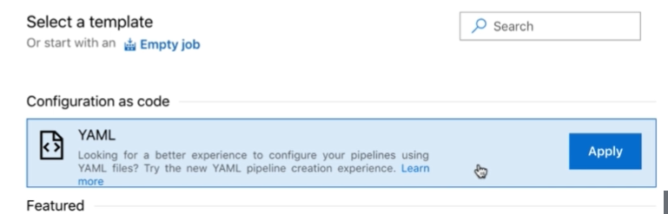

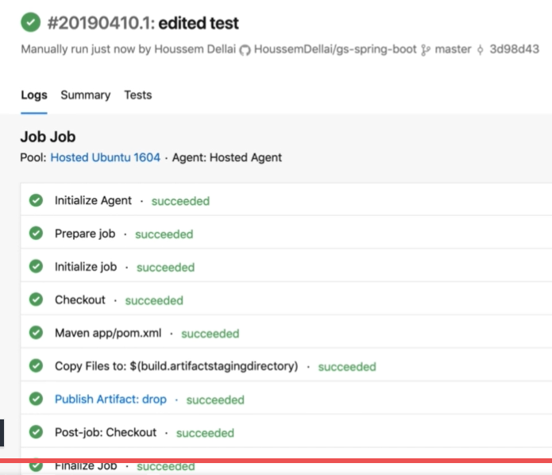

**CI/CD with .net code:**

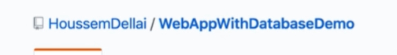

**dotnet restore** –it will restore the structure of the project by default.

**dotnet build** –it will build the dotnet code.

**dotnet run** –it will run the webpage

create new project for the dotnet project then start to create the Azure pipeline build for the dotnet project using respective branch.

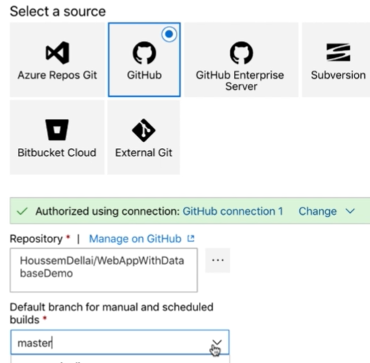

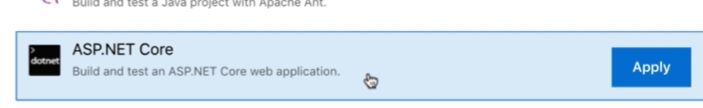

This will generate CI/CD pipeline for the dotnet applications.

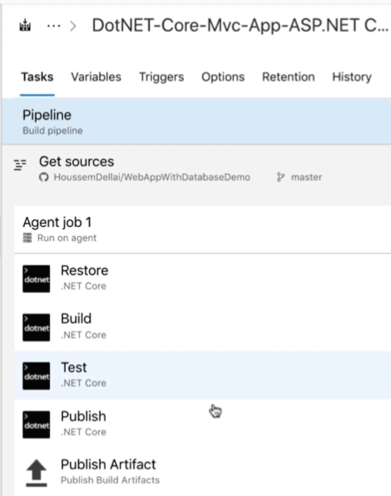

1.Pipeline tab: 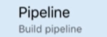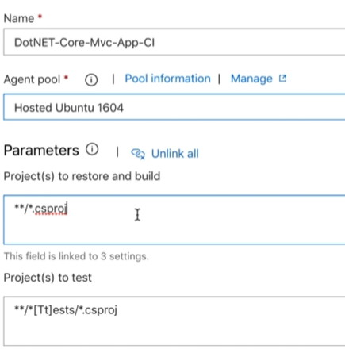

2.Source code: 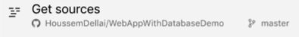

3.Agent jobs: 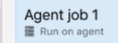

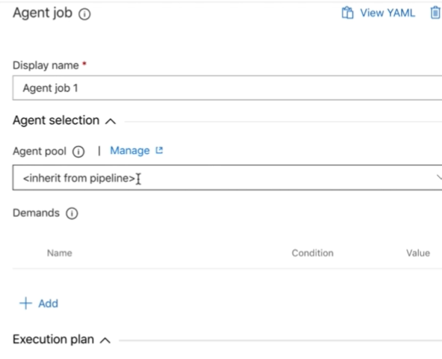

4. Restore: 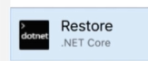

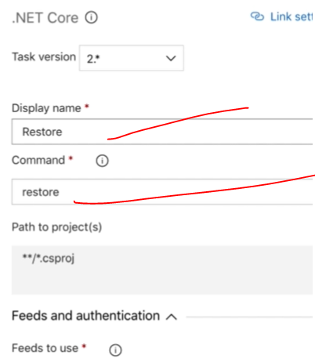

5.Build: 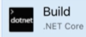

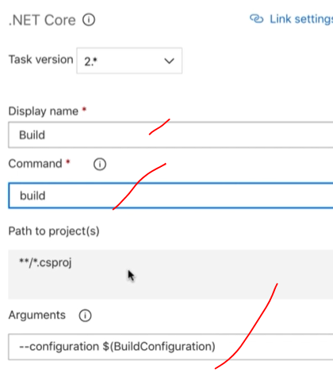

BuildConfiguration is variable saved in the Azure Variables.

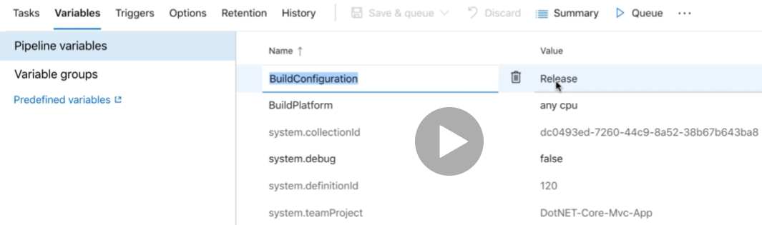

6.Test: 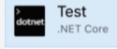will run the unit test.

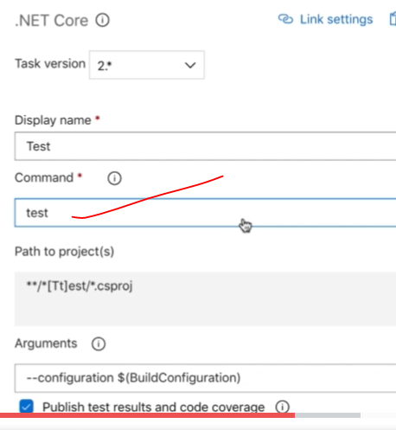

7.Publish: 

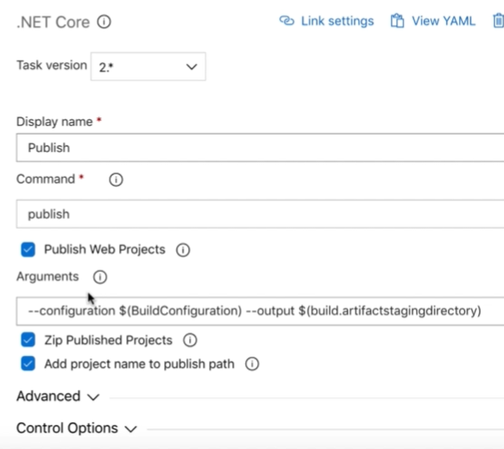

8.Publish Artefactsx`: 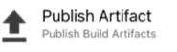

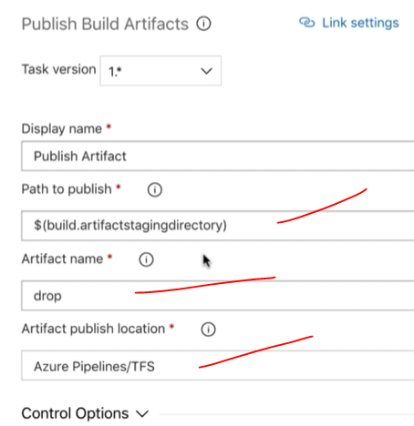

Start the queue the job: it will start the job automatically set by step.

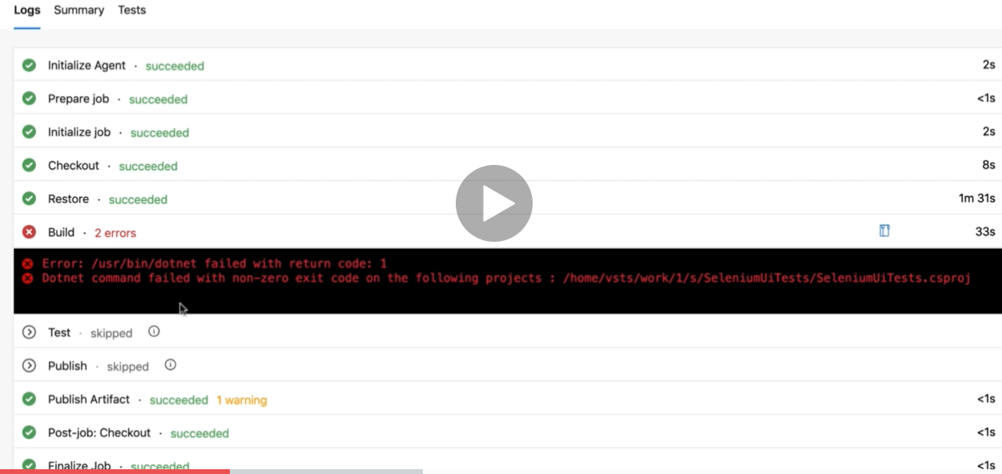

We didn’t update properly for the selenium project and update in the file with exclusion of selenium and finally it’s got completed successfully.

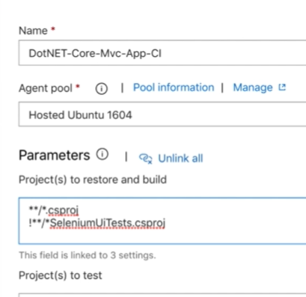

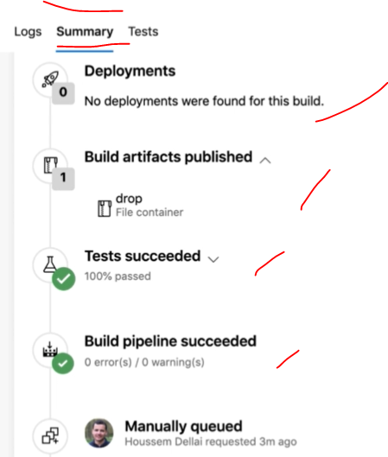

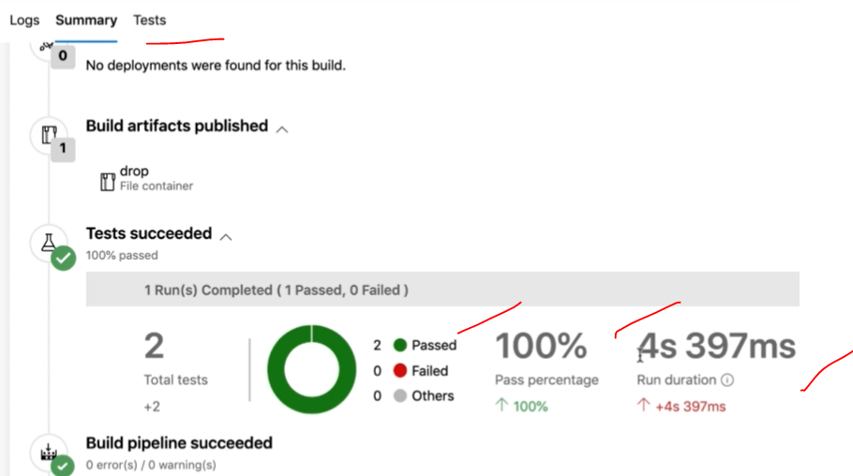

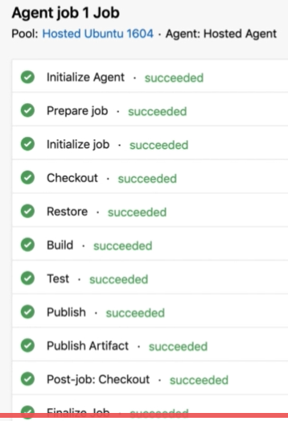

For we need to deploy dotnet code into webapp need to create new Azure webapp.as we create above webapp and got to Azure pipelines then go for Release to create the deployment job.

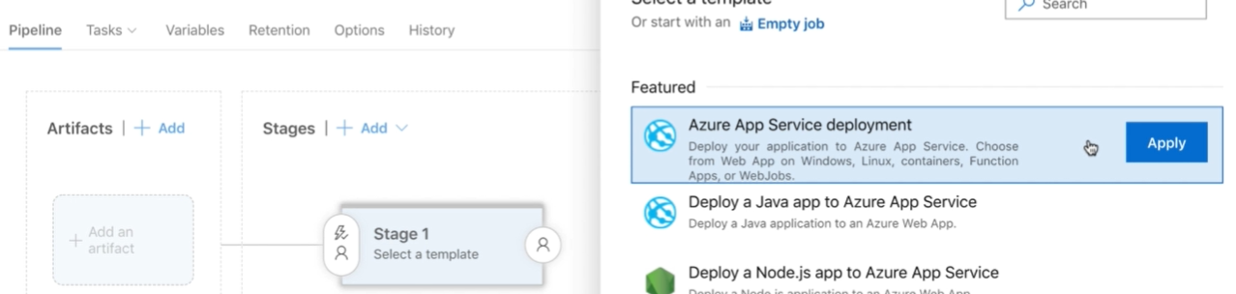

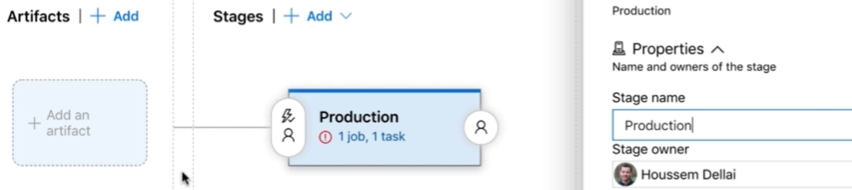

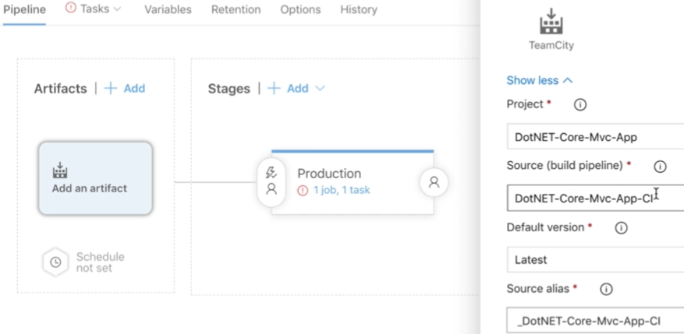

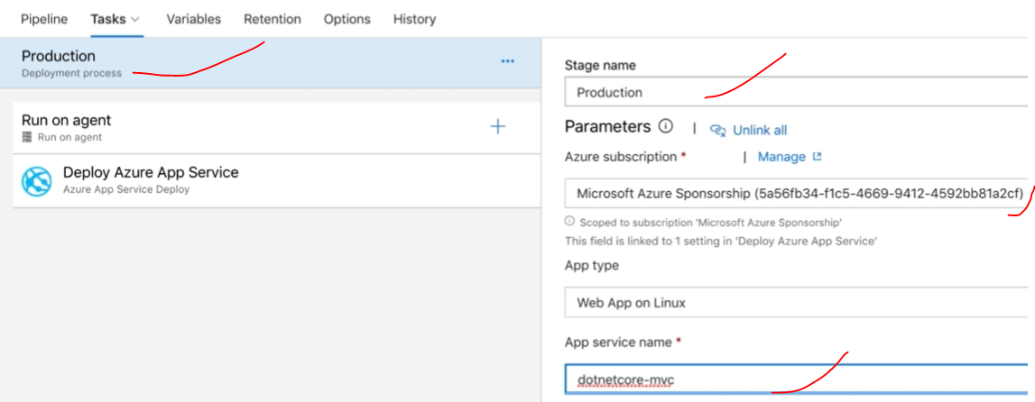

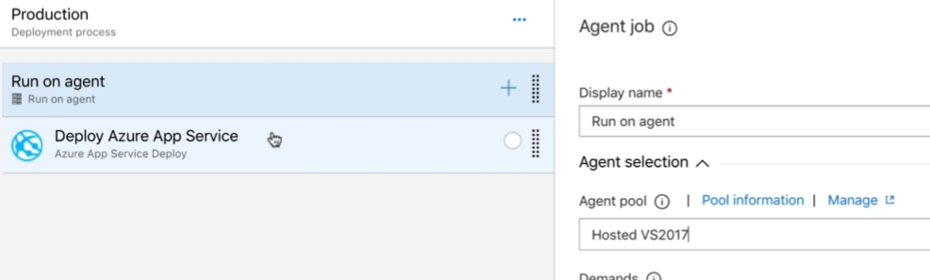

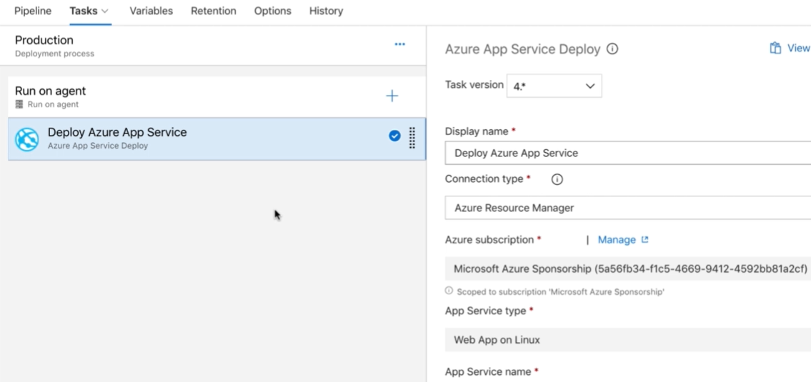

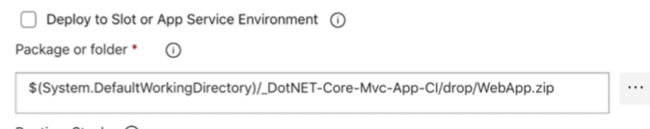

Save & release the job for the deployment.

Finally verify the output of console output status of job. Then once deployment has done please webapp URL the latest changes are updated or not.

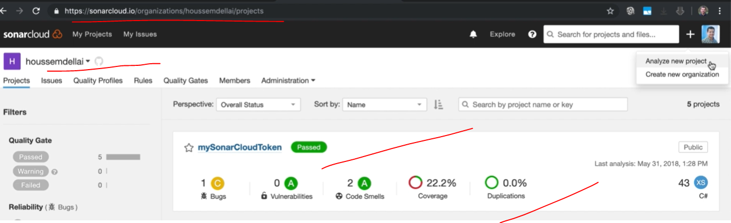

**In the Sonar Portal:** Create new project to scan the sonar bugs. click setup to generate the token to access the devops process.

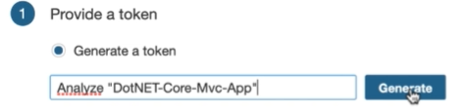

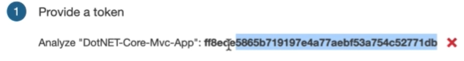

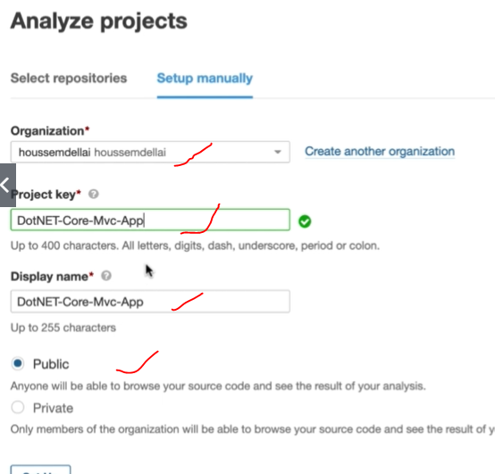

Add + icon in the Azure Release job and add all below 3 templates.

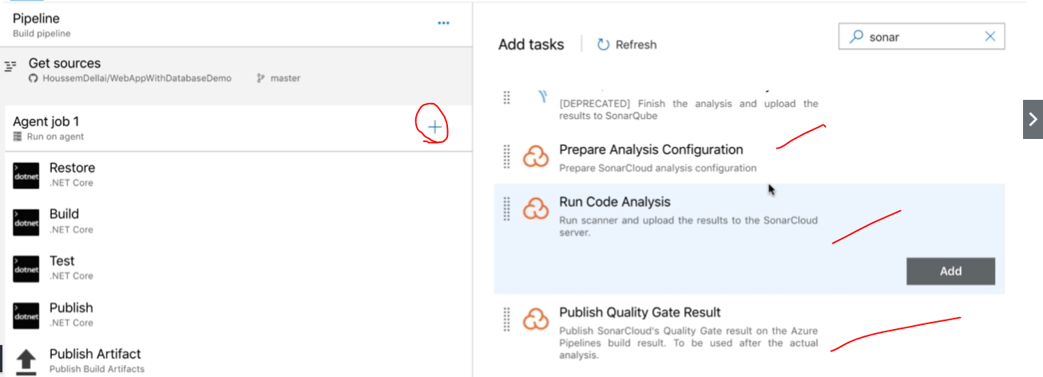

And need to run those 3 sonars as a sequential order as in the below. Then configure as per the below requirement.

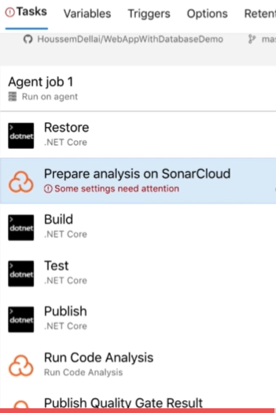

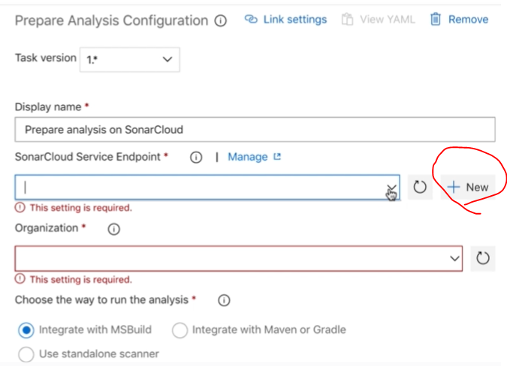

Create new Butten and configure with sonar token then add connection name and past token and verify it-ok then select organization=sonar account name and project key =token name

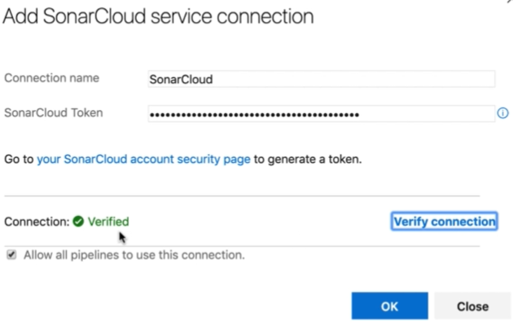

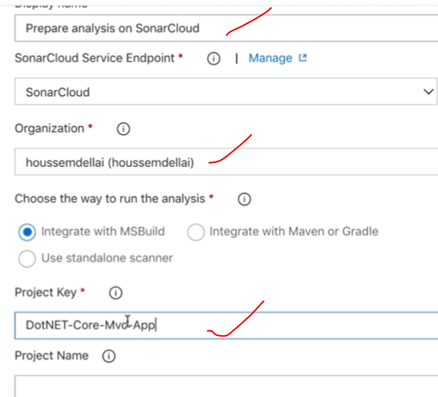

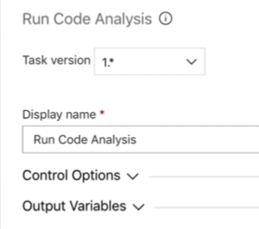

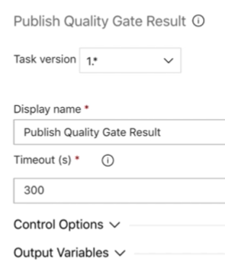

Currently my project doesn’t have csproj GUID to add power shell task, add configurations and save queue the job for the deployment.

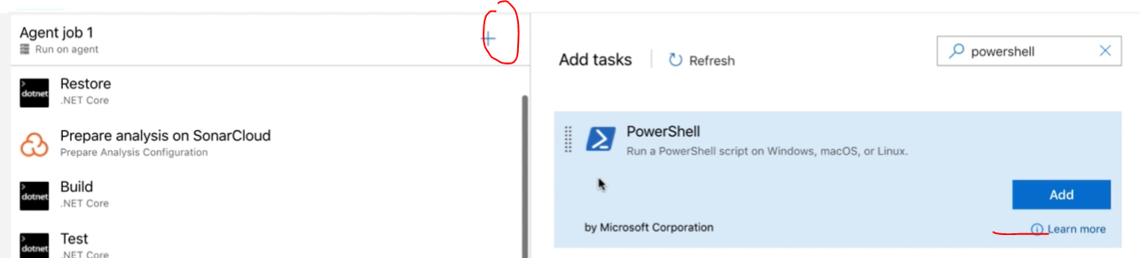

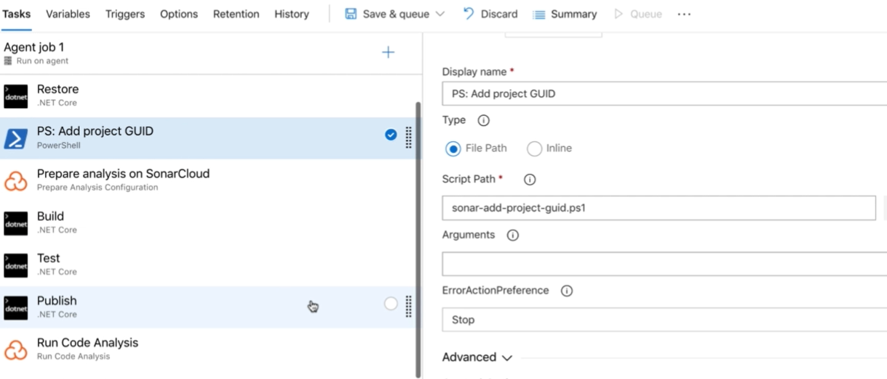

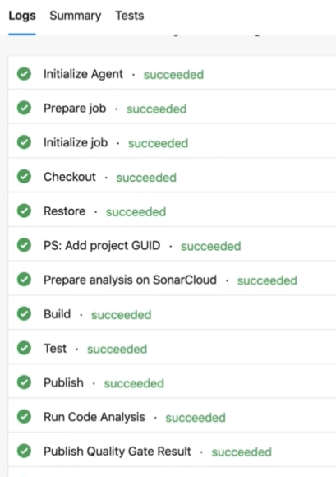

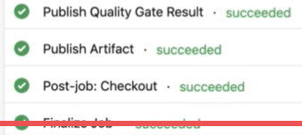

Finally check in the sonar clod how our project got reported and how many bugs are identified.

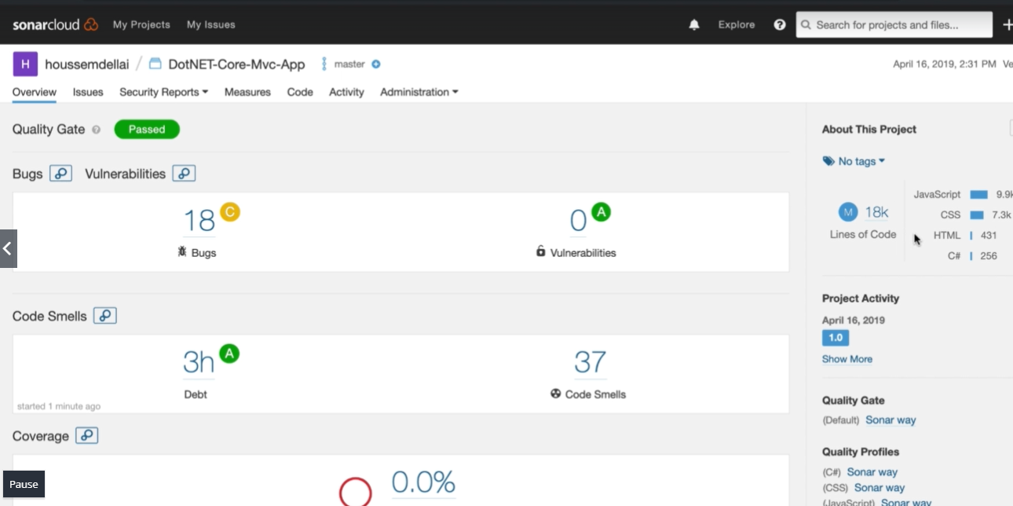

**White source boult on CI/CD:**

**Open new pipeline and add source code and use and chose asp.net code template.**

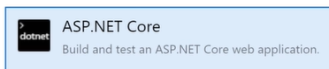

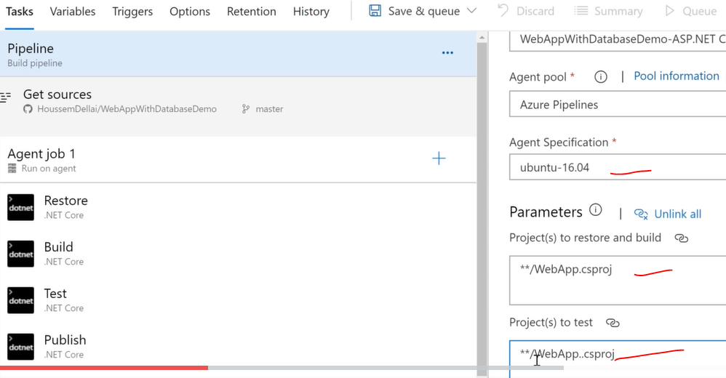

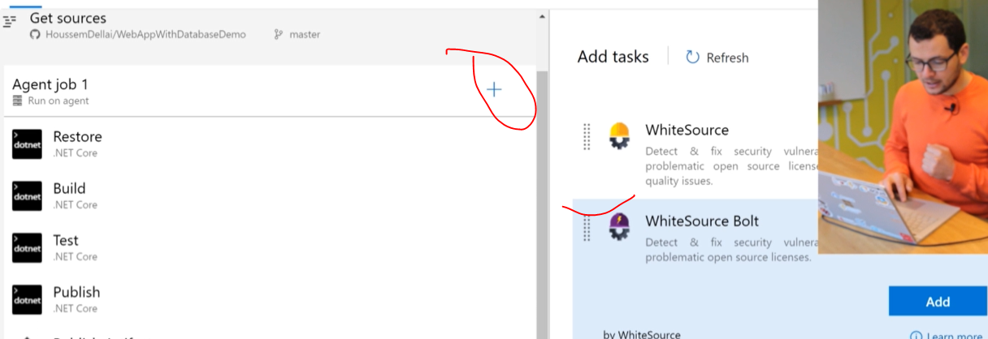

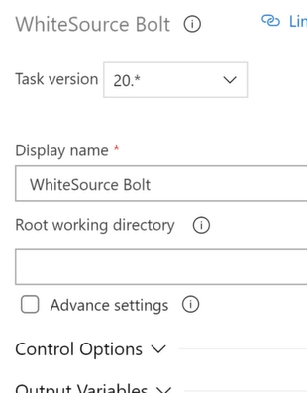

**Save and run the job and will display the test results in the dash board.**

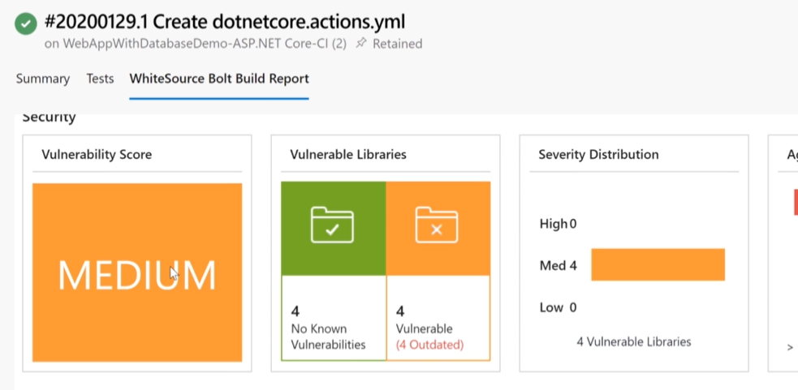

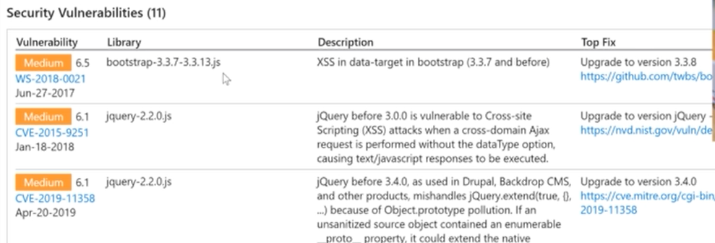

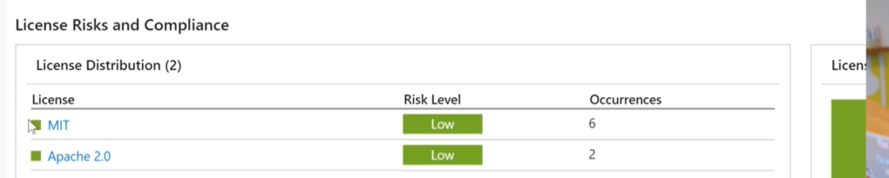

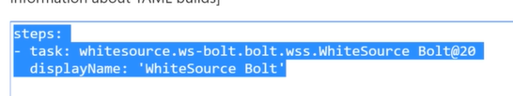



**The above script will multiple stages and about 317 lines similar to real time script.**

**CD/CD for the Database:**

**Create project for the SQL database**

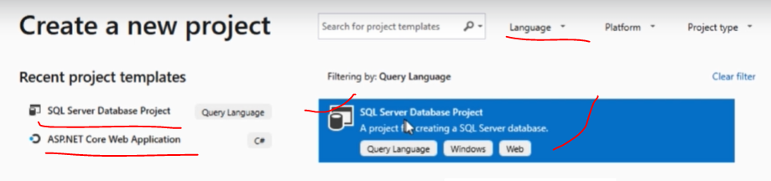

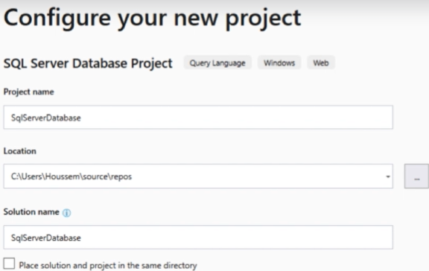

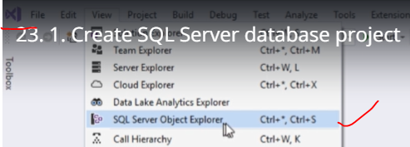

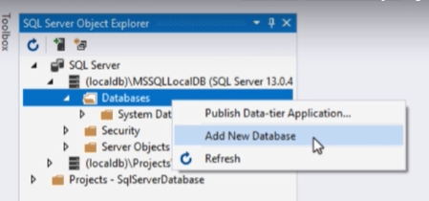

**If we create new database will default databases. And by using publish option we can build and publish the database.**

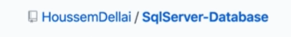

**Create new project and create new pipeline build.**

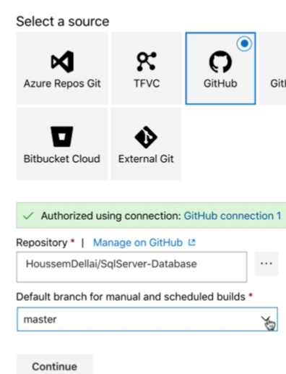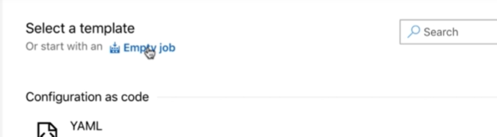

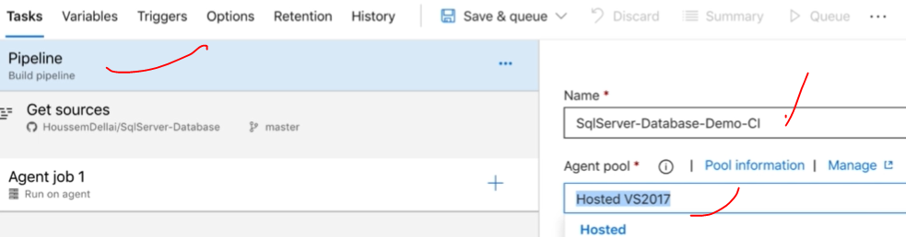

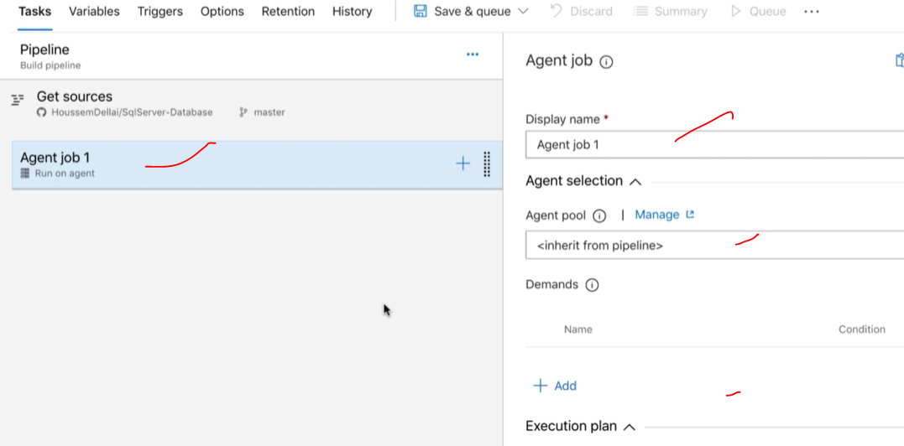

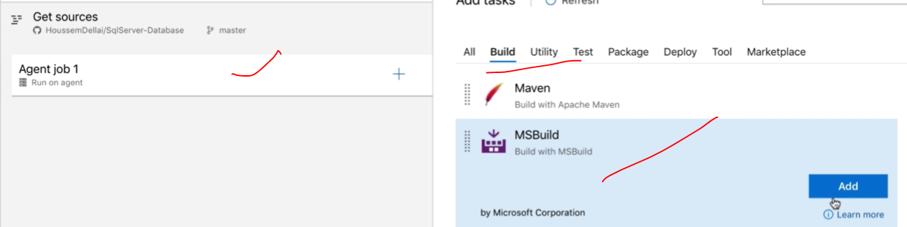

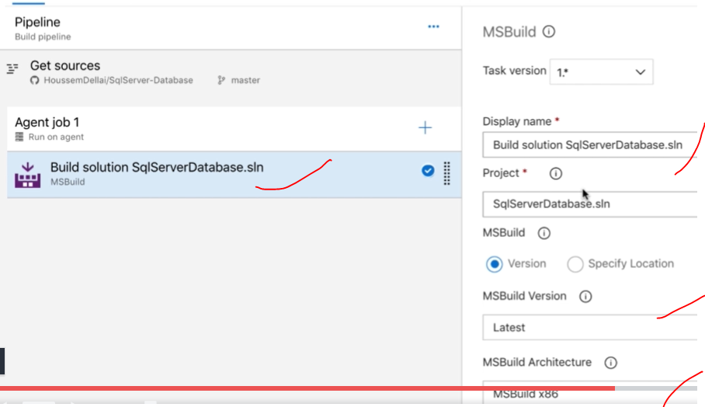

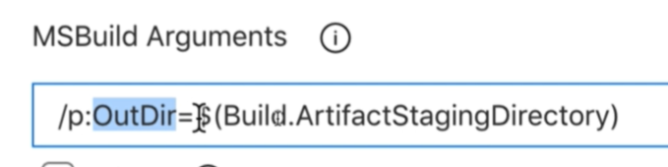

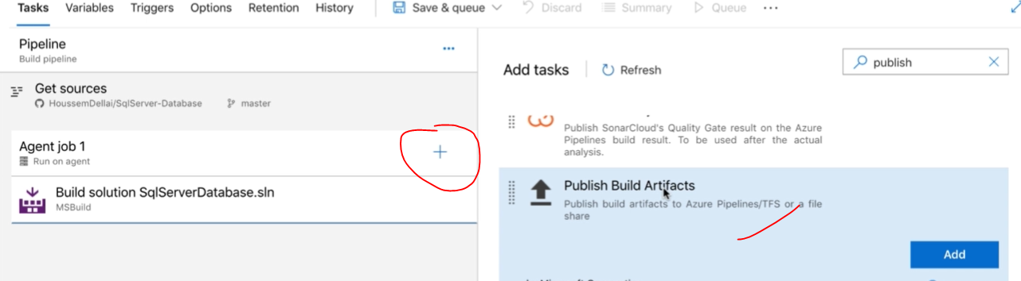

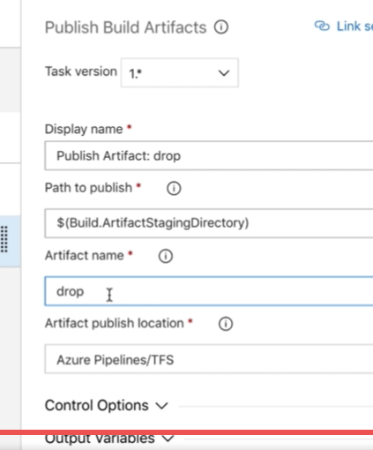

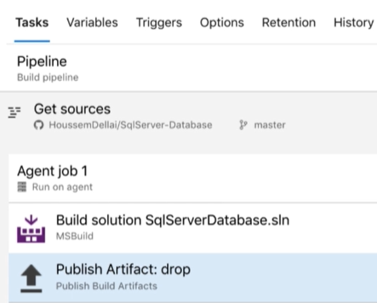

**Save and queue run the CI pipeline.**

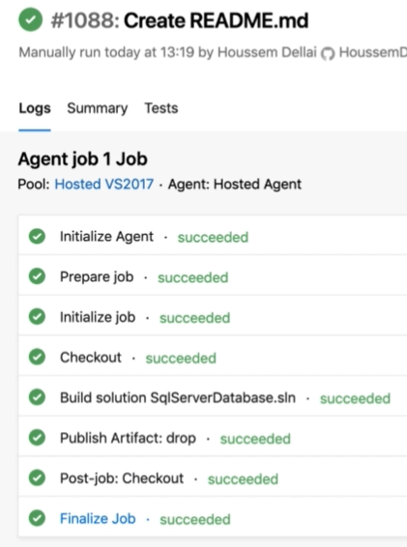

**Finally, DOCPAC file will be created for the deployment.**

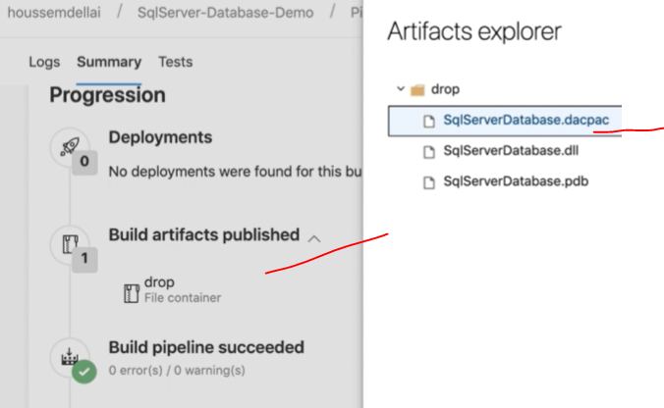

**Then create Azure SQL database for the deployment.**

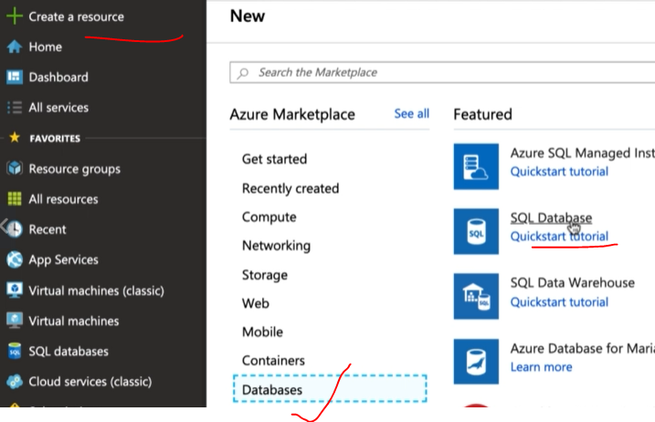

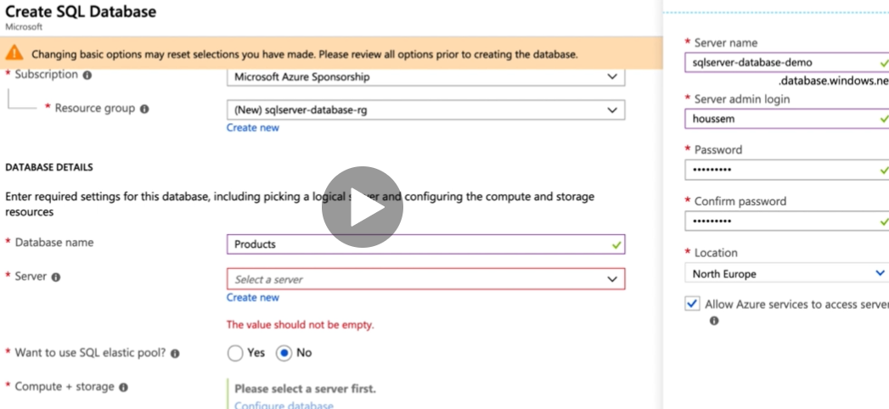

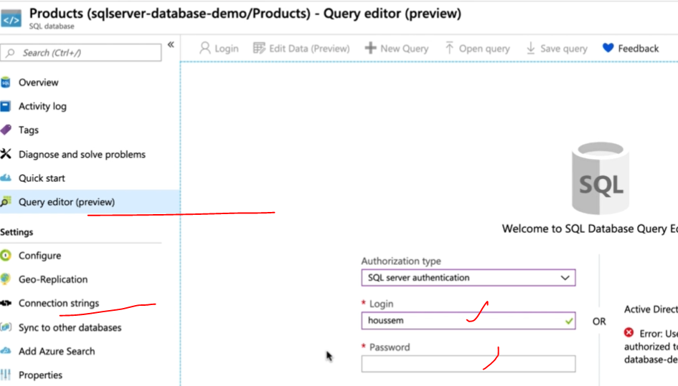

**Create new pipeline release for the deployment in the database. There is no templet for the SQL database deployment.**

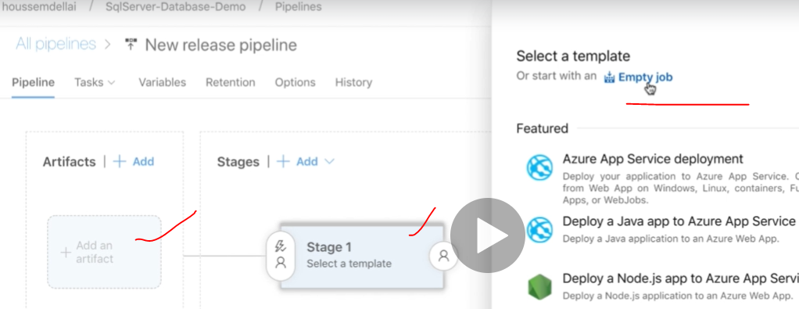

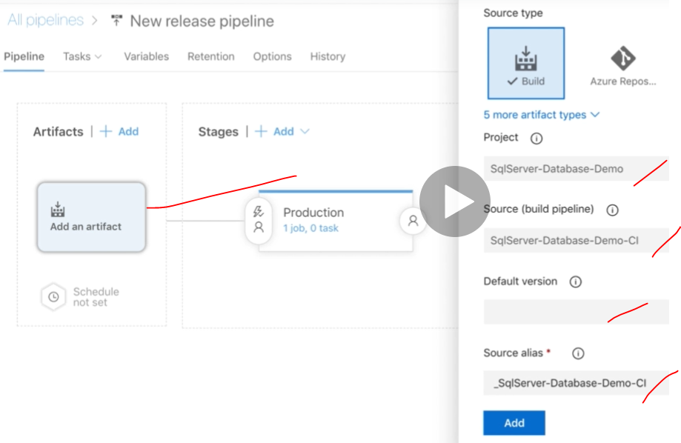

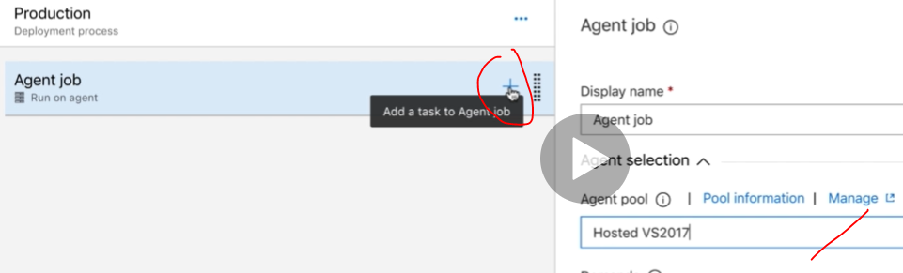

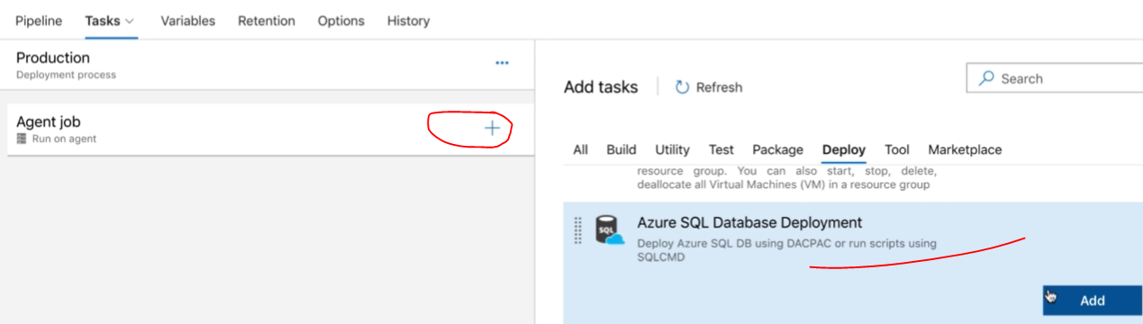

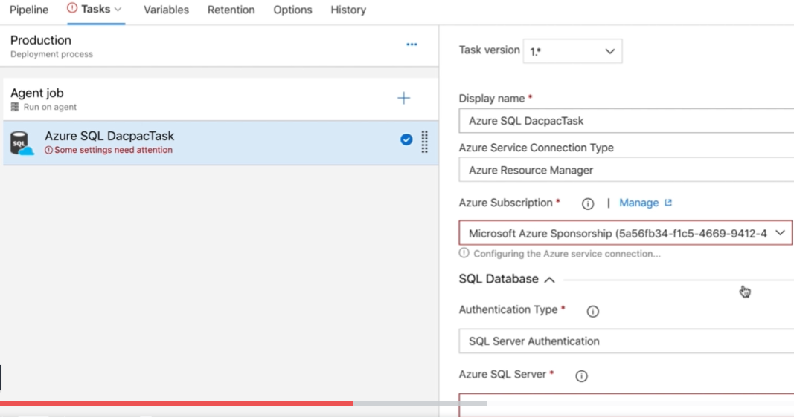

**Add database information need to add azure database connection string authentication tokens.**

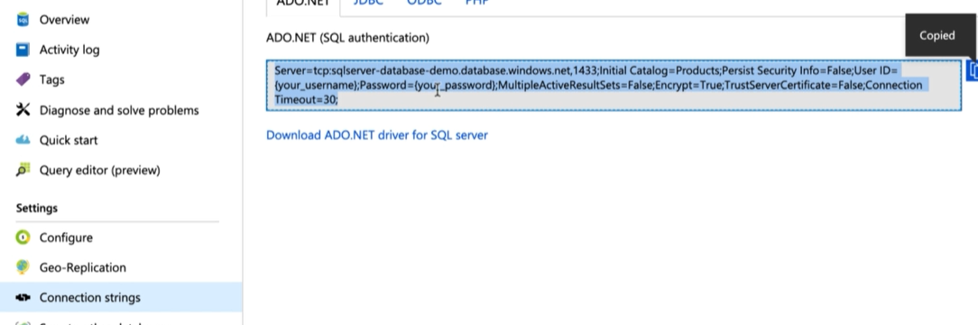

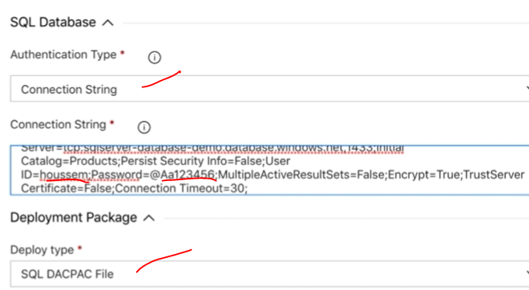

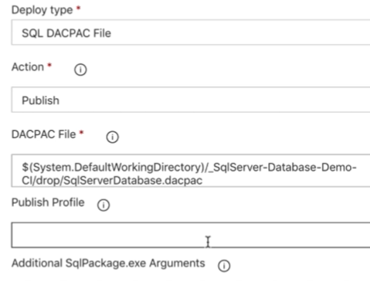

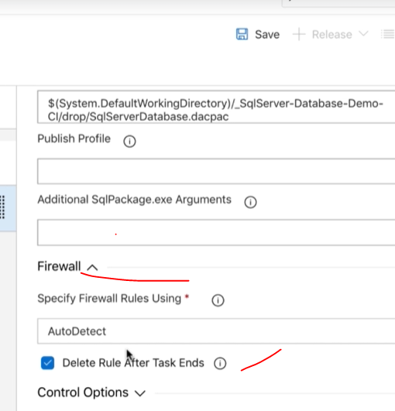

**Adding env variable instead of adding directly user name & password**

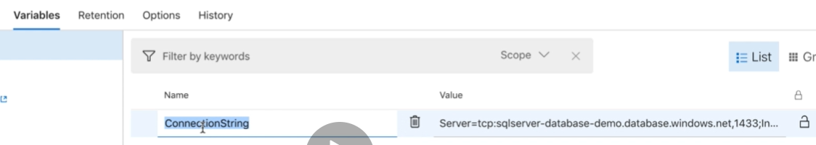

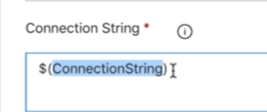

**Save and run it.**

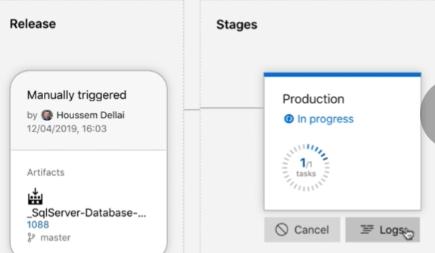

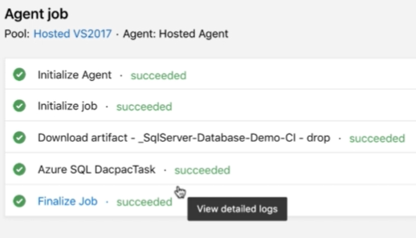

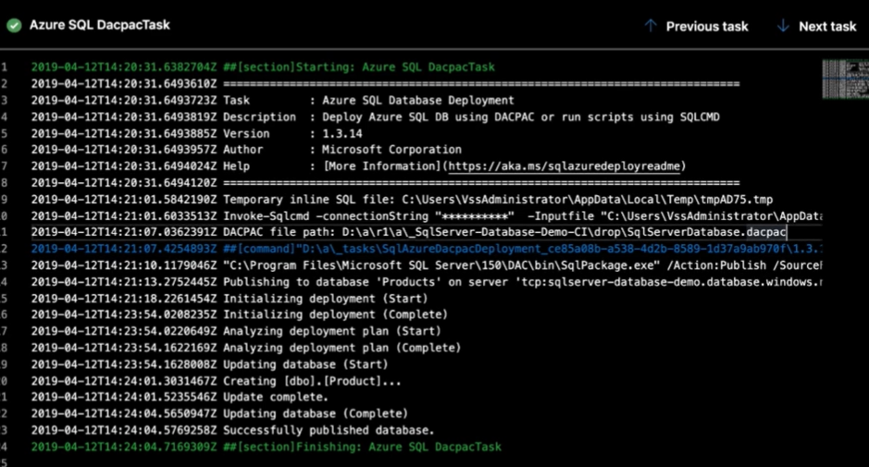

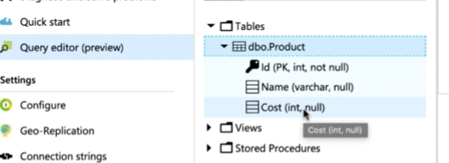

**CI Enabling:**

**To enabled auto trigger need to enable the triggers with enable continuous integrations.**

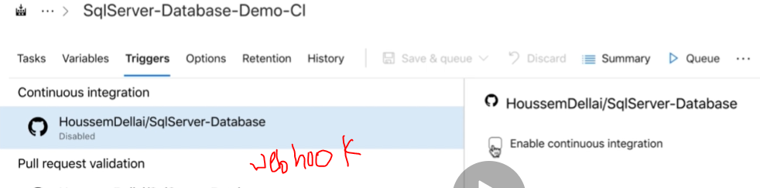

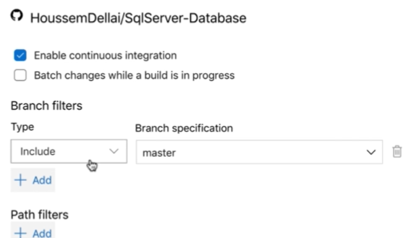

**CD Enabling:**

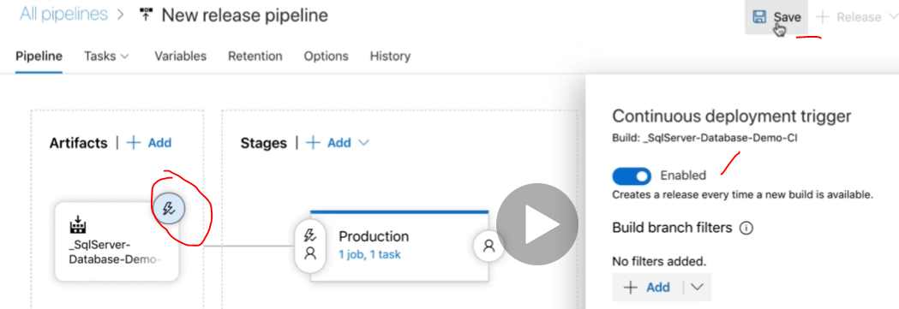

**Update in the local repo and test it. the job will start and completed automatically without any manual intervention.**

**Azure pipeline build (CI) and Azure pipeline release are completed automatically.**

**ARM Templets:** 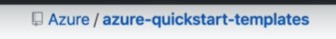

**By using Visual studio, we can create new template project using below Azure resource group.**

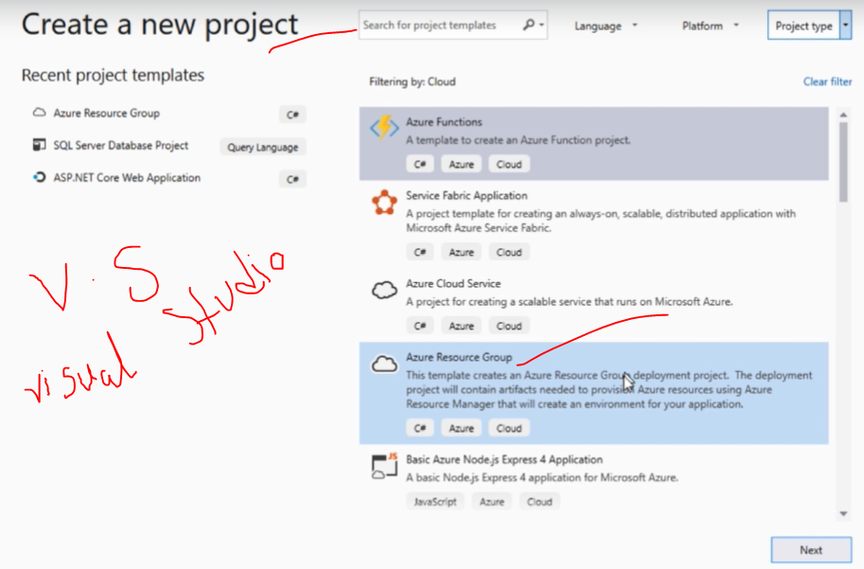

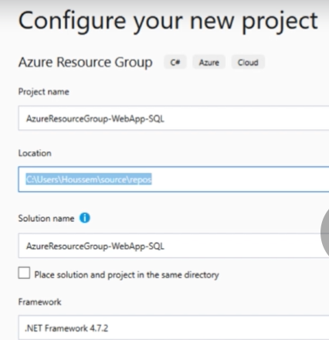

**Create**

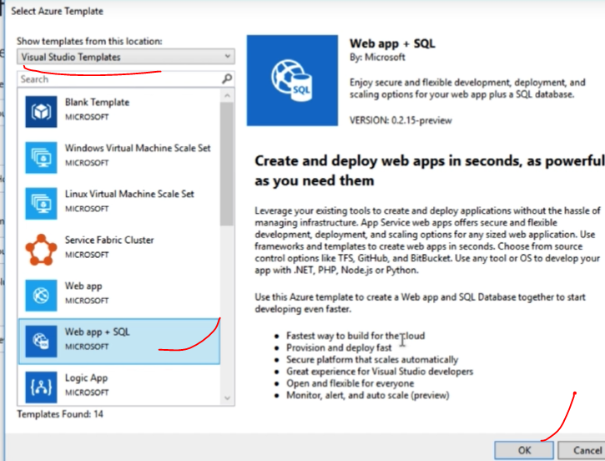

**Ok then template will be created and launched in the visual studio**

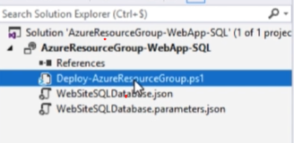

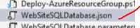

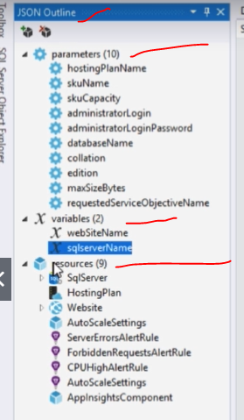

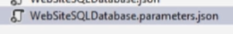

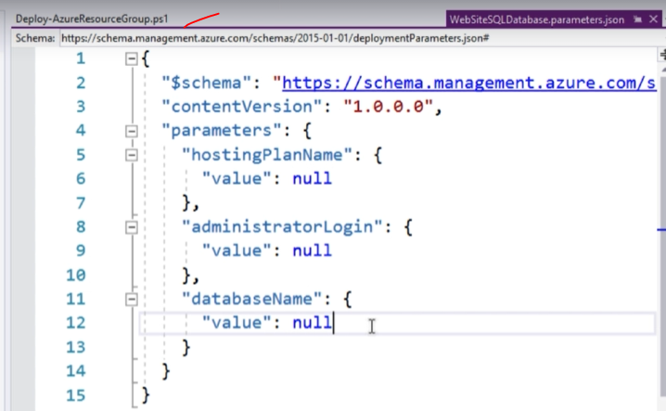

**By using visual studio will try to deploy the code.**

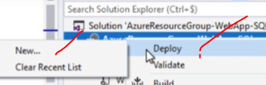

**Finally deploy the code using Azure subscription into Azure webapp**



**By using Azure DevOps pipelines, we are going to deploy code into using the ARM temples.**

**Create the project and then click pipeline builds then specify the repository parameters.**

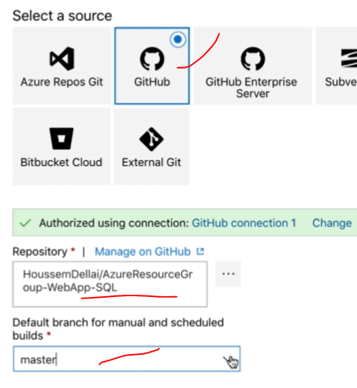

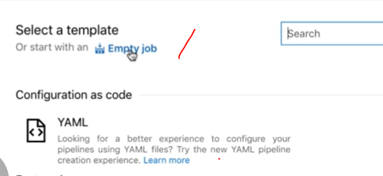

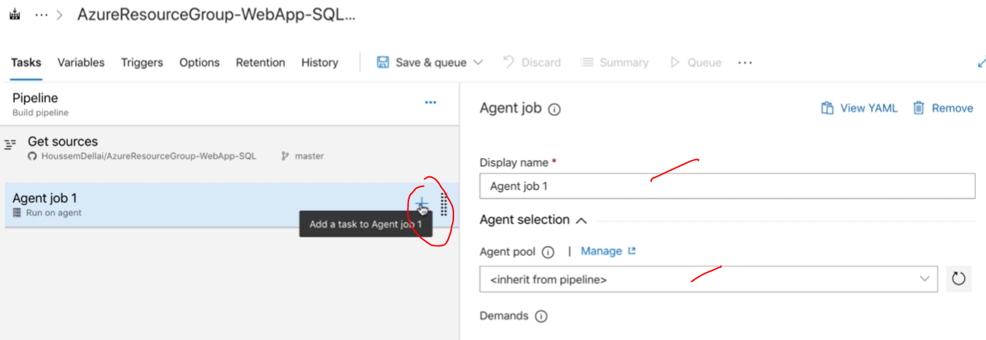

**Search below temp name will get in the search folder.**

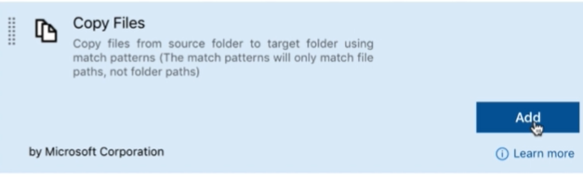

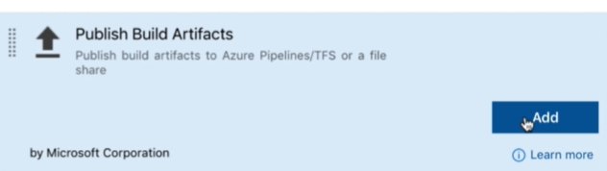

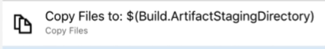

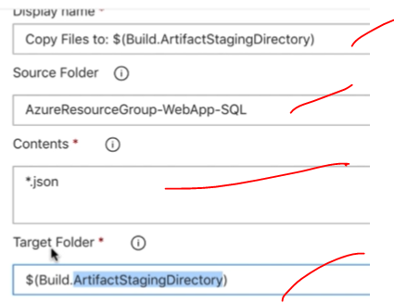

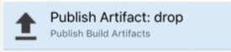

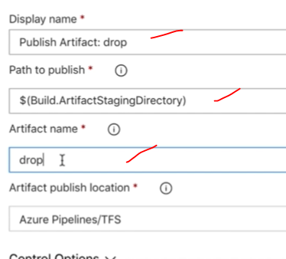

**Save and start the job. then check the summary of the job status. and the artefacts are saved in the respective Azure server for deployment.**

**Start new pipeline Release for the deployment. and start with empty job and configure artefact section.**

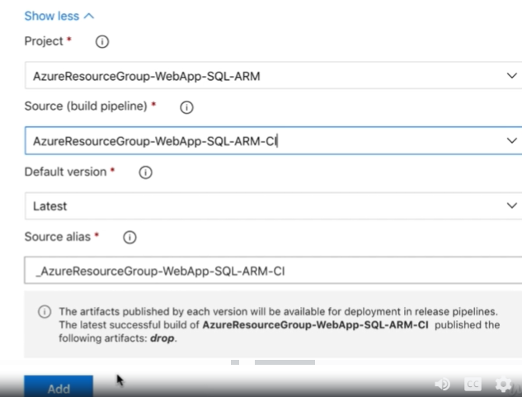

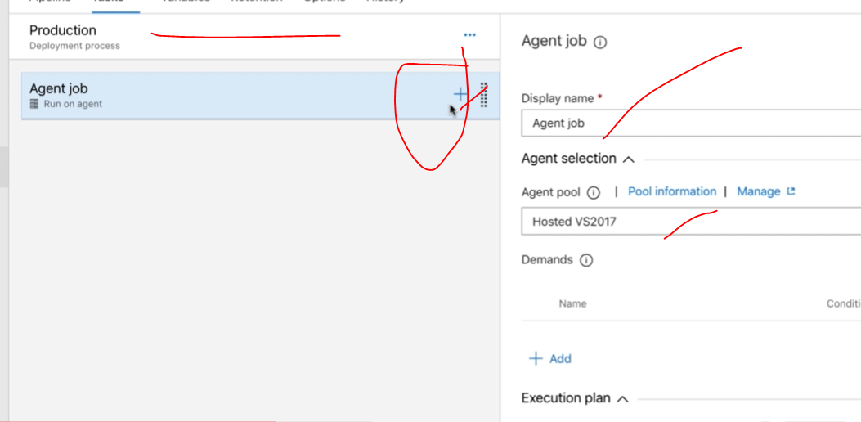

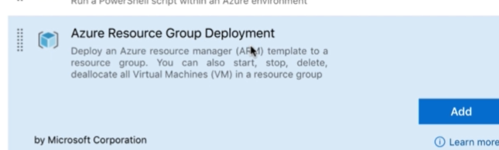

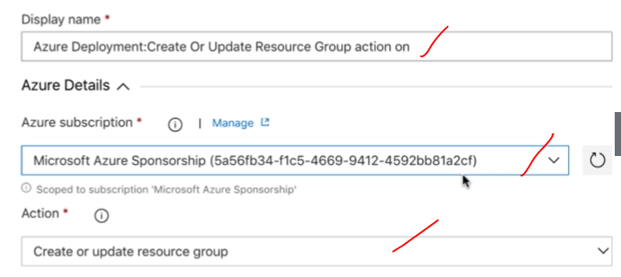

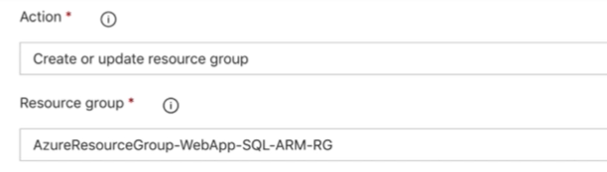

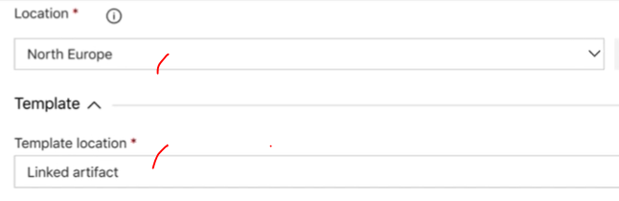

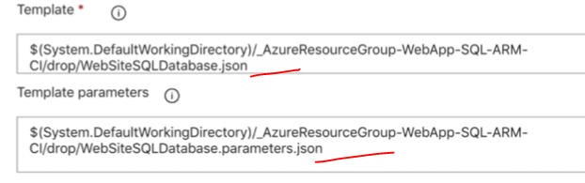

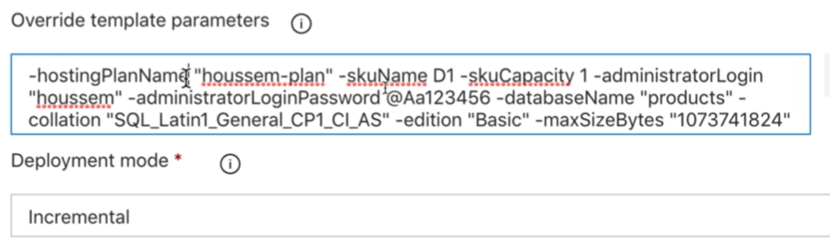

**Save & run the job**

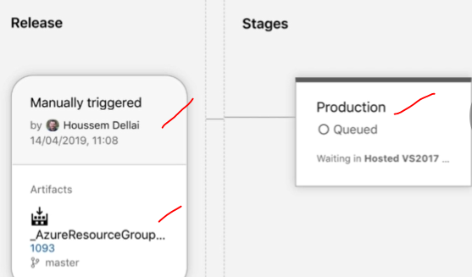

**COMPLETE CI PIPELINE:** SCM

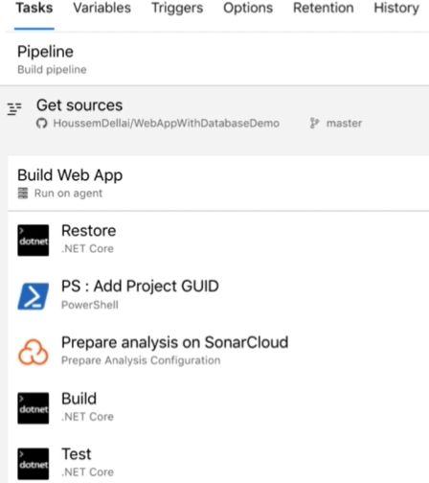

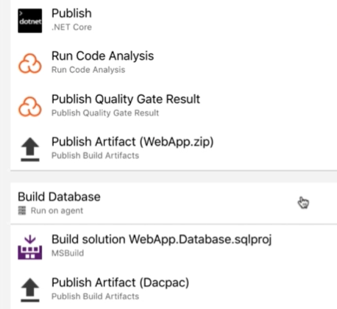

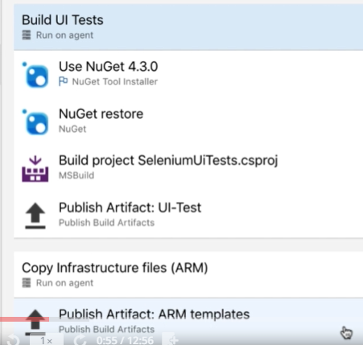

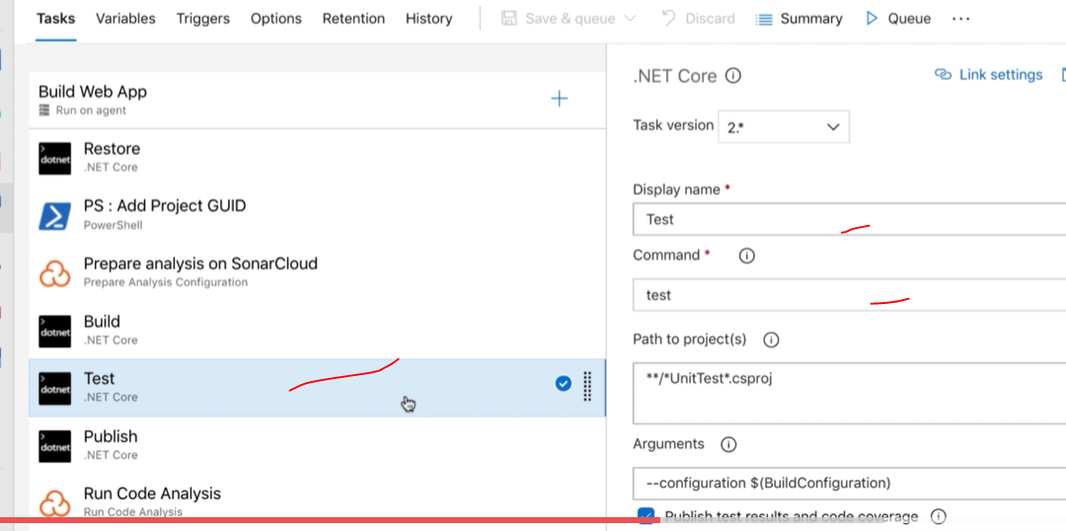

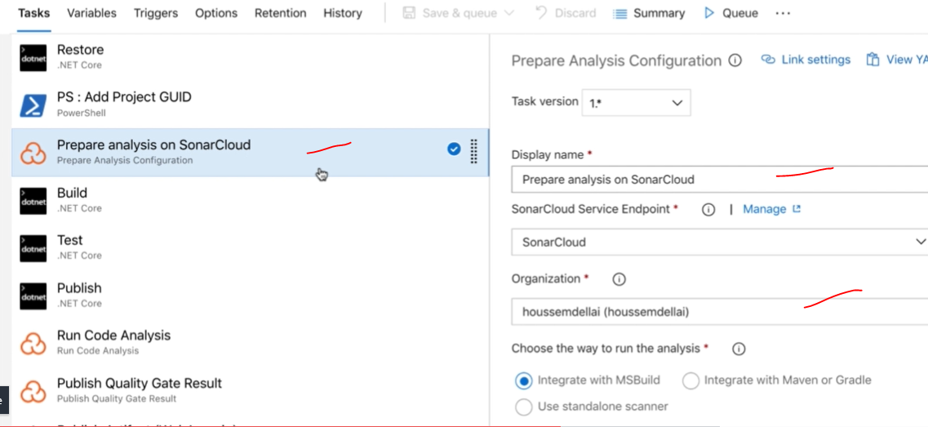

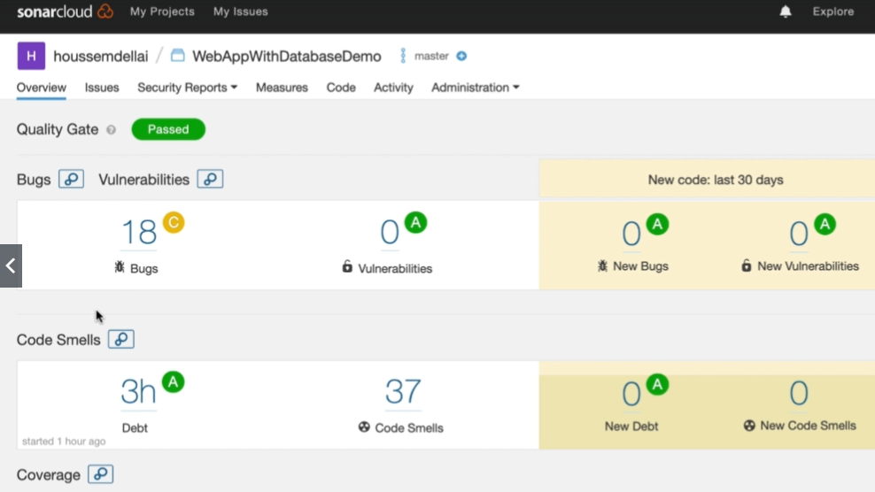

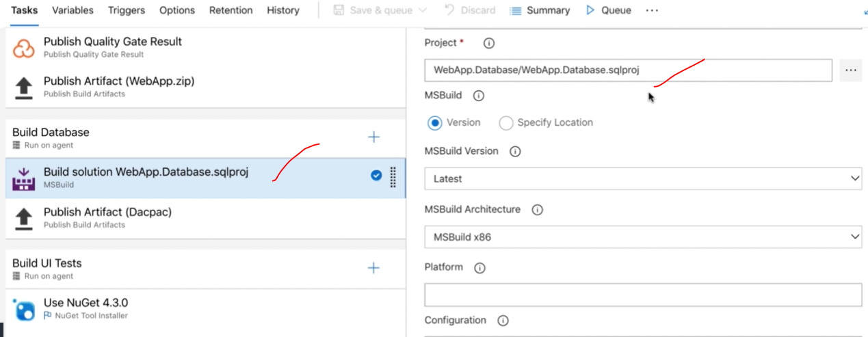

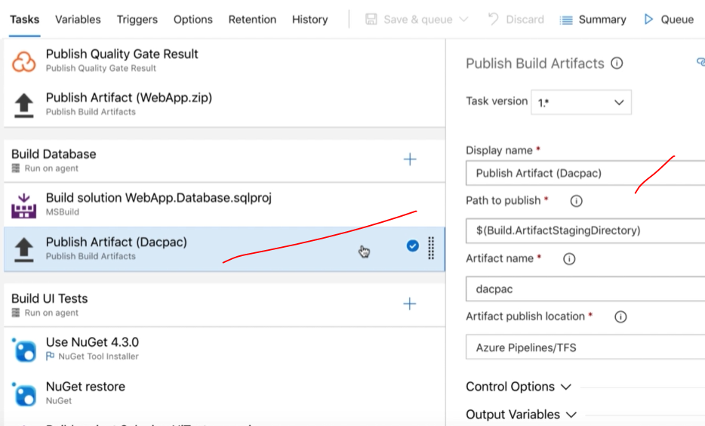

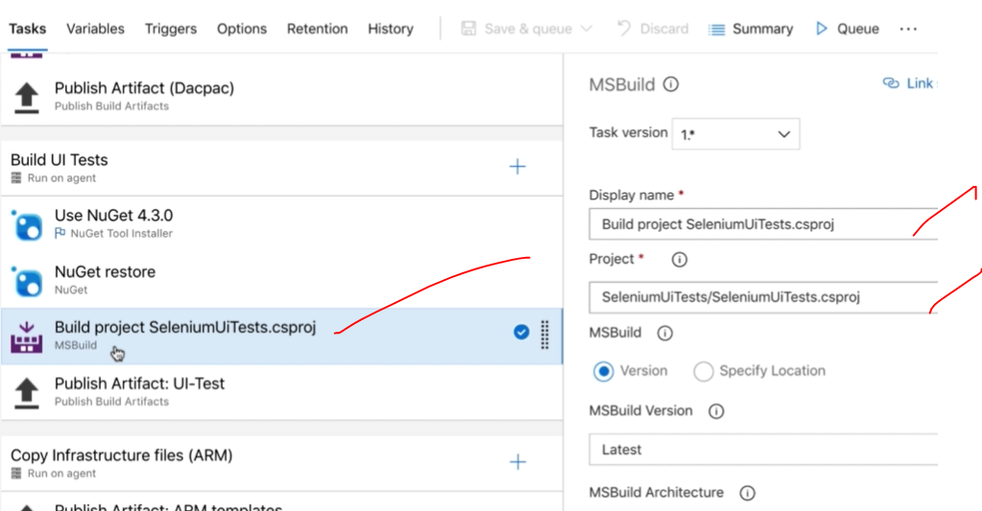

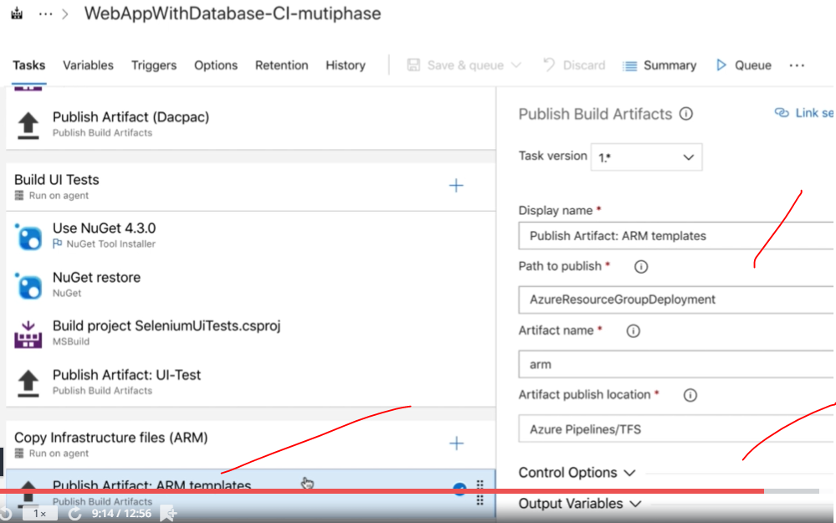

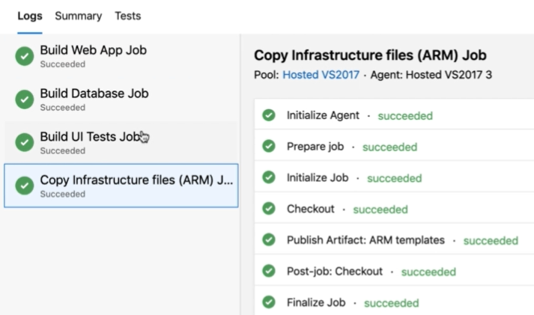

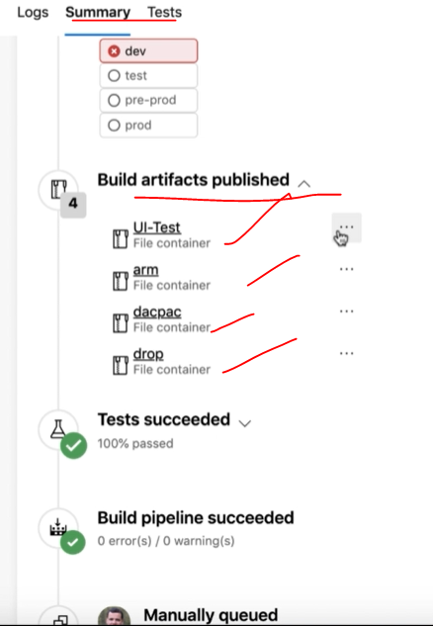

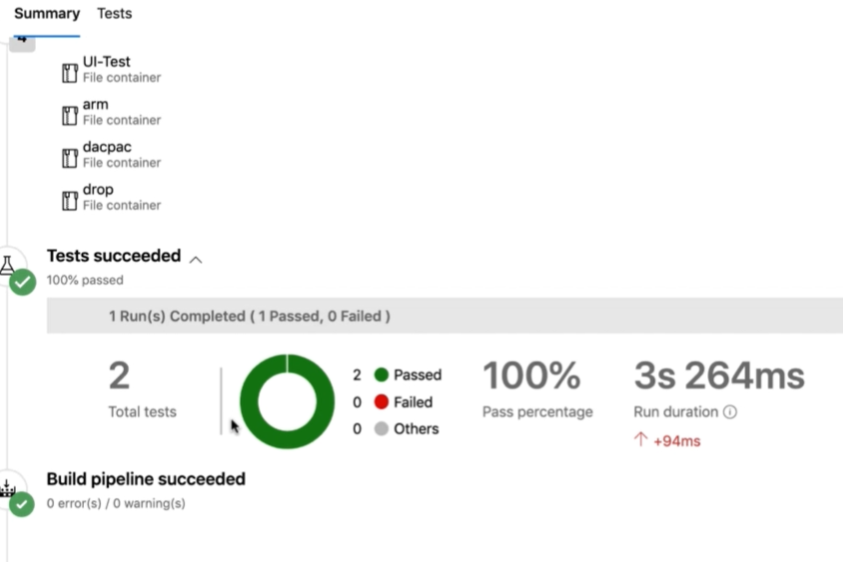

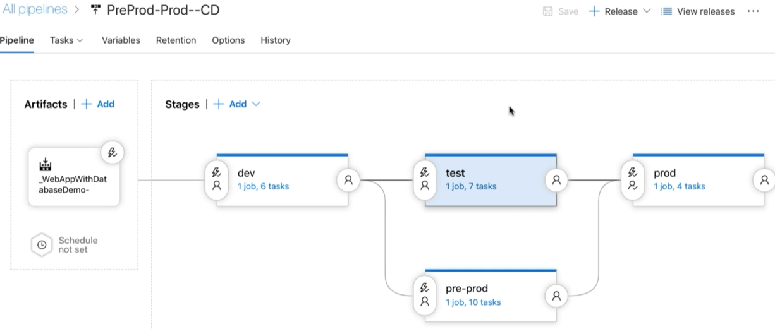

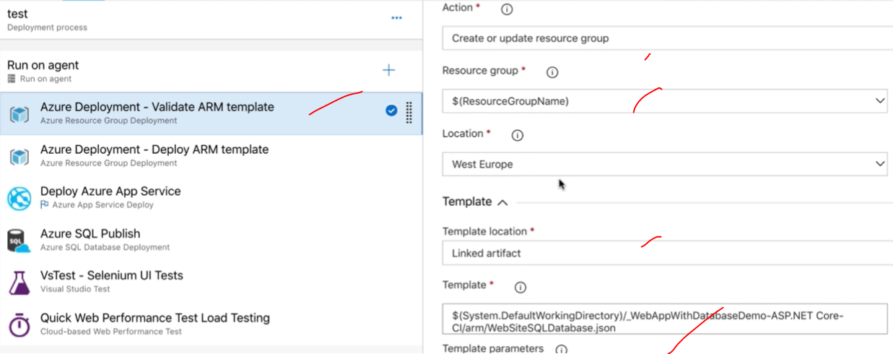

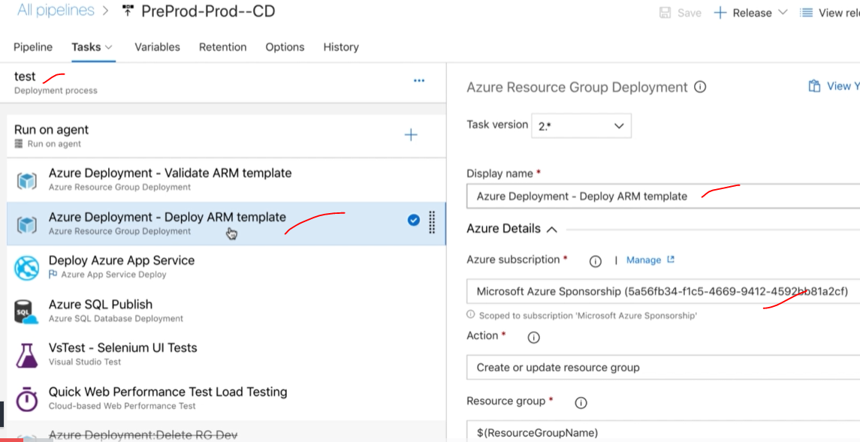

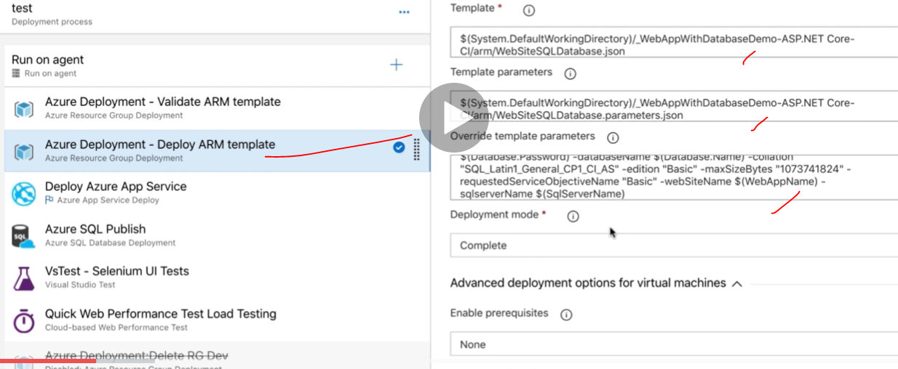

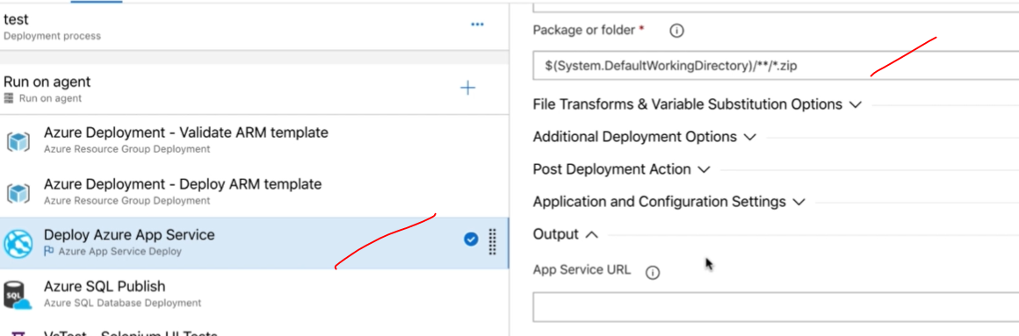

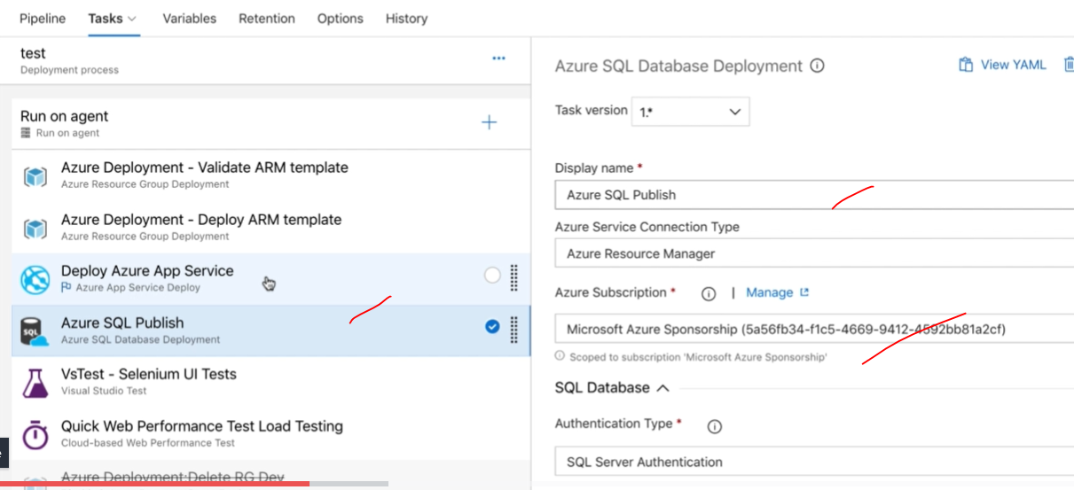

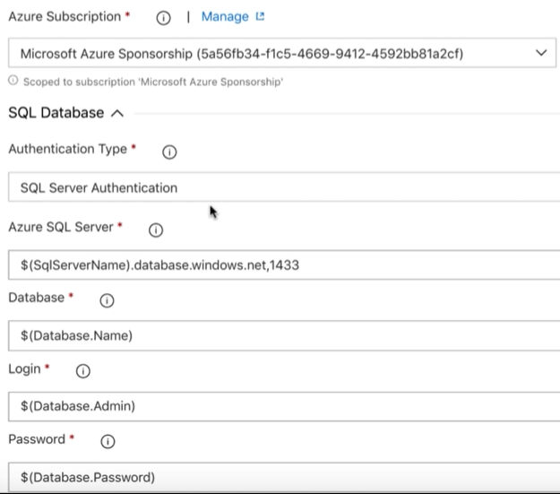

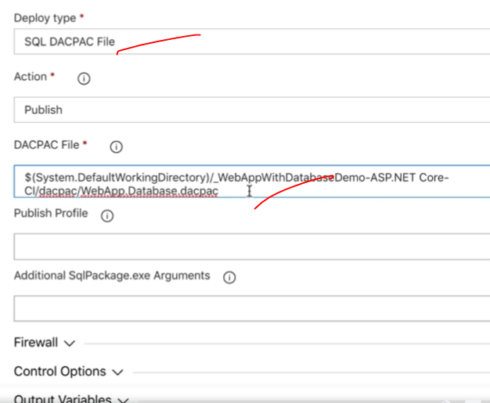

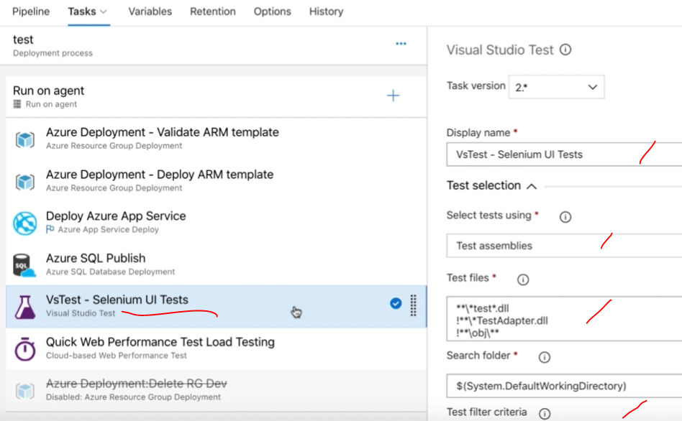

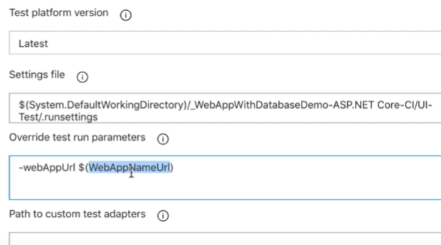

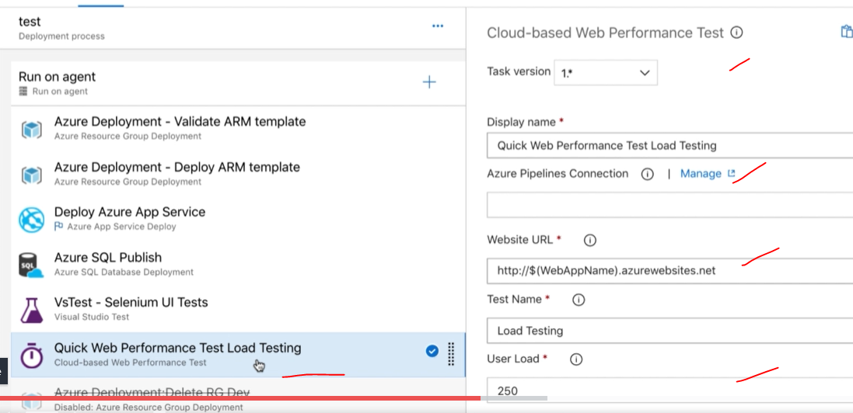

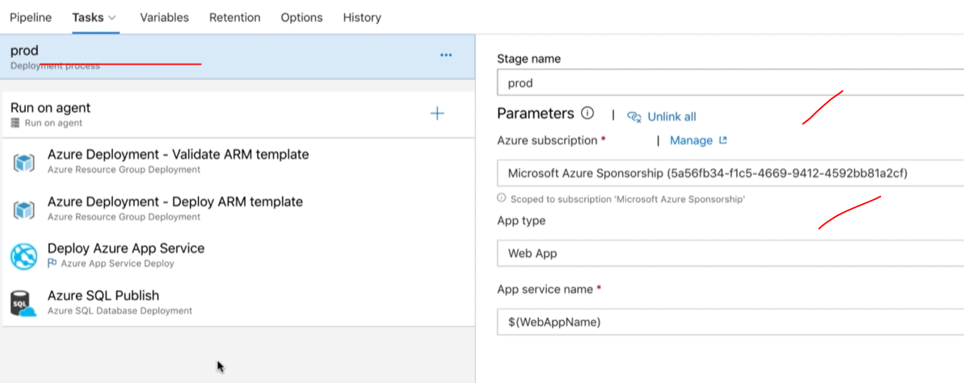

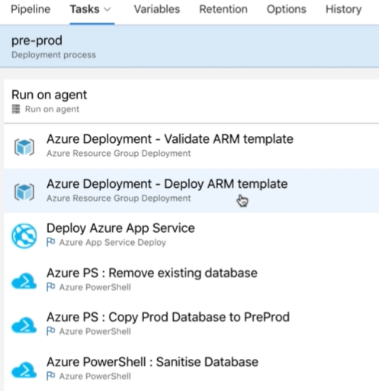

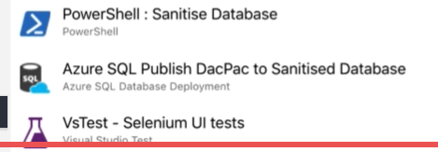

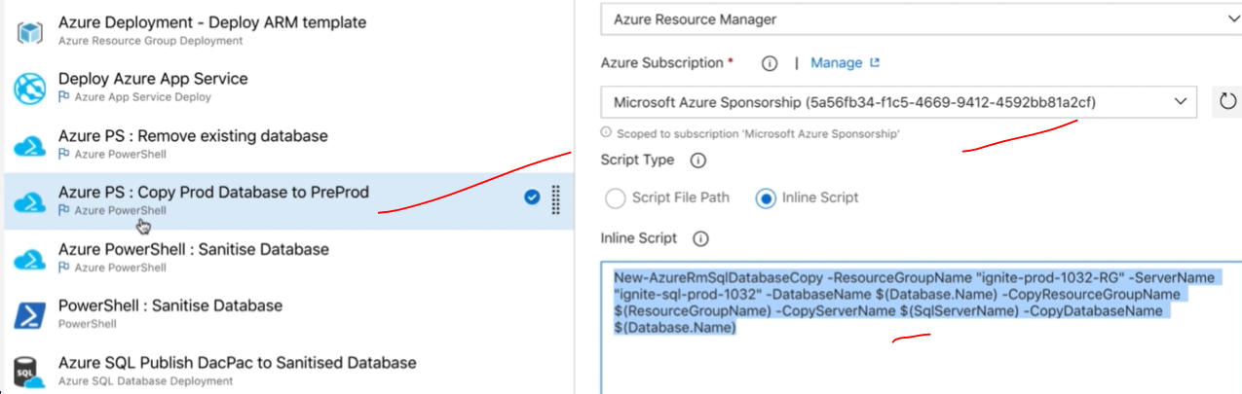

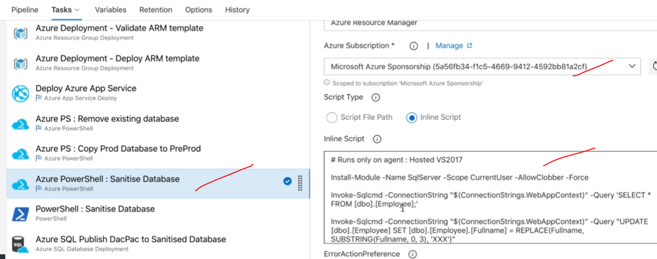

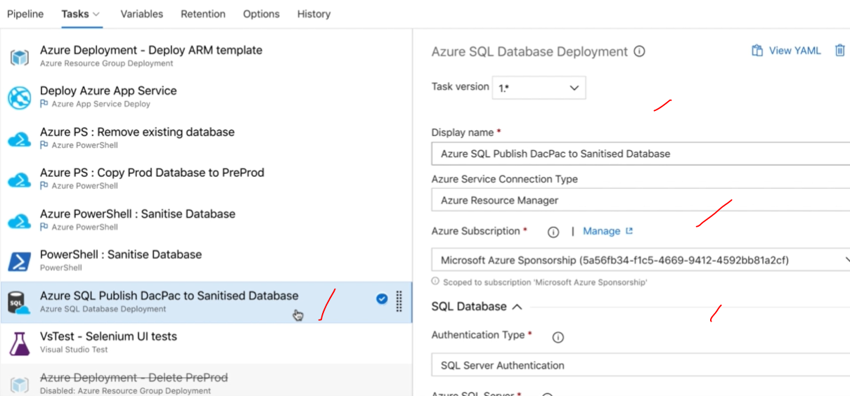

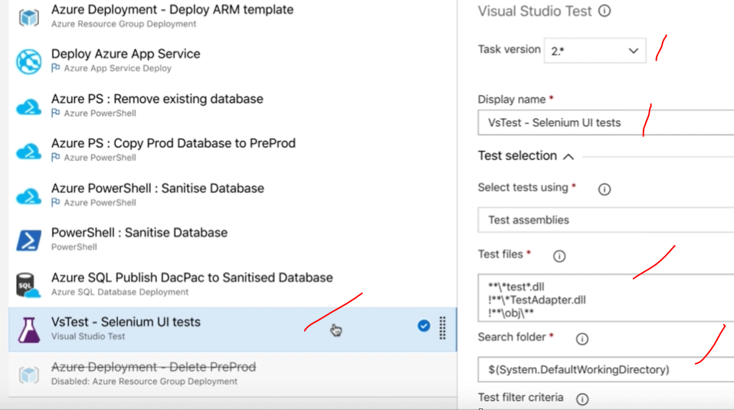

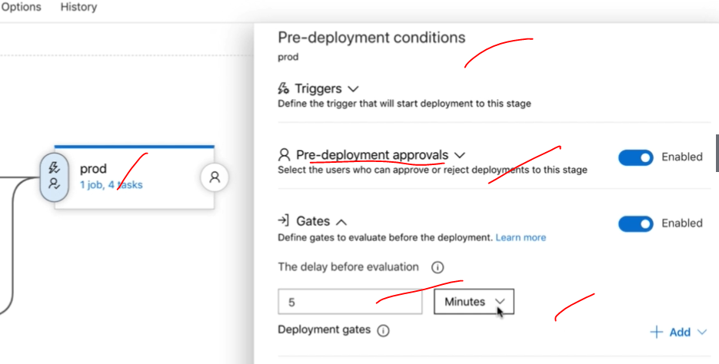

**CI/CD DOCKER AND KUBERNETES:** 

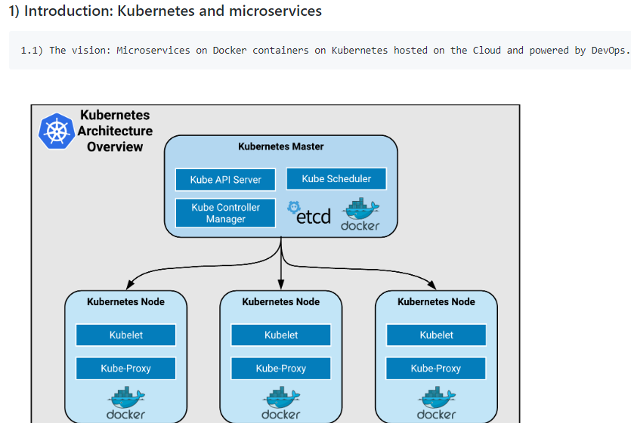

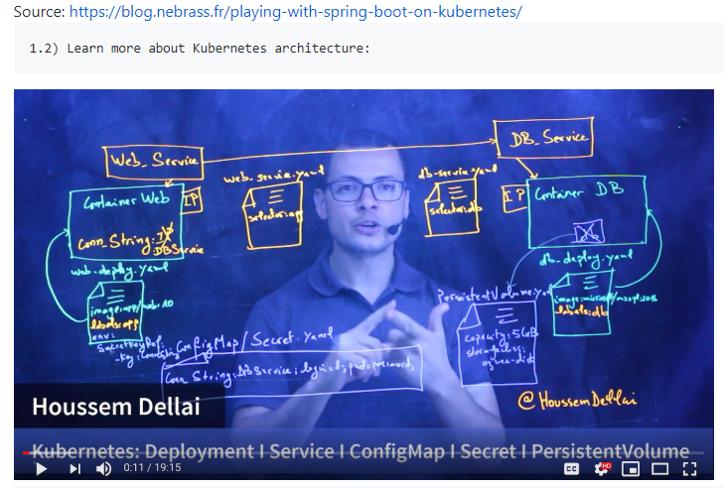

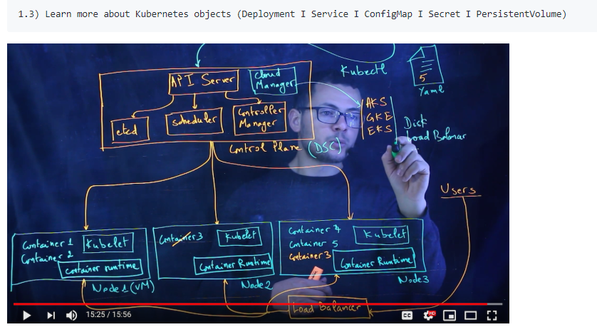

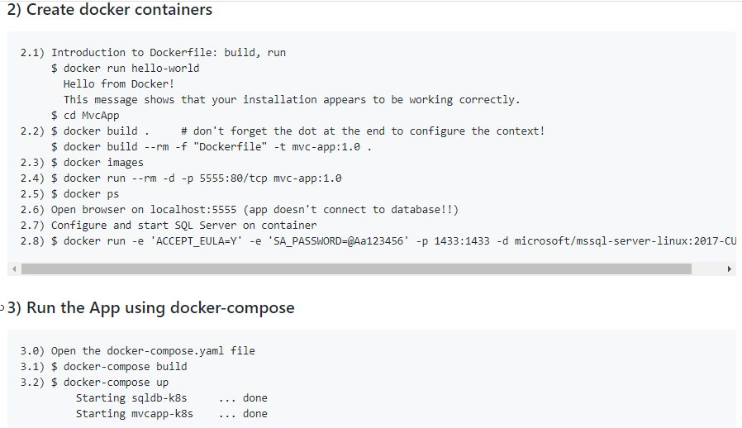

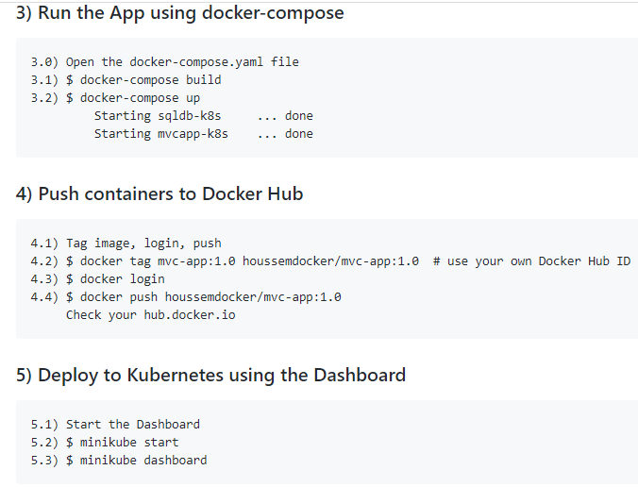

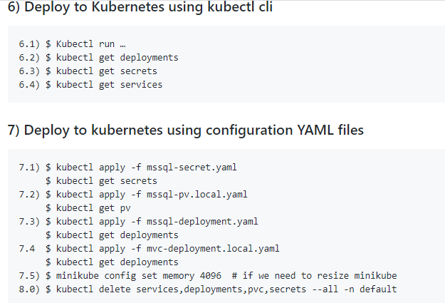

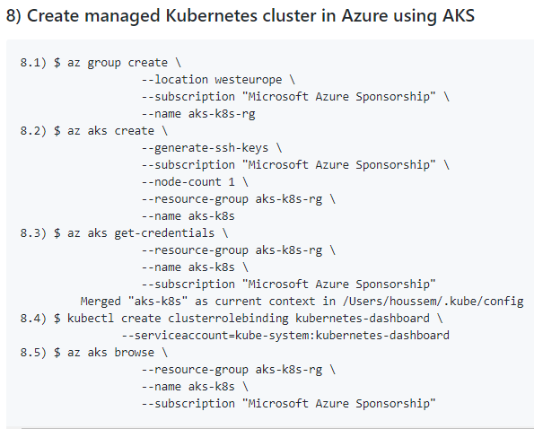

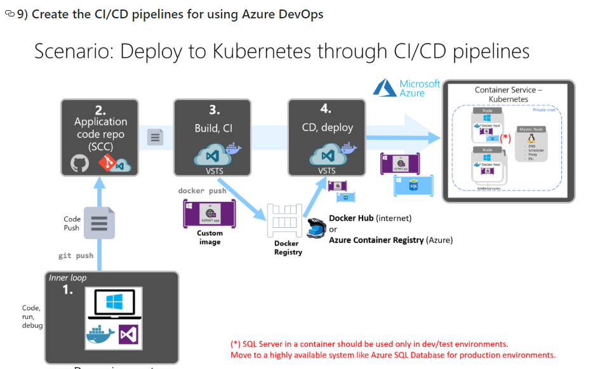

**DOCKER file:** 

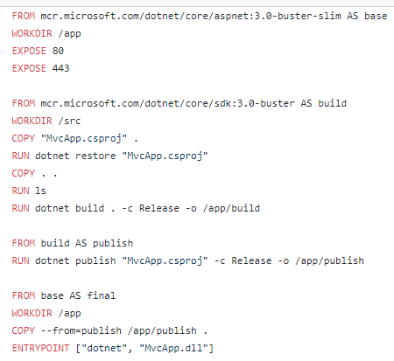

[**docker-compose.yaml**](https://github.com/madhureddy87/ProductsStoreOnKubernetes/blob/master/docker-compose.yaml)

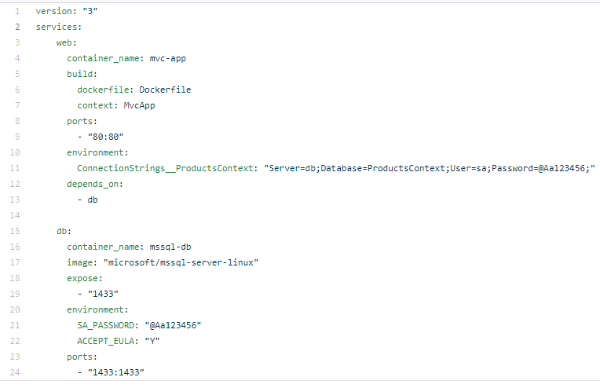

[appsettings.json](https://github.com/madhureddy87/ProductsStoreOnKubernetes/blob/master/MvcApp/appsettings.json)

|  |
| --- |
| { |
|  | "Logging": { |
|  | "LogLevel": { |
|  | "Default": "Warning" |
|  | } |
|  | }, |
|  | "AllowedHosts": "*", |
|  | "ConnectionStrings": { |
|  | "ProductsContext": "Server=(localdb)\\mssqllocaldb;Database=ProductsContext-a6ef76b7-14bd-4fb6-ab66-70e3a3b98f30;Trusted_Connection=True;MultipleActiveResultSets=true" |
|  | } |
|  | } |

[**ProductsStoreOnKubernetes**](https://github.com/madhureddy87/ProductsStoreOnKubernetes)**/**[**kubernetes**](https://github.com/madhureddy87/ProductsStoreOnKubernetes/tree/master/kubernetes)**/mssql-config-map.yaml**

|  |
| --- |
| apiVersion: v1 |
|  | kind: ConfigMap |
|  | metadata: |
|  | name: mssql-connection-configmap |
|  | labels: |
|  | app: mvc |
|  | data: |
|  | db-connection-string: Server=mssql-service;Database=ProdcutsDB;User=SA;Password=@Aa123456; |

## [ProductsStoreOnKubernetes](https://github.com/madhureddy87/ProductsStoreOnKubernetes)/[kubernetes](https://github.com/madhureddy87/ProductsStoreOnKubernetes/tree/master/kubernetes)/****mssql-deployment.yaml****

|  |
| --- |
| apiVersion: apps/v1beta1 |
|  | kind: Deployment |
|  | metadata: |
|  | name: mssql-deployment |
|  | spec: |
|  | replicas: 1 |
|  | template: |
|  | metadata: |
|  | labels: |
|  | app: mssql |
|  | spec: |
|  | terminationGracePeriodSeconds: 10 |
|  | containers: |
|  | - name: mssql |
|  | image: microsoft/mssql-server-linux |
|  | # resources: |
|  | # limits: |
|  | # cpu: "2" |
|  | # memory: "2Gi" |
|  | # requests: |
|  | # cpu: "0.5" |
|  | ports: |
|  | - containerPort: 1433 |
|  | env: |
|  | - name: ACCEPT_EULA |
|  | value: "Y" |
|  | - name: SA_PASSWORD |
|  | value: "@Aa123456" |
|  | volumeMounts: |
|  | - name: mssql-persistent-storage |
|  | mountPath: /var/opt/mssql |
|  | volumes: |
|  | - name: mssql-persistent-storage |
|  | persistentVolumeClaim: |
|  | claimName: mssql-pv-claim |
|  | --- |
|  | apiVersion: v1 |
|  | kind: Service |
|  | metadata: |
|  | name: mssql-service |
|  | spec: |
|  | selector: |
|  | app: mssql |
|  | ports: |
|  | - protocol: TCP |
|  | port: 1433 |
|  | targetPort: 1433 |
|  | nodePort: 30200 |
|  | type: NodePort |

## [ProductsStoreOnKubernetes](https://github.com/madhureddy87/ProductsStoreOnKubernetes)/[kubernetes](https://github.com/madhureddy87/ProductsStoreOnKubernetes/tree/master/kubernetes)/****mssql-pv.azure.yaml****

|  |
| --- |
| kind: StorageClass |
|  | apiVersion: storage.k8s.io/v1 |
|  | metadata: |
|  | name: azure-disk |
|  | provisioner: kubernetes.io/azure-disk |
|  | parameters: |
|  | storageaccounttype: Standard_LRS |
|  | kind: Managed |
|  | --- |
|  | apiVersion: v1 |
|  | kind: PersistentVolumeClaim |
|  | metadata: |
|  | name: mssql-pv-claim |
|  | annotations: |
|  | volume.beta.kubernetes.io/storage-class: azure-disk |
|  | spec: |
|  | storageClassName: default |
|  | accessModes: |
|  | - ReadWriteOnce |
|  | resources: |
|  | requests: |
|  | storage: 1Gi |

## [ProductsStoreOnKubernetes](https://github.com/madhureddy87/ProductsStoreOnKubernetes)/[kubernetes](https://github.com/madhureddy87/ProductsStoreOnKubernetes/tree/master/kubernetes)/****mssql-pv.local.yaml****

|  |
| --- |
| kind: PersistentVolume |
|  | apiVersion: v1 |
|  | metadata: |
|  | name: mssql-persistent-volume |
|  | labels: |
|  | type: local |
|  | spec: |
|  | capacity: |
|  | storage: 1Gi |
|  | accessModes: |
|  | - ReadWriteOnce |
|  | hostPath: |
|  | path: /data |
|  | --- |
|  | apiVersion: v1 |
|  | kind: PersistentVolumeClaim |
|  | metadata: |
|  | name: mssql-pv-claim |
|  | spec: |
|  | accessModes: |
|  | - ReadWriteMany |
|  | resources: |
|  | requests: |
|  | storage: 1Gi |

## [ProductsStoreOnKubernetes](https://github.com/madhureddy87/ProductsStoreOnKubernetes)/[kubernetes](https://github.com/madhureddy87/ProductsStoreOnKubernetes/tree/master/kubernetes)/****mssql-secret.yaml****

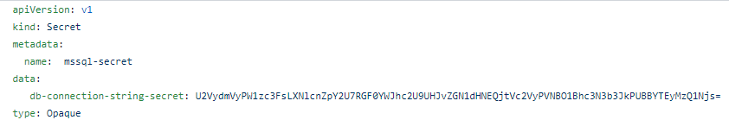

## [ProductsStoreOnKubernetes](https://github.com/madhureddy87/ProductsStoreOnKubernetes)/[kubernetes](https://github.com/madhureddy87/ProductsStoreOnKubernetes/tree/master/kubernetes)/****mvc-deployment.azure.yaml****

|  |
| --- |
| apiVersion: apps/v1 # for versions before 1.9.0 use apps/v1beta2 |
|  | kind: Deployment |
|  | metadata: |
|  | name: mvc-deployment |
|  | spec: |
|  | selector: |
|  | matchLabels: |
|  | app: mvc |
|  | replicas: 1 # tells deployment to run 2 pods matching the template |
|  | template: |
|  | metadata: |
|  | labels: |
|  | app: mvc |
|  | spec: |
|  | containers: |
|  | - name: mvc |
|  | image: houssemdocker/products-store-mvc:3.0-prometheus #{ImageTag}# # v2.#{Build.BuildId}# |
|  | ports: |
|  | - containerPort: 80 |
|  | resources: |
|  | limits: |
|  | cpu: "1" |
|  | memory: "200Mi" |
|  | requests: |
|  | cpu: "0.1" |
|  | memory: "100Mi" |
|  | env: |
|  | - name: ConnectionStrings__ProductsContext |
|  | valueFrom: |
|  | secretKeyRef: |
|  | name: mssql-secret |
|  | key: db-connection-string-secret |
|  | # configMapKeyRef: |
|  | # name: mssql-connection-configmap |
|  | # key: db-connection-string |
|  | --- |
|  | kind: Service |
|  | apiVersion: v1 |
|  | metadata: |
|  | name: mvc-service |
|  | spec: |
|  | selector: |
|  | app: mvc |
|  | ports: |
|  | - protocol: TCP |
|  | port: 80 |
|  | targetPort: 80 |
|  | type: LoadBalancer |

## [ProductsStoreOnKubernetes](https://github.com/madhureddy87/ProductsStoreOnKubernetes)/[kubernetes](https://github.com/madhureddy87/ProductsStoreOnKubernetes/tree/master/kubernetes)/****mvc-deployment.local.yaml****

|  |
| --- |
| apiVersion: apps/v1 |
|  | kind: Deployment |
|  | metadata: |
|  | name: mvc-deployment |
|  | spec: |
|  | selector: |
|  | matchLabels: |
|  | app: mvc |
|  | replicas: 1 # tells deployment to run 2 pods matching the template |
|  | template: |
|  | metadata: |
|  | labels: |
|  | app: mvc |
|  | spec: |
|  | containers: |
|  | - name: mvc |
|  | image: houssemdocker/products-store-mvc:v1.0 |
|  | ports: |
|  | - containerPort: 80 |
|  | resources: |
|  | limits: |
|  | cpu: "1" |
|  | memory: "200Mi" |
|  | requests: |
|  | cpu: "0.1" |
|  | memory: "100Mi" |
|  | env: |
|  | - name: ConnectionStrings__ProductsContext |
|  | valueFrom: |
|  | secretKeyRef: |
|  | name: mssql-secret |
|  | key: db-connection-string-secret |
|  | --- |
|  | kind: Service |
|  | apiVersion: v1 |
|  | metadata: |
|  | name: mvc-service |
|  | spec: |
|  | selector: |
|  | app: mvc |
|  | ports: |
|  | - protocol: TCP |
|  | port: 80 |
|  | targetPort: 80 |
|  | nodePort: 30101 |
|  | type: NodePort |

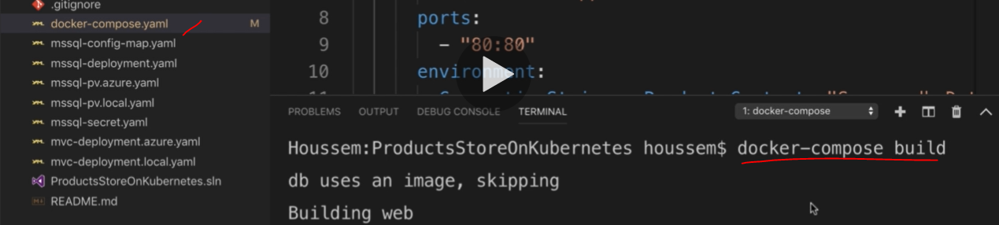

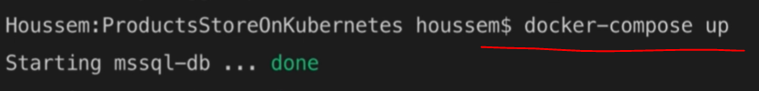

**Run kubernetes from CMD:**

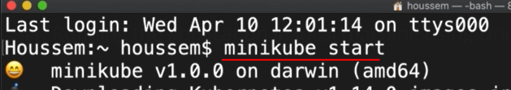

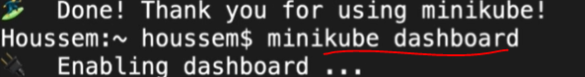

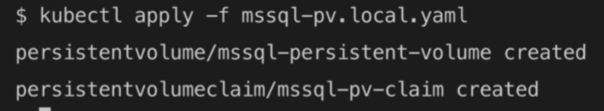







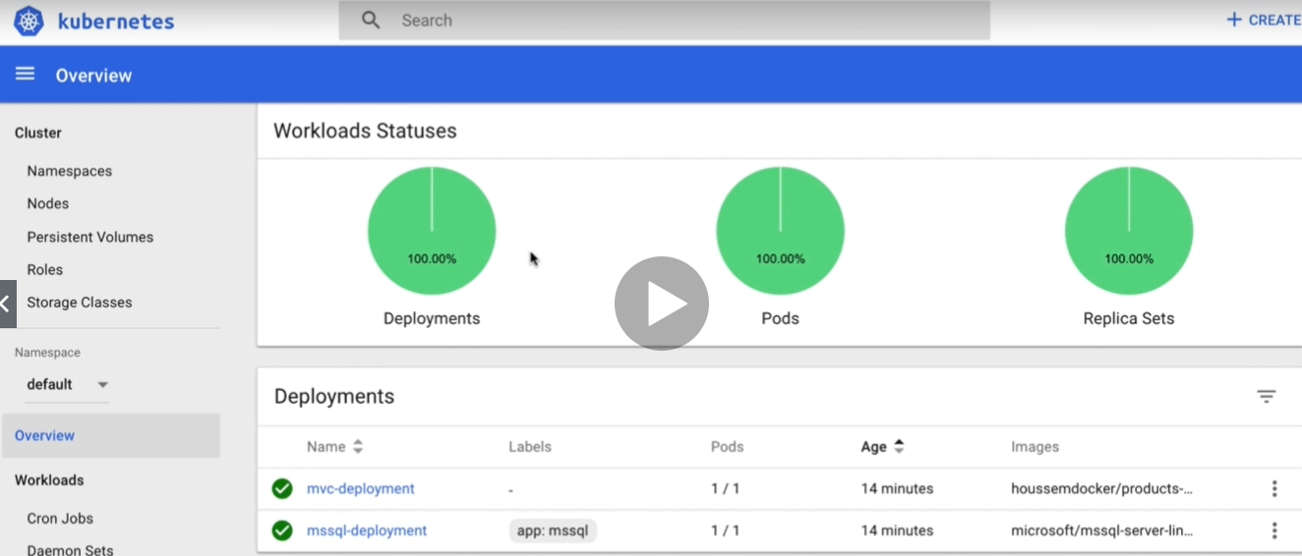

**Creating the Azure pipeline Kubernetes: create new Azure pipeline project for the build pipline.**

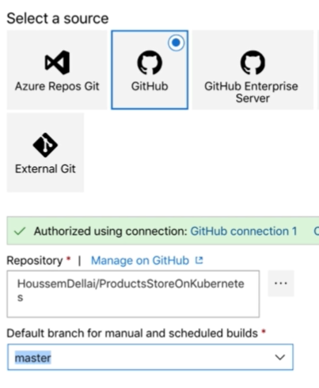

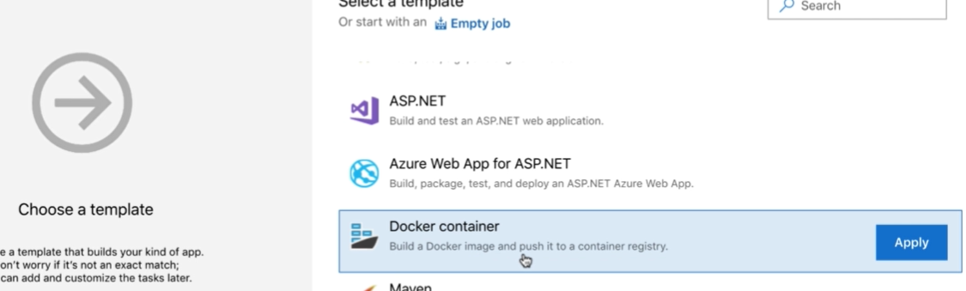

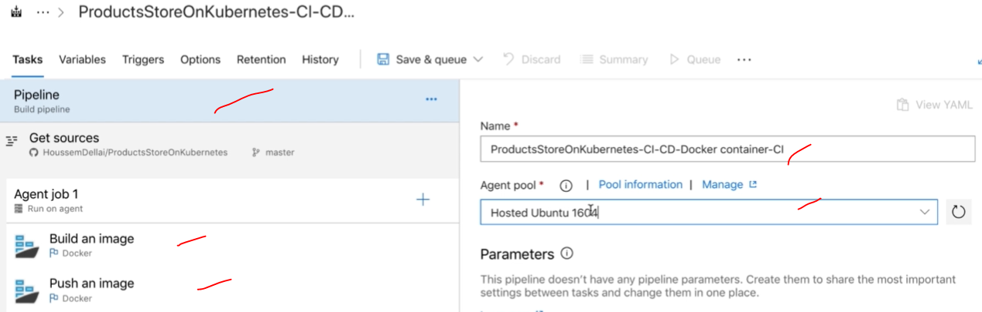

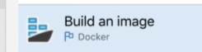

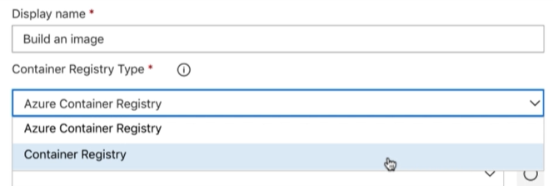

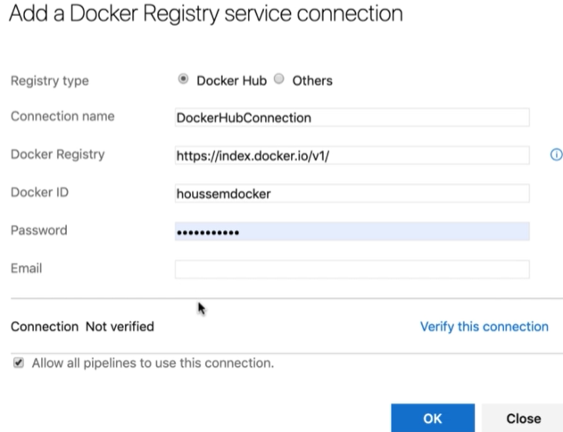

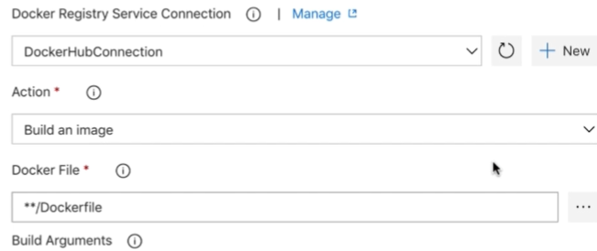

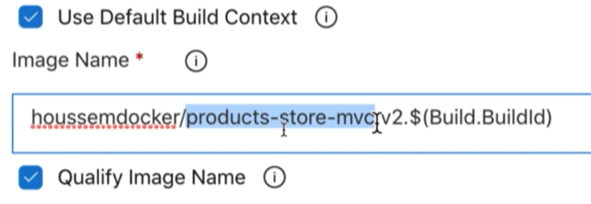

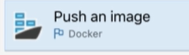

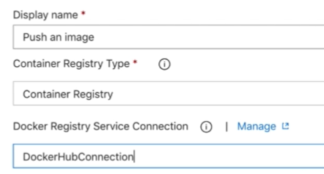

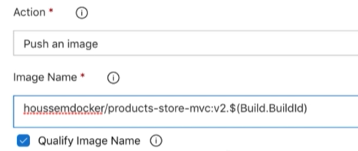

**Save**

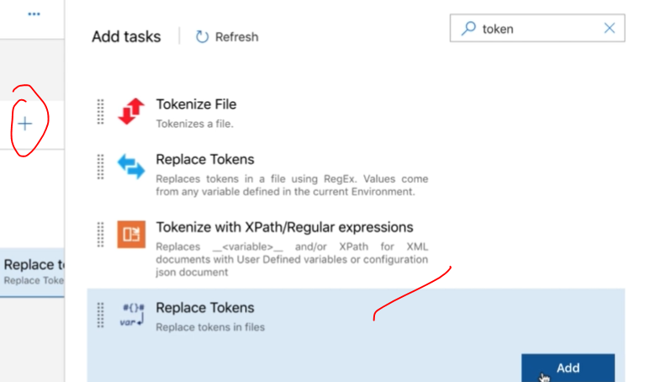

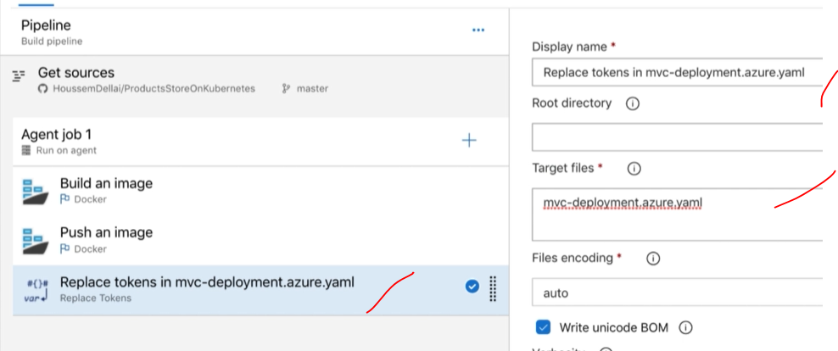

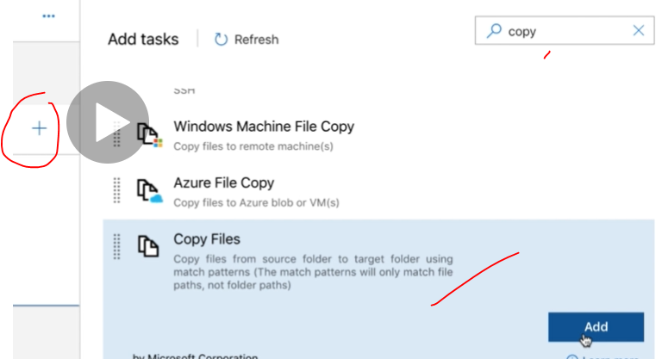

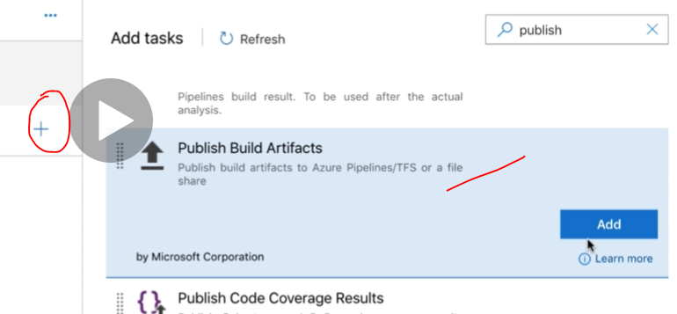

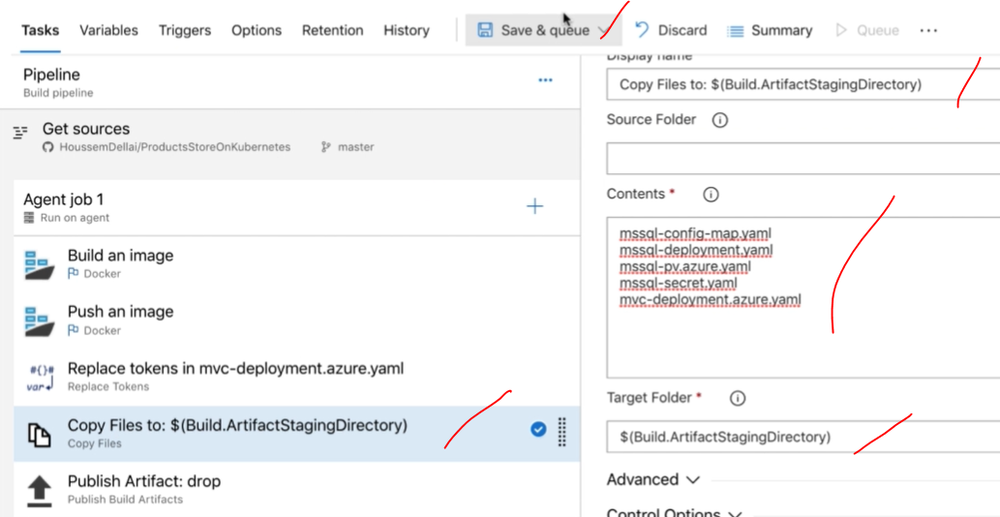

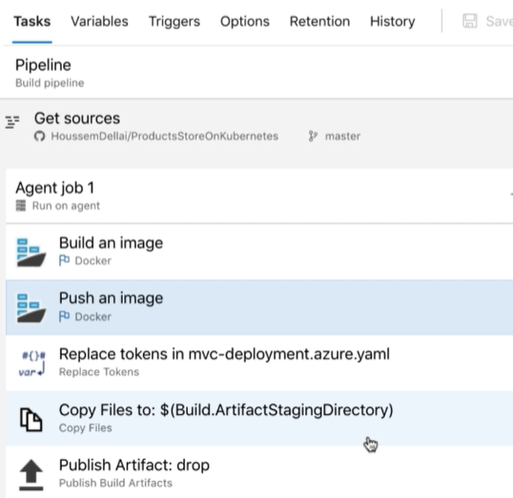

**Run it it.**

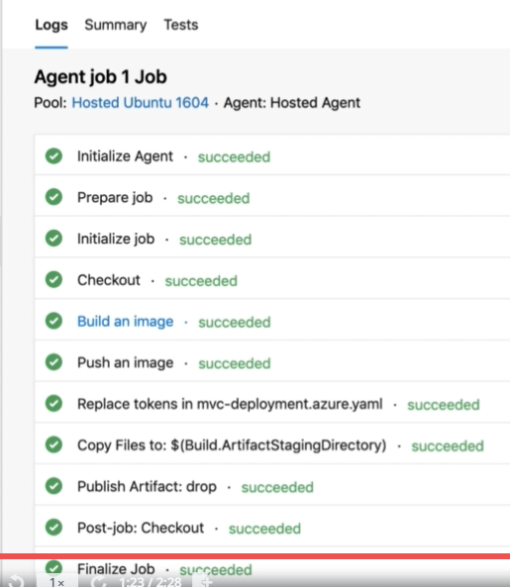

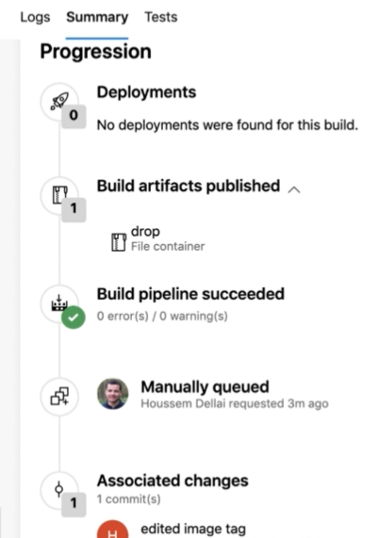

**Create the Azure kubernetes section for the deployment:**

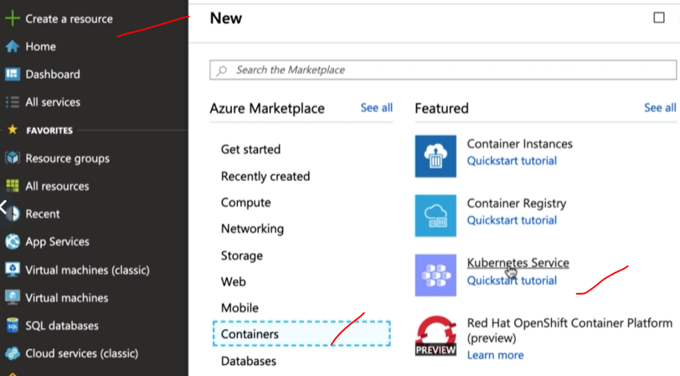

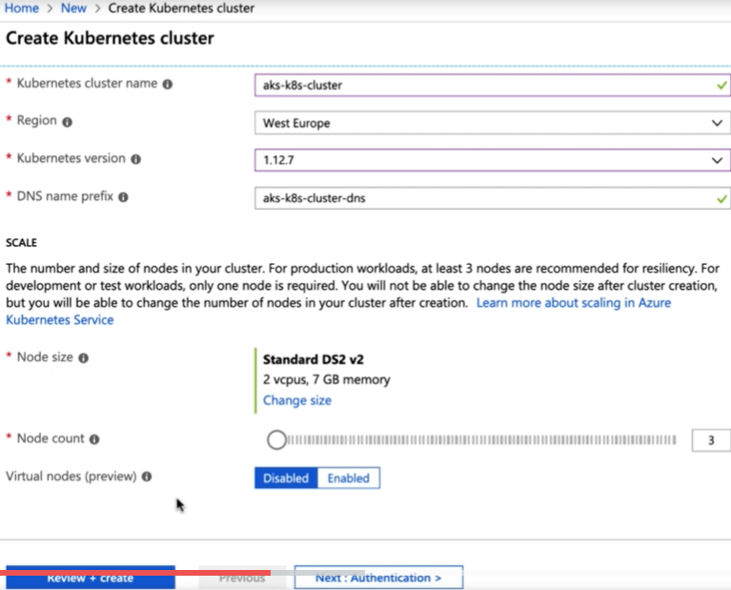

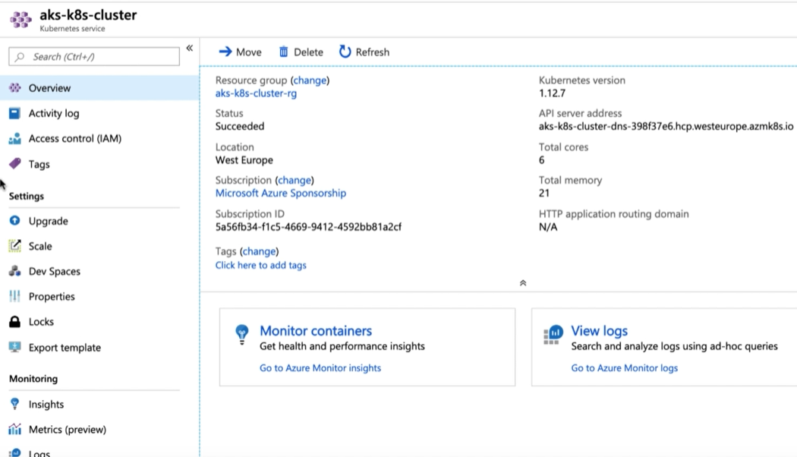

**CD pipeline for the Azure Deployment:**

**Create Azure pipeline Release for the deployment.**

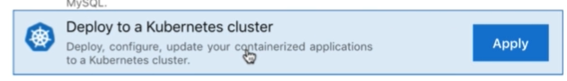

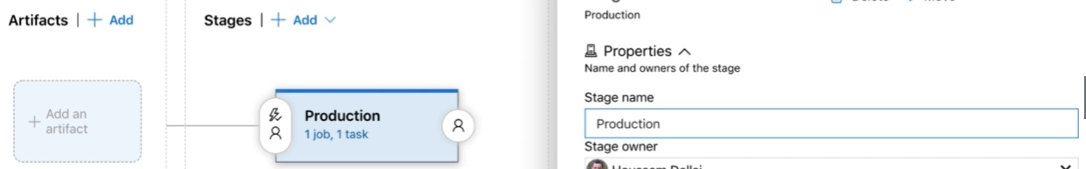

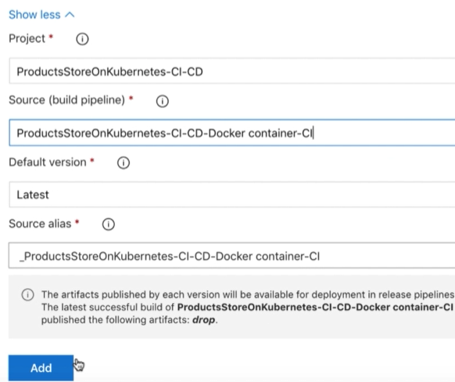

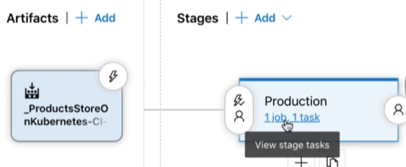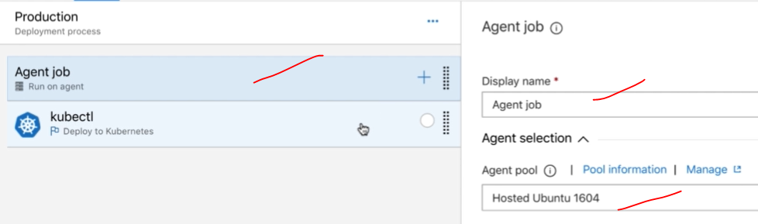

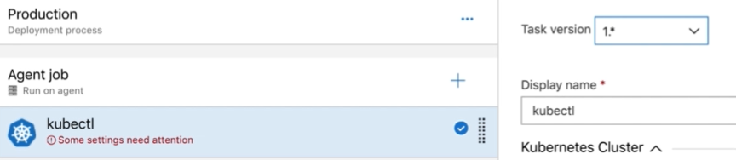

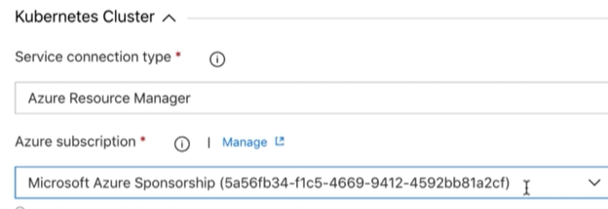

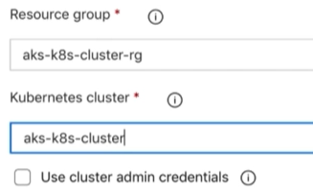

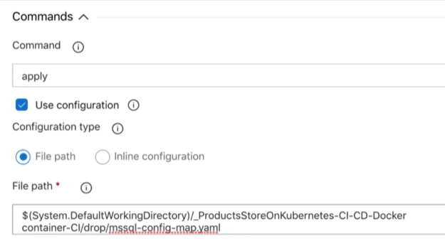

**For other tasks need to clone the kubectl apply with clone task option in the below. Need to configure with respective scripts.**

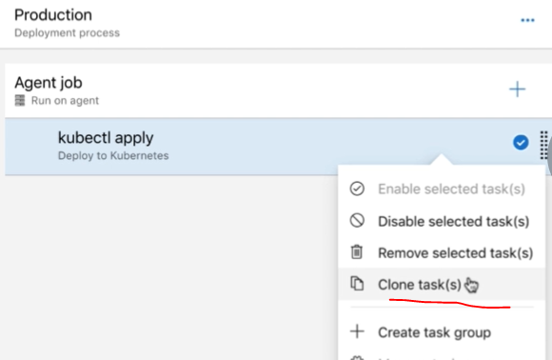

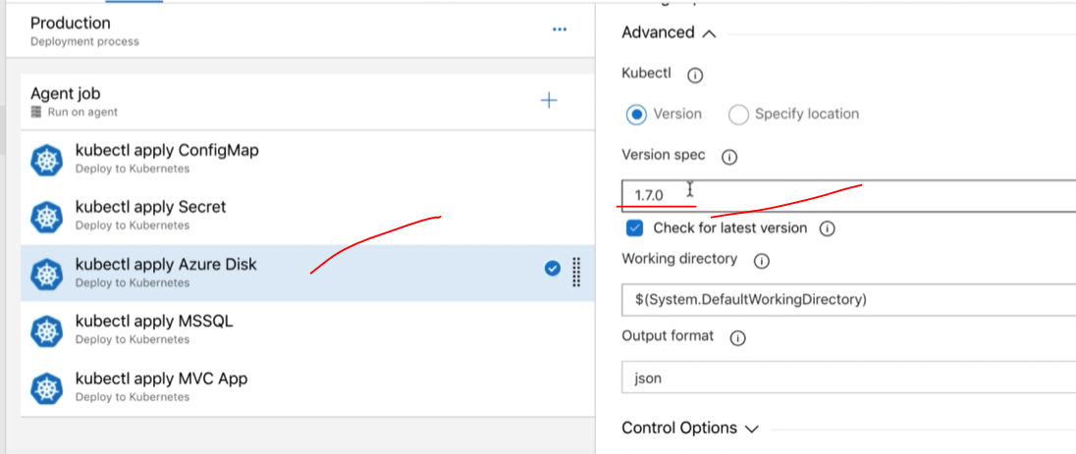

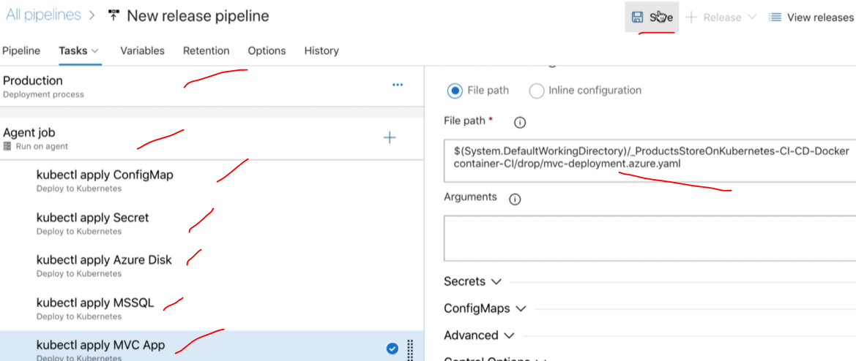

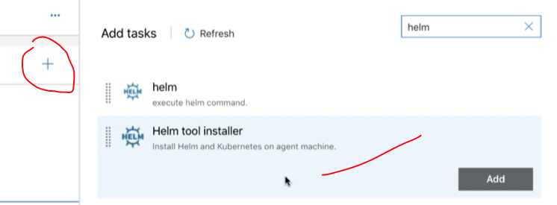

**Helm too install templated is used to deploy the kubernetes code in to Azure kubernetes webapp. Then finally run the release job for the deployment.**

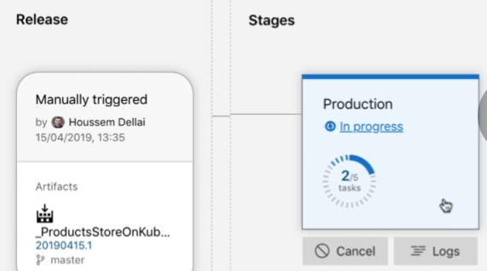

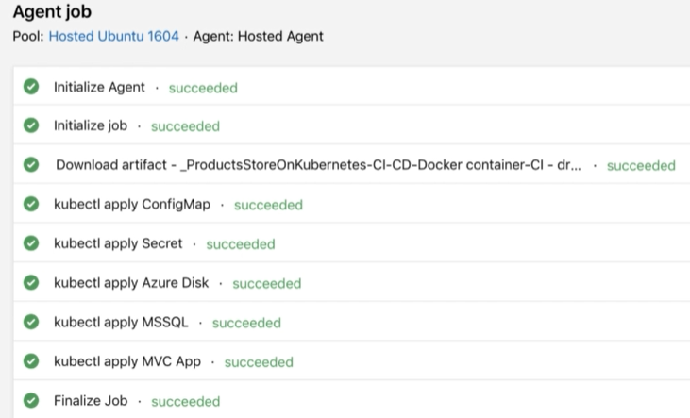

**To update the point 8 commands in the CMD to connect to Azure Kubernetes. then open Azure kubernetes link and check the deployment has been completed successfully or not.**

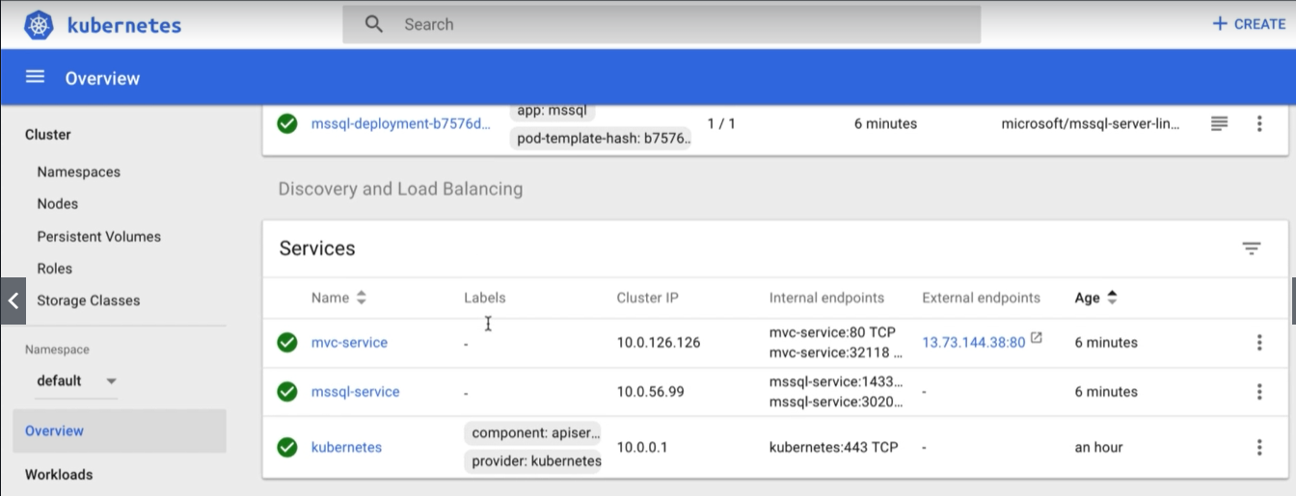

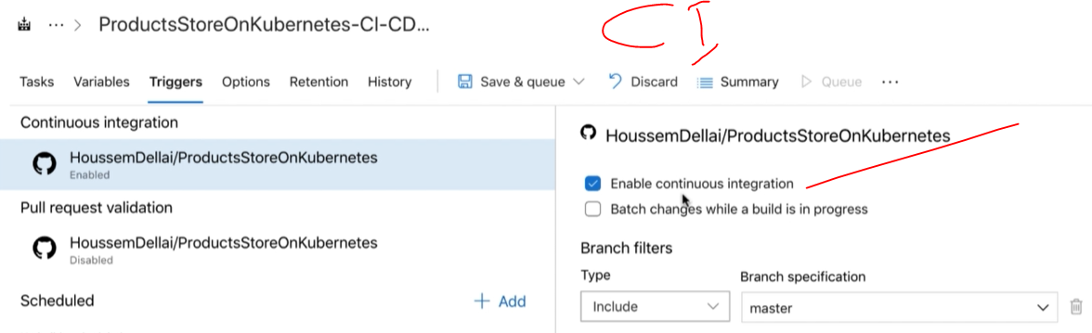

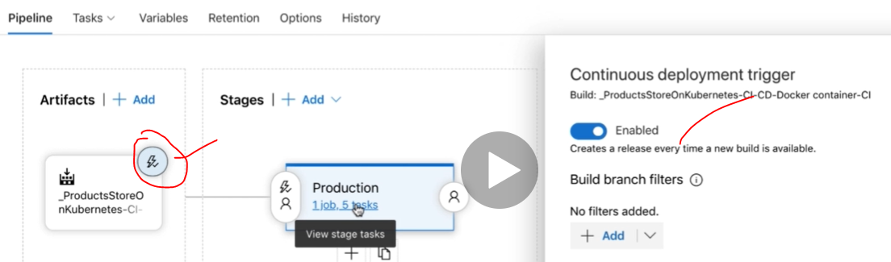

**If there is any change in the SCM automatically job will be trigger and deploy the code into Azure webapp.and finally the docker latest images will save into respective docker account.**

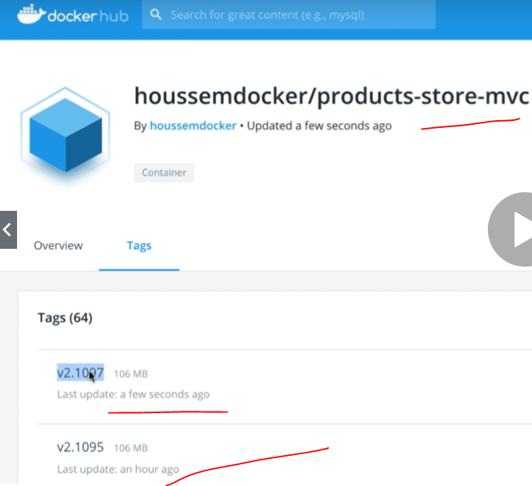

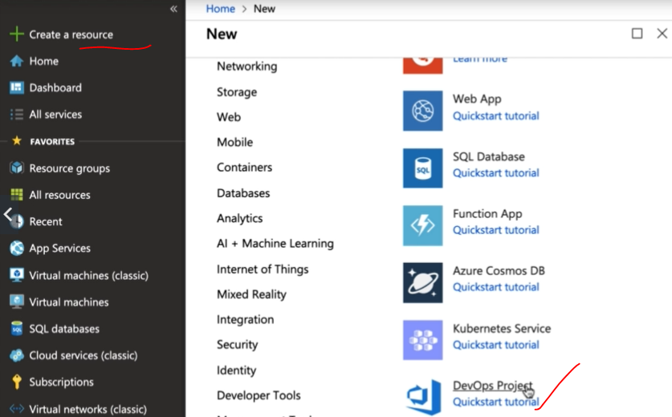

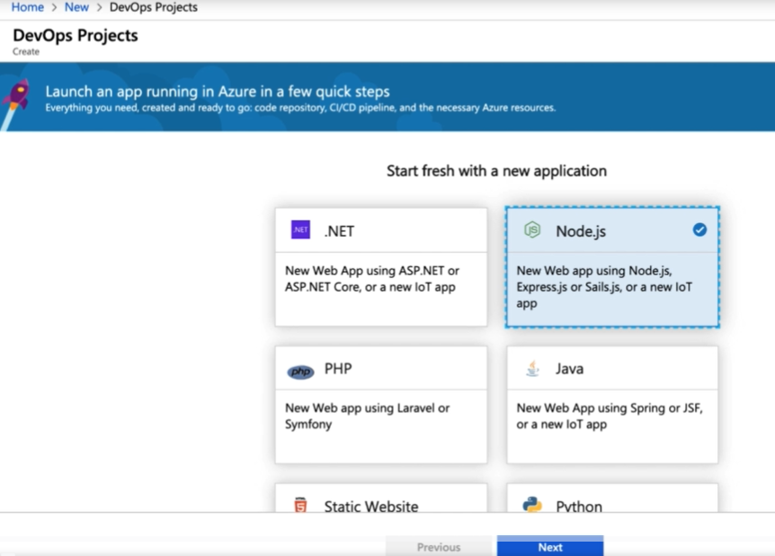

**Select Node js application and select framework as Express js then the below**

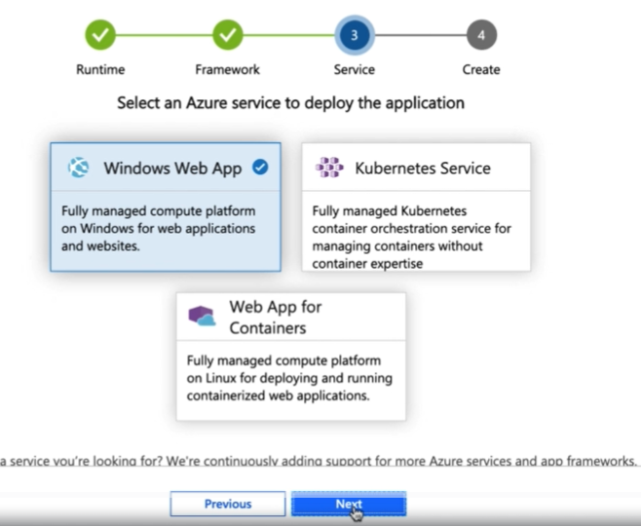

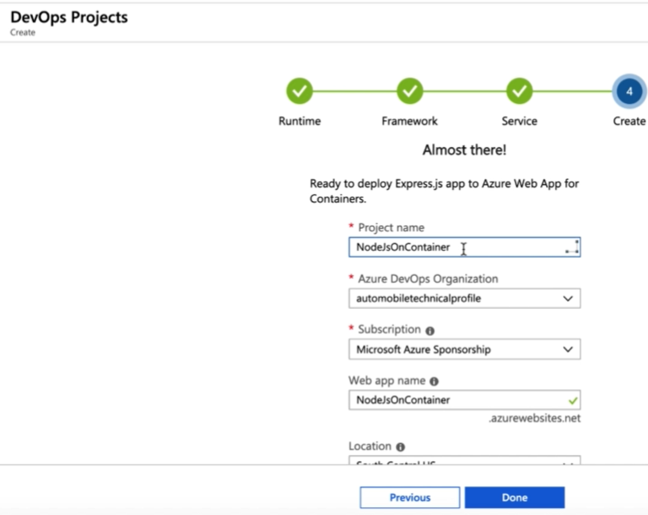

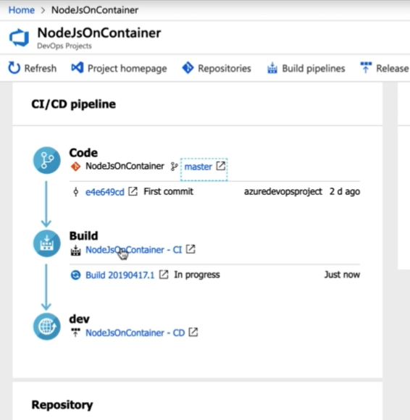

**After completion of the CI/CD process the Azure devops page will updated with release details.**

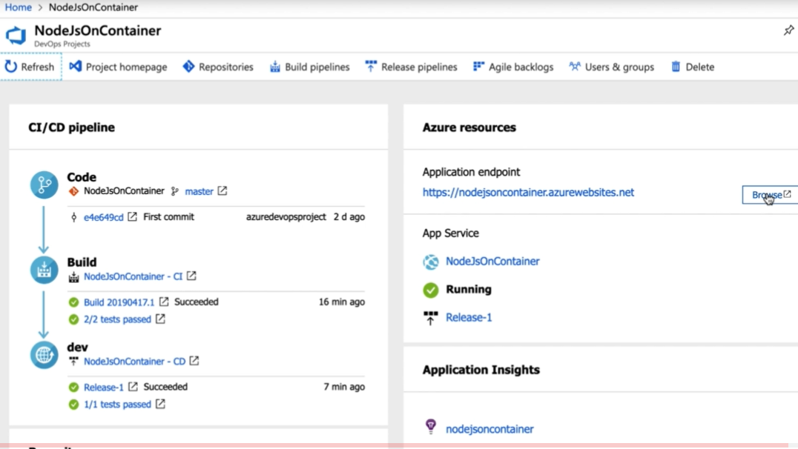

**Azure Key Vaults: Azure key Vault is a to store the user name and password and certificates to use as variable in the Azure DevOps pipelines.**

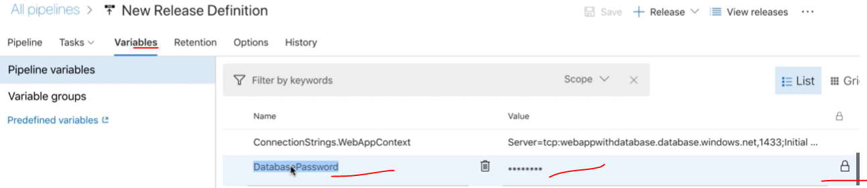

**Search key vault in the Azure resource search**

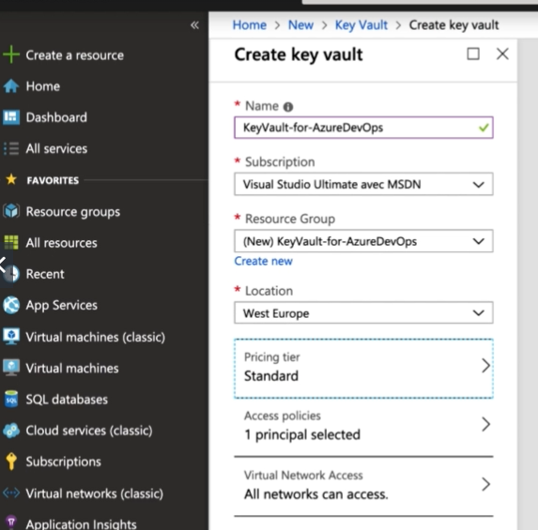

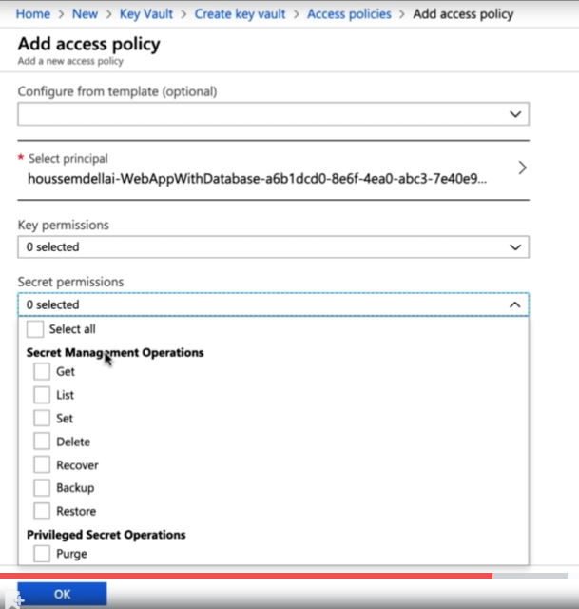

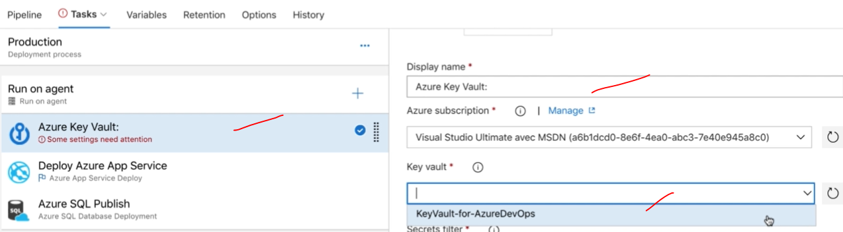

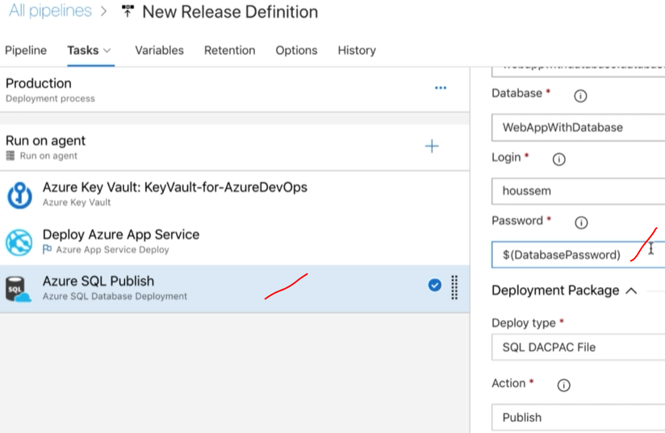

**Save and run it..**

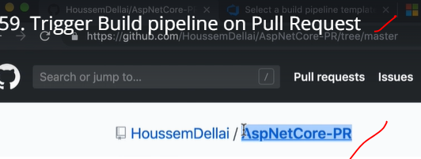

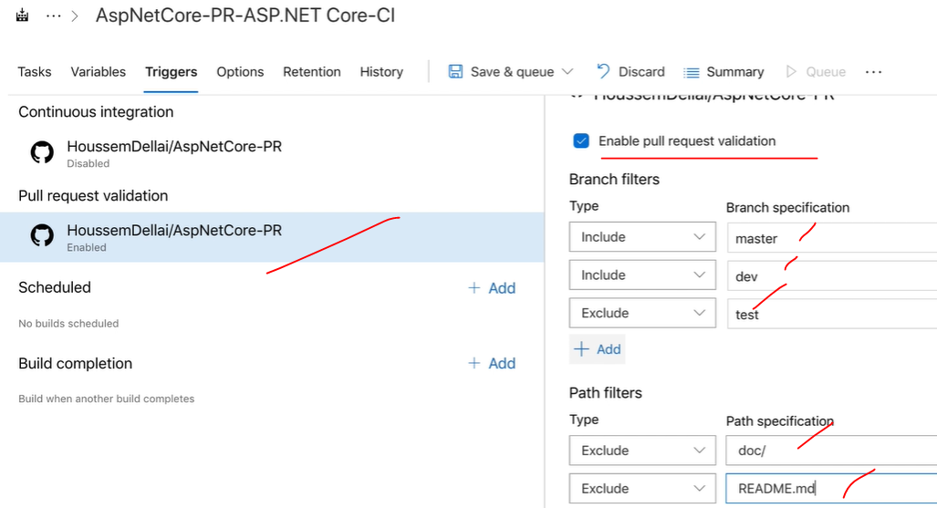

**Need to install azure pipelines from GitHub market place, Template for the webhook for the GitHub and azure pipelines.**

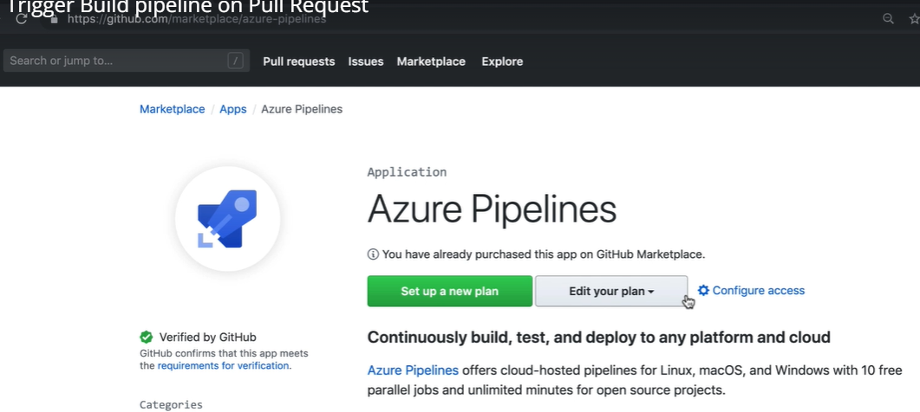

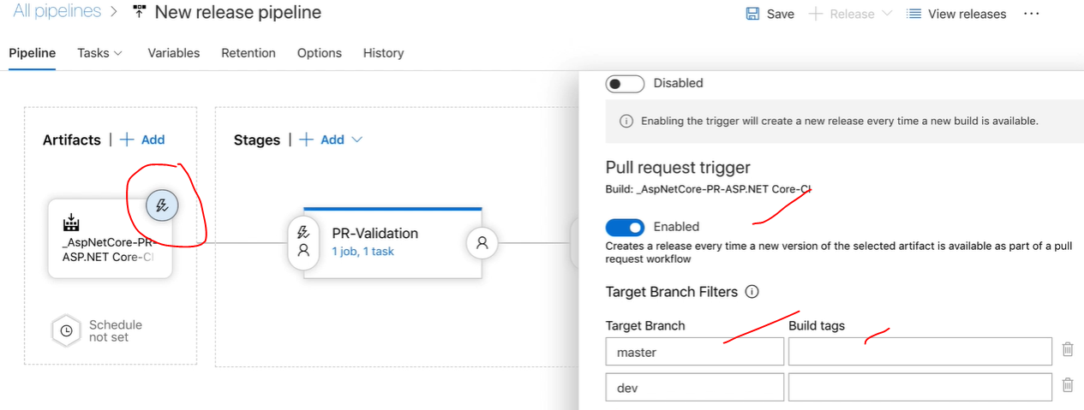

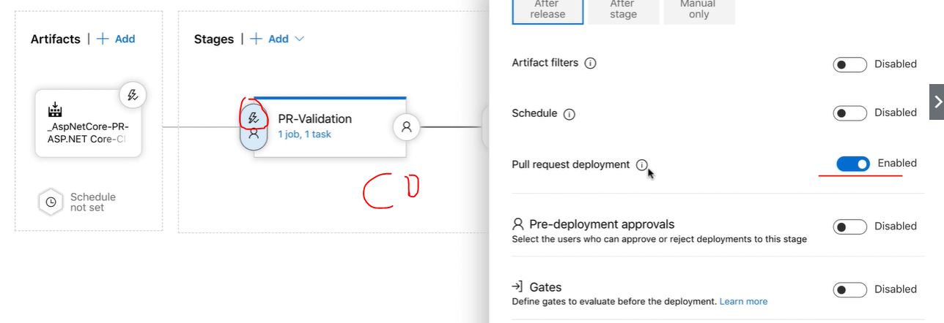

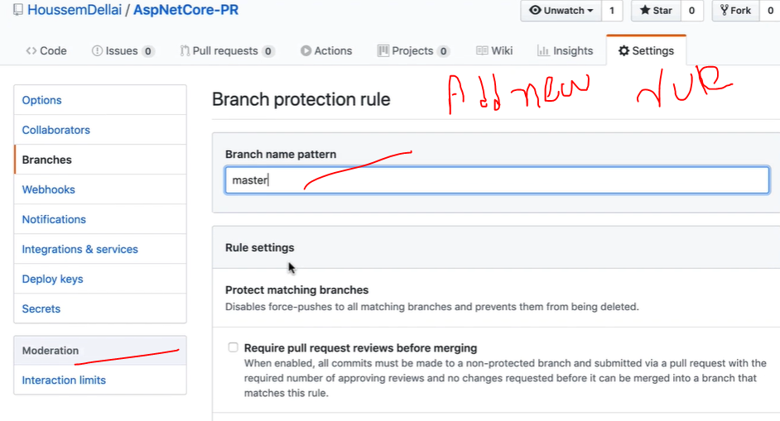

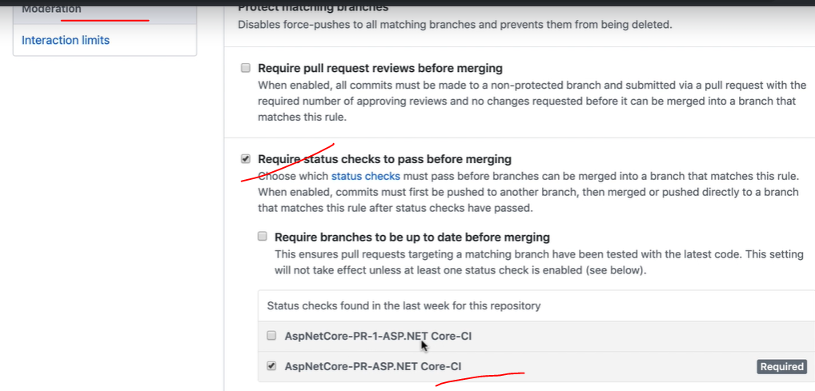

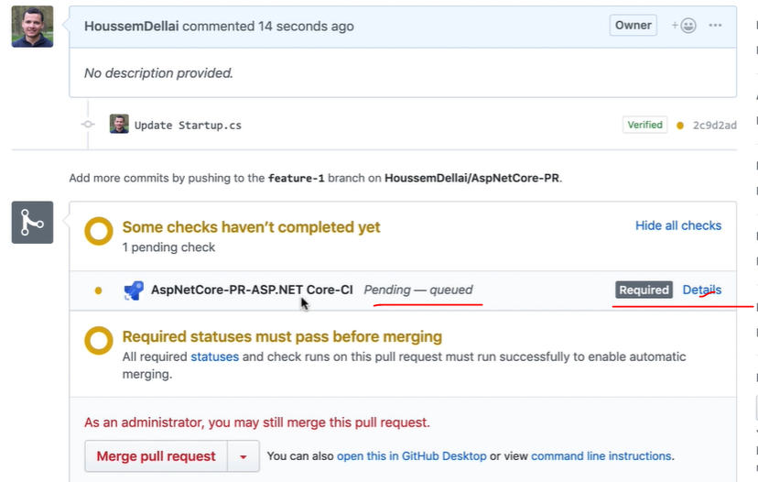

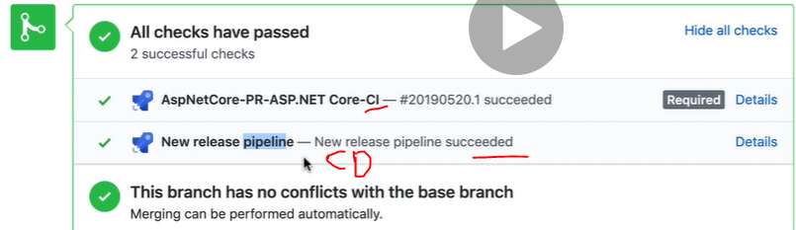

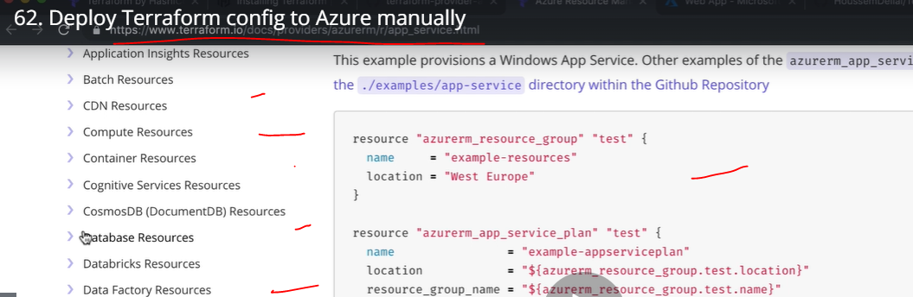

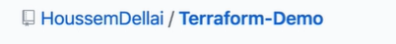

## To create Azure webapp and database with connection string: [Terraform-Demo](https://github.com/madhureddy87/Terraform-Demo)/[app-service](https://github.com/madhureddy87/Terraform-Demo/tree/master/app-service)/****main.tf****

**resource "azurerm_resource_group" "test" {**

**name = "terraform-resource-group"**

**location = "West Europe"**

**}**

**resource "azurerm_app_service_plan" "test" {**

**name = "terraform-appserviceplan"**

**location = "${azurerm_resource_group.test.location}"**

**resource_group_name = "${azurerm_resource_group.test.name}"**

**sku {**

**tier = "Standard"**

**size = "S1"**

**}**

**}**

**resource "azurerm_app_service" "test" {**

**name = "terraform-app-service"**

**location = "${azurerm_resource_group.test.location}"**

**resource_group_name = "${azurerm_resource_group.test.name}"**

**app_service_plan_id = "${azurerm_app_service_plan.test.id}"**

**site_config {**

**dotnet_framework_version = "v4.0"**

**scm_type = "LocalGit"**

**}**

**app_settings = {**

**"SOME_KEY" = "some-value"**

**}**

**connection_string {**

**name = "Database"**

**type = "SQLServer"**

**value = "Server=some-server.mydomain.com;Integrated Security=SSPI"**

**}**

**}**

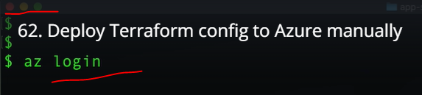

**When we try to login with Azure CLI need to provide the Azure subscription login credentials.**

**The below command list the Azure available subscriptions: and install the terraform in the below portal.**

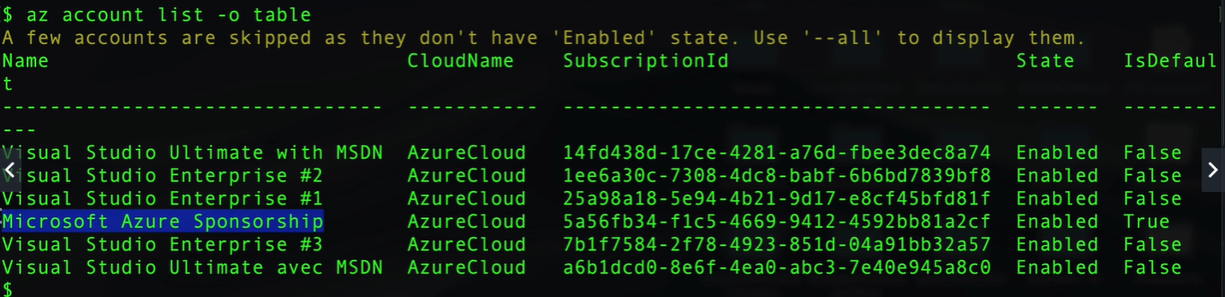

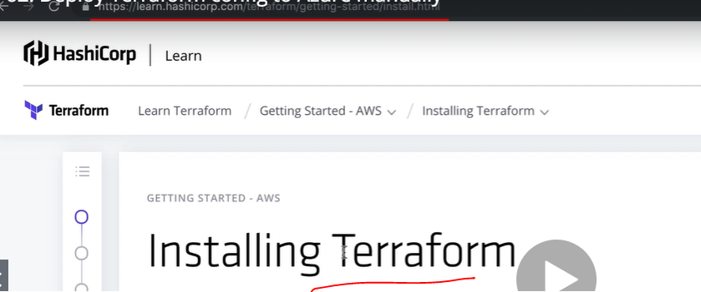

**Terraform ---it will give you list of commands you are going to use.**

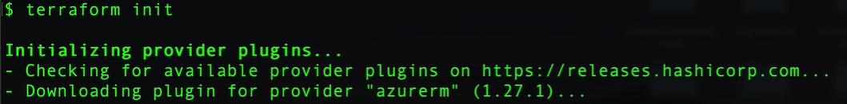

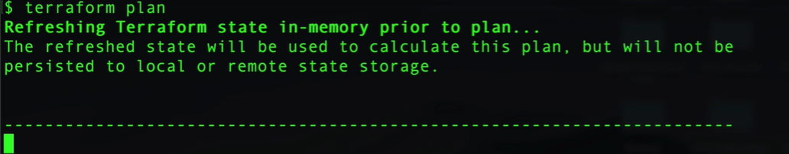



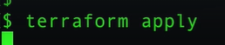

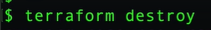

**Terraform Pipeline:**

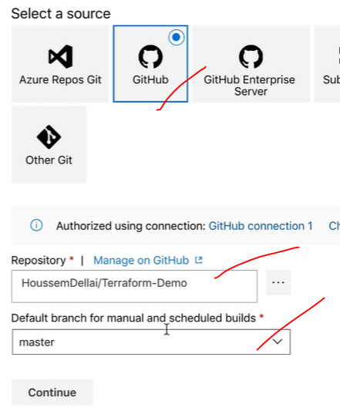

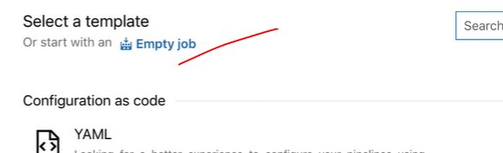

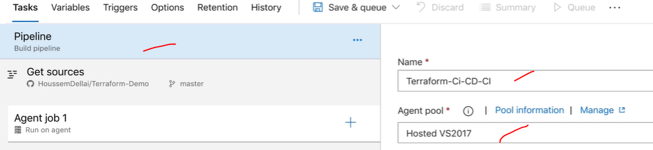

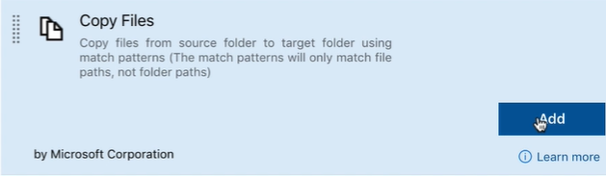

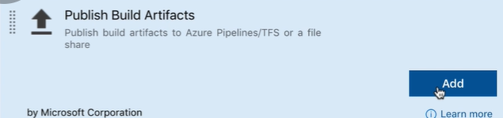

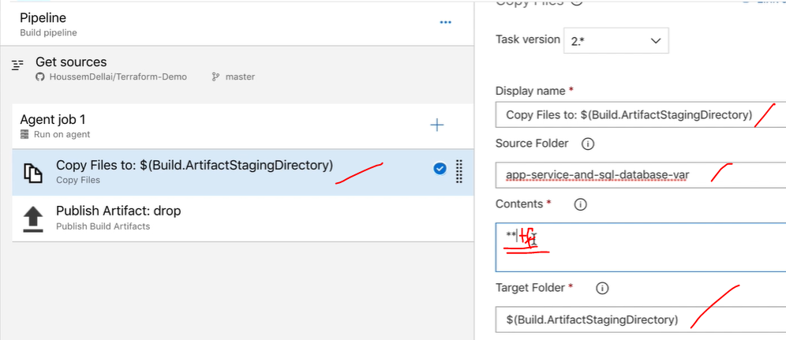

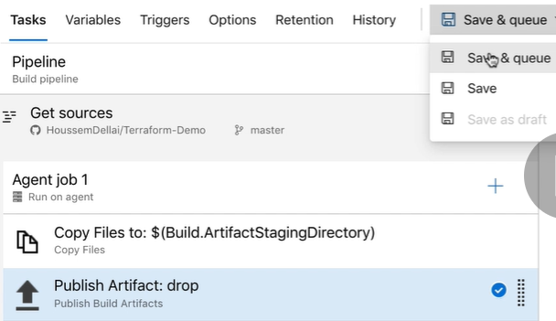

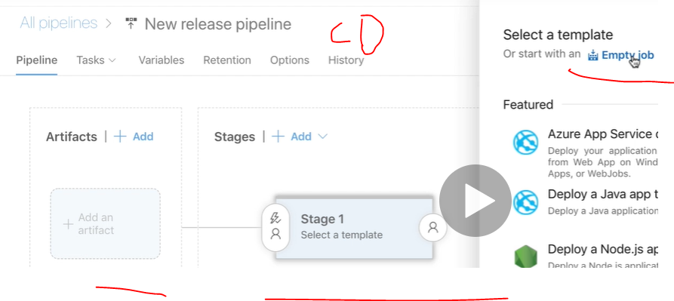

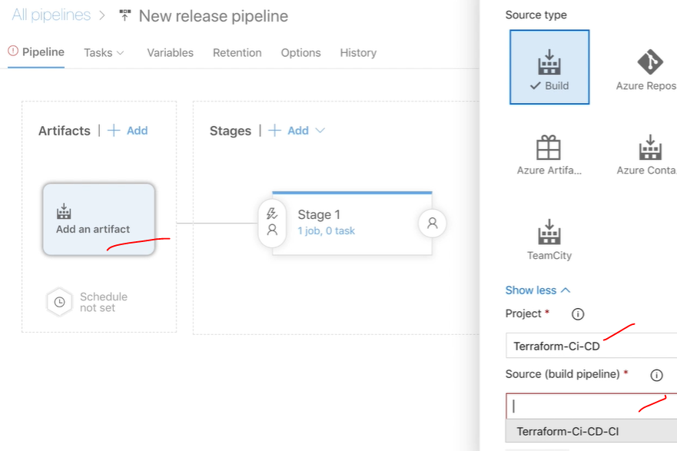

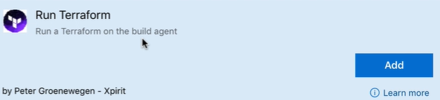

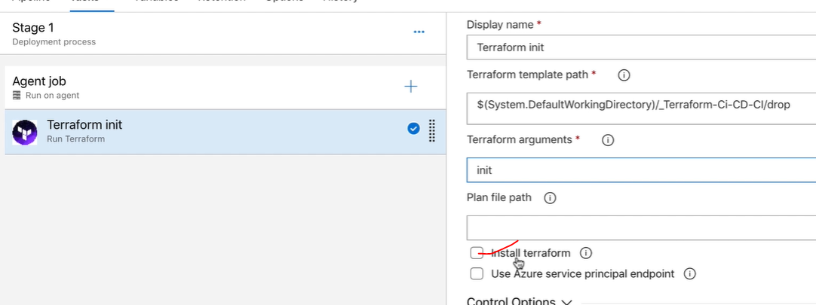

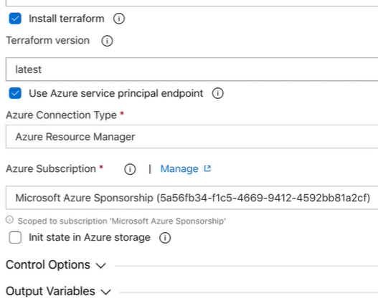

**Clone it**

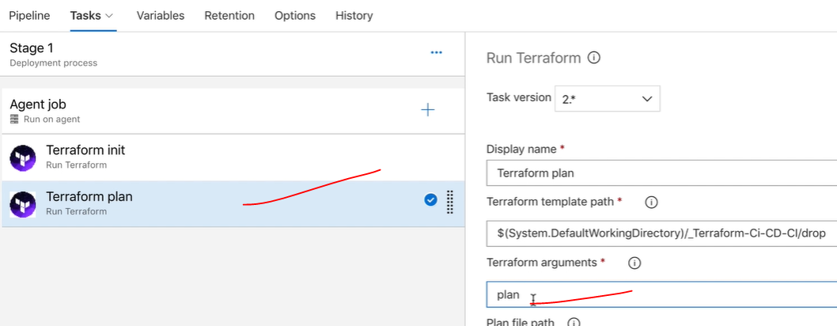

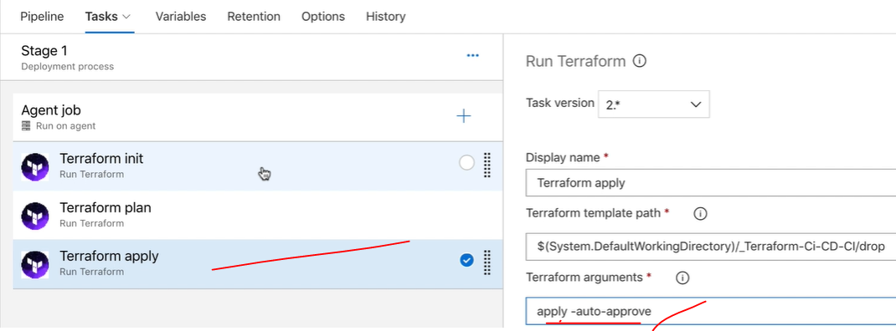

**Then run it.**

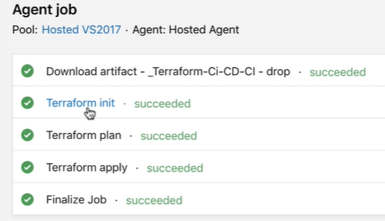

**CI/CD Pipeline with NuGet packages:**

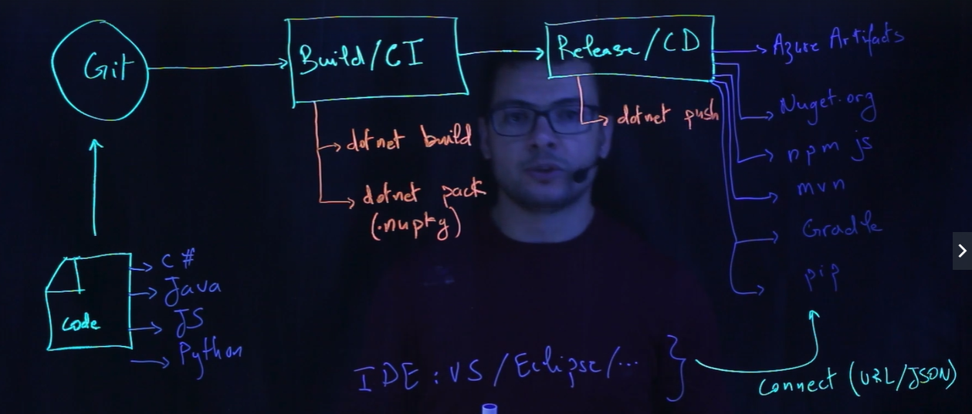



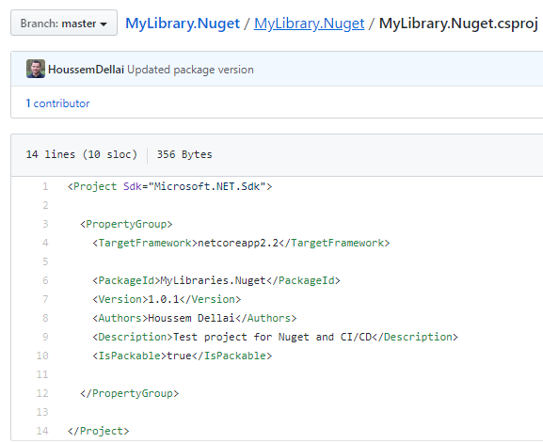

## [MyLibrary.Nuget](https://github.com/madhureddy87/MyLibrary.Nuget)/****azure-pipelines.yml****

**trigger:**

**- master**

**pool:**

**vmImage: 'ubuntu-16.04'**

**stages:**

**- stage: Build_Stage**

**displayName:**

**jobs:**

**- job: BuildNuget**

**displayName: Build Nuget packages**

**variables:**

**BuildConfiguration: release**

**steps:**

**- task: DotNetCoreCLI@2**

**inputs:**

**command: 'restore'**

**projects: '**/*.csproj'**

**feedsToUse: 'select'**

**- task: DotNetCoreCLI@2**

**inputs:**

**command: 'build'**

**projects: '**/*.csproj'**

**arguments: '--configuration $(BuildConfiguration)'**

**- task: DotNetCoreCLI@2**

**inputs:**

**command: 'pack'**

**packagesToPack: '**/*.csproj'**

**versioningScheme: 'off'**

**- task: DotNetCoreCLI@2**

**inputs:**

**command: 'push'**

**packagesToPush: '$(Build.ArtifactStagingDirectory)/*.nupkg'**

**nuGetFeedType: 'internal'**

**publishVstsFeed: 'f50482f5-11a3-4eea-9ab0-2b4c997bd0e2'**

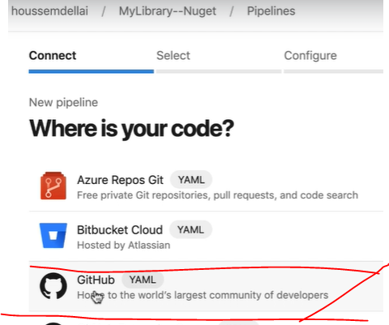

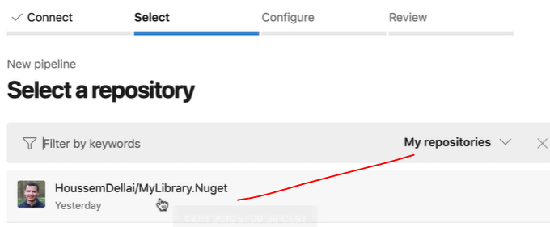

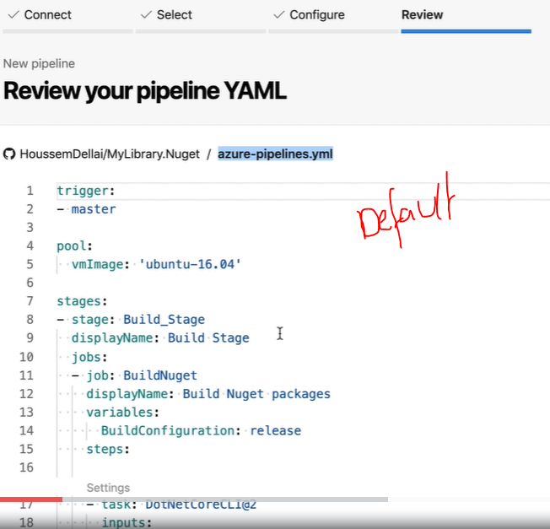

**We are creating yml scripting generated step by step.**

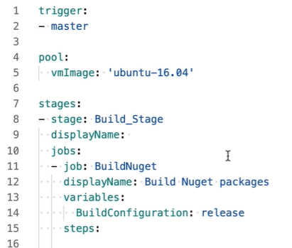

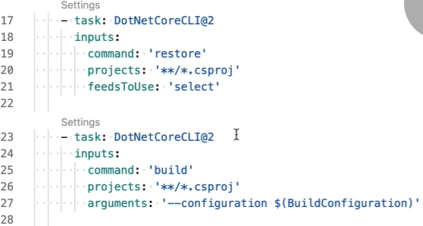

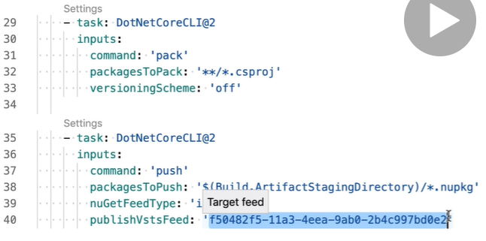

**Save and run it..**

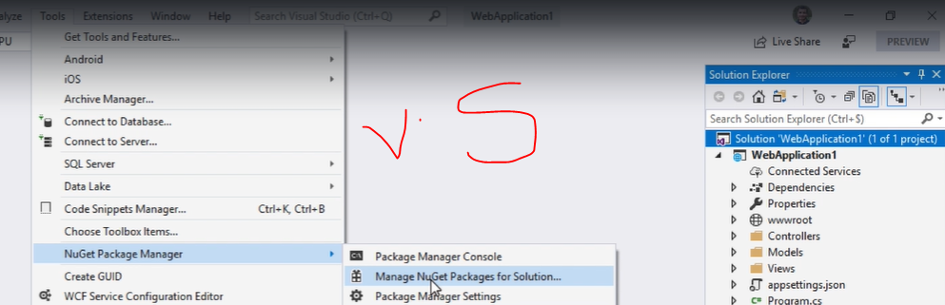

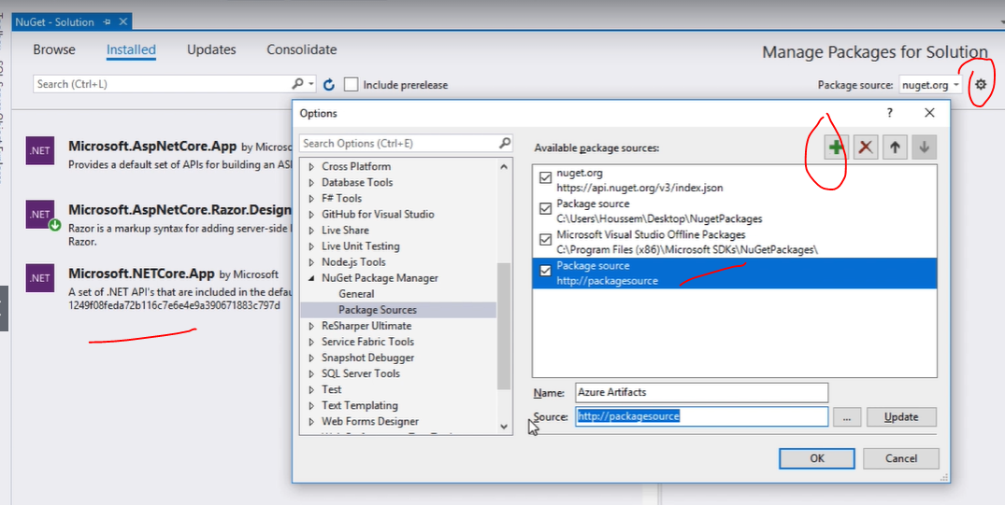

**Secure DevOps Kit for Azure**

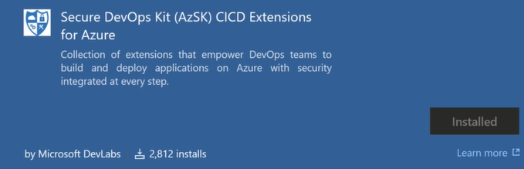





**pr:**

**branches:**

**include:**

**- dev**

**paths:**

**exclude:**

**- docs/\***

**- README.md**

**trigger:**

**branches:**

**include:**

**- master**

**paths:**

**exclude:**

**- docs/\***

**- README.md**

**- azure-pipelines-ci.yml**

**- azure-pipelines-ci-cd.yml**

**stages:**

**- stage: Build_Stage**

**displayName: Build Stage**

**jobs:**

**- job: WebApp**

**displayName: Build Web App Job**

**pool:**

**name: Hosted Windows 2019 with VS2019**

**vmImage: 'windows-2019'**

**demands: java**

**variables:**

**BuildConfiguration: release**

**steps:**

**- task: DotNetCoreCLI@2**

**displayName: Restore**

**inputs:**

**command: restore**

**projects: '**/WebApp.csproj'**

**- task: WhiteSource Bolt@20**

**- powershell: |**

**Write-Host "Hello World"**

**$paths = Get-ChildItem -include *.csproj -Recurse**

**foreach($pathobject in $paths)**

**{**

**$path = $pathobject.fullname**

**$doc = New-Object System.Xml.XmlDocument**

**$doc.Load($path)**

**$child = $doc.CreateElement("ProjectGuid")**

**$child.InnerText = [guid]::NewGuid().ToString().ToUpper()**

**$node = $doc.SelectSingleNode("//Project/PropertyGroup")**

**$node.AppendChild($child)**

**$doc.Save($path)**

**}**

**workingDirectory: WebApp**

**displayName: 'PS : Add Project GUID'**

**- task: SonarCloudPrepare@1**

**displayName: Prepare analysis on SonarCloud**

**inputs:**

**SonarCloud: SonarCloud**

**organization: houssemdellai**

**projectKey: WebAppWithDatabaseDemo**

**- task: DotNetCoreCLI@2**

**displayName: Build**

**inputs:**

**projects: '**/WebApp.csproj'**

**arguments: '--configuration $(BuildConfiguration)'**

**- task: DotNetCoreCLI@2**

**displayName: Test**

**inputs:**

**command: test**

**projects: '**/*UnitTest*.csproj'**

**arguments: '--configuration $(BuildConfiguration)'**

**- task: DotNetCoreCLI@2**

**displayName: Publish**

**inputs:**

**command: publish**

**publishWebProjects: True**

**arguments: '--configuration $(BuildConfiguration) --output $(build.artifactstagingdirectory)'**

**zipAfterPublish: True**

**- task: SonarCloudAnalyze@1**

**displayName: Run Code Analysis**

**- task: SonarCloudPublish@1**

**displayName: Publish Quality Gate Result**

**- task: PublishBuildArtifacts@1**

**displayName: Publish Artifact (WebApp.zip)**

**inputs:**

**PathtoPublish: '$(build.artifactstagingdirectory)'**

**ArtifactName: drop**

**- job: Database**

**displayName: Build Database Job**

**pool:**

**name: Hosted Windows 2019 with VS2019**

**vmImage: 'windows-2019'**

**demands: msbuild**

**steps:**

**- task: MSBuild@1**

**displayName: Build solution WebApp.Database.sqlproj**

**inputs:**

**solution: WebApp.Database/WebApp.Database.sqlproj**

**msbuildArguments: '/p:OutDir=$(Build.ArtifactStagingDirectory)'**

**- task: PublishBuildArtifacts@1**

**displayName: Publish Artifact (Dacpac)**

**inputs:**

**ArtifactName: dacpac**

**- job: Selenium**

**displayName: Build UI Tests Job**

**pool:**

**name: Hosted Windows 2019 with VS2019**

**vmImage: 'windows-2019'**

**demands: msbuild**

**steps:**

**- task: NuGetToolInstaller@0**

**displayName: Use NuGet 4.3.0**

**- task: NuGetCommand@2**

**displayName: NuGet restore**

**inputs:**

**restoreSolution: WebAppWithDatabase.sln**

**- task: MSBuild@1**

**displayName: Build project SeleniumUiTests.csproj**

**inputs:**

**solution: SeleniumUiTests/SeleniumUiTests.csproj**

**msbuildArguments: '/p:OutDir=$(Build.ArtifactStagingDirectory)'**

**- task: PublishBuildArtifacts@1**

**displayName: 'Publish Artifact: UI-Test'**

**inputs:**

**ArtifactName: ui-tests**

**- job: Infrastructure**

**displayName: Publish Infra files Job**

**pool:**

**name: Hosted Ubuntu 1604**

**vmImage: 'ubuntu-16.04'**

**steps:**

**- task: PublishBuildArtifacts@1**

**displayName: 'Publish Artifact: ARM templates'**

**inputs:**

**PathtoPublish: AzureResourceGroupDeployment**

**ArtifactName: arm**

**- stage: Dev_Stage**

**displayName: Dev Stage**

**dependsOn: Build_Stage**

**jobs:**

**- job: Dev**

**displayName: Deploy to Dev Job**

**pool:**

**name: Hosted Windows 2019 with VS2019**

**vmImage: 'windows-2019'**

**variables:**

**Parameters.ConnectedServiceName: 'Visual Studio Enterprise' # couldn't be referenced**

**ResourceGroupName: '$(Prefix)-$(Release.EnvironmentName)-$(UniqueId)-RG'**

**Database.Admin: 'houssem'**

**Database.Password: '@Aa123456'**

**Database.Name: 'EmployeesDB'**

**WebAppName: '$(Prefix)-$(Release.EnvironmentName)-$(UniqueId)'**

**WebAppNameUrl: 'https://$(WebAppName).azurewebsites.net/'**

**SqlServerName: '$(Prefix)-sql-$(Release.EnvironmentName)-$(UniqueId)'**

**Prefix: 'tunis'**

**Release.EnvironmentName: 'dev'**

**UniqueId: '1280' #'$(Build.BuildId)'**

**steps:**

**- checkout: none**

**- task: DownloadBuildArtifacts@0**

**displayName: Download Build Artifacts**

**inputs:**

**artifactName: arm**

**downloadPath: $(System.DefaultWorkingDirectory)**

**- task: AzureResourceGroupDeployment@2**

**displayName: Validate ARM template**

**enabled: 'true'**

**inputs:**

**azureSubscription: 'Visual Studio Enterprise'**

**action: 'Create Or Update Resource Group'**

**resourceGroupName: '$(ResourceGroupName)'**

**location: 'West Europe'**

**templateLocation: 'Linked artifact'**

**csmFile: '$(System.DefaultWorkingDirectory)/**/arm/WebSiteSQLDatabase.json'**

**csmParametersFile: '$(System.DefaultWorkingDirectory)/**/arm/WebSiteSQLDatabase.parameters.json'**

**overrideParameters: '-hostingPlanName "houssemdellai-service-plan" -skuName "F1" -skuCapacity 1 -administratorLogin $(Database.Admin) -administratorLoginPassword $(Database.Password) -databaseName $(Database.Name) -collation "SQL_Latin1_General_CP1_CI_AS" -edition "Basic" -maxSizeBytes "1073741824" -requestedServiceObjectiveName "Basic" -webSiteName $(WebAppName) -sqlserverName $(SqlServerName)'**

**deploymentMode: 'Validation'**

**- task: AzSKARMTemplateChecker@4**

**inputs:**

**ARMTemplateFilePath: '$(System.DefaultWorkingDirectory)/**/arm/WebSiteSQLDatabase.json'**

**ARMTemplateParameterFilePath: '$(System.DefaultWorkingDirectory)/**/arm/WebSiteSQLDatabase.parameters.json'**

**- task: AzureResourceGroupDeployment@2**

**displayName: Create Or Update Resource Group**

**enabled: 'true'**

**inputs:**

**azureSubscription: 'Visual Studio Enterprise'**

**action: 'Create Or Update Resource Group'**

**resourceGroupName: '$(ResourceGroupName)'**

**location: 'West Europe'**

**templateLocation: 'Linked artifact'**

**csmFile: '$(System.DefaultWorkingDirectory)/**/arm/WebSiteSQLDatabase.json'**

**csmParametersFile: '$(System.DefaultWorkingDirectory)/**/arm/WebSiteSQLDatabase.parameters.json'**

**overrideParameters: '-hostingPlanName "houssemdellai-service-plan" -skuName "F1" -skuCapacity 1 -administratorLogin $(Database.Admin) -administratorLoginPassword $(Database.Password) -databaseName $(Database.Name) -collation "SQL_Latin1_General_CP1_CI_AS" -edition "Basic" -maxSizeBytes "1073741824" -requestedServiceObjectiveName "Basic" -webSiteName $(WebAppName) -sqlserverName $(SqlServerName)'**

**deploymentMode: Complete**

**- task: AzSKSVTs@4**

**inputs:**

**ConnectedServiceNameARM: 'Visual Studio Enterprise'**

**GenerateMethodParameterSetSelection: 'ResourceGroupName'**

**ResourceGroupName: '$(ResourceGroupName)'**

**SubscriptionId: '17b12858-3960-4e6f-a663-a06fdae23428'**

**EnableGSSscan: true**

**- task: DownloadBuildArtifacts@0**

**displayName: Download WebApp.zip**

**inputs:**

**buildType: 'current'**

**downloadType: 'single'**

**artifactName: 'drop'**

**itemPattern: '**/WebApp.zip'**

**downloadPath: '$(System.DefaultWorkingDirectory)'**

**- task: CmdLine@2**

**inputs:**

**script: |**

**ls $(System.DefaultWorkingDirectory)**

**- task: AzureRmWebAppDeployment@3**

**displayName: Deploy Web App to Azure App Service**

**enabled: 'true'**

**inputs:**

**azureSubscription: 'Visual Studio Enterprise'**

**appType: 'webApp'**

**WebAppName: '$(WebAppName)'**

**TakeAppOfflineFlag: true**

**JSONFiles: '**/appsettings.json'**

**packageForLinux: '$(System.DefaultWorkingDirectory)/drop/WebApp.zip' #'$(System.ArtifactsDirectory)/**/drop/WebApp.zip'**

**- task: DownloadBuildArtifacts@0**

**displayName: Download DacPac**

**inputs:**

**buildType: 'current'**

**downloadType: 'single'**

**artifactName: 'dacpac'**

**itemPattern: '**/*.dacpac'**

**downloadPath: '$(System.DefaultWorkingDirectory)'**

**- task: SqlAzureDacpacDeployment@1**

**displayName: Azure SQL Publish DacPac to SQL Azure**

**inputs:**

**azureSubscription: 'Visual Studio Enterprise'**

**ServerName: '$(SqlServerName).database.windows.net,1433'**

**DatabaseName: '$(Database.Name)'**

**SqlUsername: '$(Database.Admin)'**

**SqlPassword: '$(Database.Password)'**

**DacpacFile: '$(System.DefaultWorkingDirectory)/dacpac/WebApp.Database.dacpac'**

**- task: DownloadBuildArtifacts@0**

**displayName: Download Selenium Tests**

**inputs:**

**buildType: 'current'**

**downloadType: 'single'**

**artifactName: 'ui-tests'**

**itemPattern: ''**

**downloadPath: '$(System.DefaultWorkingDirectory)'**

**- task: VSTest@2**

**displayName: Selenium UI Tests**

**inputs:**

**testSelector: 'testAssemblies'**

**searchFolder: '$(System.DefaultWorkingDirectory)/ui-tests'**

**runSettingsFile: '$(System.DefaultWorkingDirectory)/ui-tests/.runsettings'**

**overrideTestrunParameters: '-webAppUrl $(WebAppNameUrl)'**

**testAssemblyVer2: |**

**\*\*\*Test*.dll**

**!**\*TestAdapter.dll**

**!**\obj\\*\***

**runInParallel: false**

**codeCoverageEnabled: false**

**- stage: Test_Stage**

**displayName: Test Stage**

**jobs:**

**- job:**

**displayName: Deploy to Test Job**

**steps:**

**- task: CmdLine@2**

**inputs:**

**script: 'ls'**

**- stage: Prod_Stage**

**displayName: Prod Stage**

**jobs:**

**- job:**

**displayName: Deploy to Prod Job**

**steps:**

**- task: CmdLine@2**

**inputs:**

**script: 'ls'**